STUFF A TRUCK!
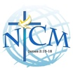
New Testament Church and Mission
604 Lemon Ave., Sebring, FL 33870
(863) 385-0035
http://www.ntcmissionsebring.org

THE VISION
The year was 1976 when Founders Mike and Pat Karl started the New Testament Church and Mission, and began to reach out to the down and out, addicted, hungry, homeless, loss, lonely and destitute.

FORTY - FIVE YEARS LATER
The Vision has continued to grow. We have fed over 1.5 million meals, housed over 735,000 individuals and have given out more food baskets than we can count. We help everyone to our best ability with the resources we have.

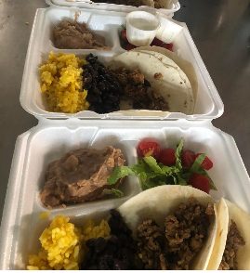
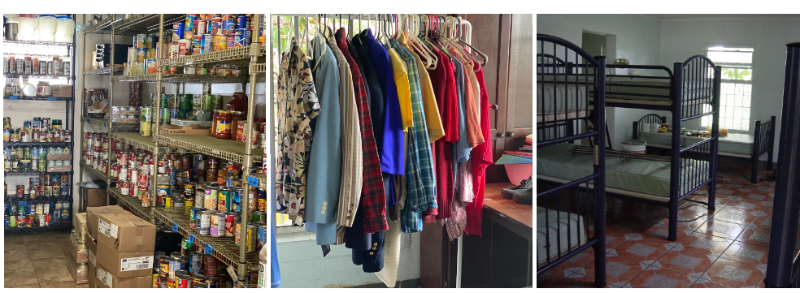
Food Pantry Clothing Shelter Meals

Greatest Needs
- Twin size bedding
- Towels, wash cloths
- Toilet paper
- Shampoo and body wash
- Deodorant, toiletries

- Plastic forks
- Disposable cups
- Food storage bags

- Cooking oil
- Drink mixes
- Non-perishable foods
- Pantry staples: beans, rice, pasta, flour, sugar

