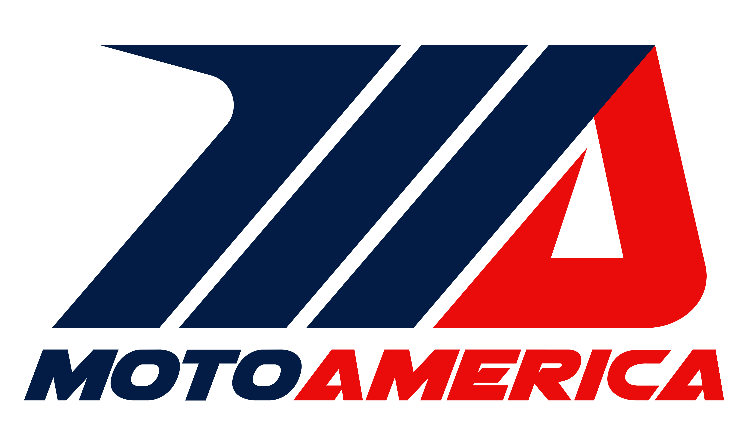

2019 AMA FIM North America License Eligibility

1. Competition Licenses
- All riders participating in any on-track practice, qualifying or racing must have a valid AMA, FIM Continental Union or FIM license of the appropriate classification. It is recommended that processing of the license be completed through the AMA office 30 days before the first event in which they wish to participate. Riders participating on an FIM Continental Union or FIM license must also provide a start permission from their host federation. Additional licensing information and applications are available from the AMA at roadrace@ama-cycle.org or at:

http://americanmotorcyclist.com/Racing/RoadRacing/RoadRacingRules.aspx.

- When a license applicant’s experience includes competition in FIM MotoGP, World Superbike, or other international or national motorcycle racing series, AMA may use its discretion to issue the appropriate license.

- AMA-licensed riders not qualifying in an AMA MotoAmerica sanctioned event for a period of three years may lose their prior classification.

- Applicants renewing a license that has been expired three or more years may be required to complete a Road Race Eligibility Questionnaire.

- Any rider who is a new applicant or changes AMA license classification will compete under a probationary period of two (2) race events. The AMA reserves the right to evaluate the supervised results to determine inclusion or exclusion in the new class.
  - Exceptions to these requirements may be applied for in writing and granted at the discretion of the MotoAmerica Permanent Bureau. The MotoAmerica Permanent Bureau consist of representatives of the Krave Group, MotoAmerica and AMA or FIM North America.
- Exceptions to the license requirements listed below may be applied for in writing and granted at the discretion of the MotoAmerica Permanent Bureau. The MotoAmerica Permanent Bureau consist of representatives of the Krave Group, MotoAmerica and AMA or FIM North America.

2. License Classifications
a. There are five classes of rider licenses for AMA-sanctioned road racing events:
- Superbike
- Supersport
- Stock 1000
- Twins Cup
- Junior Cup
3. Superbike Licenses
- The Superbike license allows participation in the Superbike class only. Superbike license holders may apply for and be granted an additional Supersport license if they are qualified. In this case, the rider may be issued a different number in the additional class due to number availability.
- AMA Superbike licenses are issued to eligible riders who have reached the minimum age of 18 years and a maximum age of 55 years. Riders over age 50 years require a medical examination and a stress test EKG.
- Riders who held an AMA Superbike license during the 2017 or 2018 season and earned points in Superbike competition may apply for this license.
- Riders who held an AMA Supersport license during the 2017 or 2018 season and earned 50 advancement points in Supersport competition may apply for this license. In this case, riders must provide documented experience on a motorcycle eligible for AMA MotoAmerica Superbike or Stock 1000 competition.
- Other new applicants must meet the following criteria:
  - Successfully completed at least two (2) full racing seasons (including at least 12 race weekends) as an Expert riding a motorcycle(s) eligible for AMA MotoAmerica Superbike, Stock 1000 or Supersport competition. In this case, riders must provide documented experience on a motorcycle eligible for AMA MotoAmerica Superbike or Superstock 1000 competition.
  - Earned at least 400 Expert points within a maximum of five (5) years, from a recognized road race organization, riding a motorcycle(s) eligible for AMA MotoAmerica Superbike competition. (Age specific classes and endurance events do not count toward rider eligibility.)
  - All new applicants must complete and have certified by the Race Director of the recognized organization the Road Race Eligibility Questionnaire verifying Expert classification, points earned and rider qualification for an AMA Superbike license.
  - All new applicants must also provide a copy of their current Expert-rated license with the recognized organization from which they are submitting points.
- Superbike-licensed riders may only compete in the Superbike class and may not return to a lower class without approval.

- The 2018 Superbike Champion may use the number one for the 2019 season. Two-digit numbers will be assigned and are compulsory for the Superbike class. Single digit numbers will be awarded to previous Superbike Champions as they are available.

4. Supersport Licenses
- The Supersport license allows participation in the Supersport class only. Supersport license holders may apply for and be granted an additional Superbike or Twins Cup class license if they are qualified. In this case, the rider may be issued a different number in the additional class due to number availability.
- An AMA Supersport licenses are issued to eligible riders who have reached the minimum age of 16 years and a maximum age of 55 years. Riders over age 50 years require a medical examination and a stress test EKG. Exceptions to the maximum age may be requested in writing to the MotoAmerica Permanent Bureau.
- Riders who have held an AMA Superbike license except those finishing in the top 10 positions in the previous year Superbike standings may apply for this license. Exceptions to this policy may be submitted in writing to the permanent bureau.

- Riders who have held an AMA Supersport or Superstock 600 license may apply for this license.
- Riders who have held an AMA Junior Cup license during the 2018 season and have earned 50 advancement points in AMA MotoAmerica Junior Cup class may apply for this license.
- Other new applicants must meet the following criteria:
- Successfully complete at least one racing season (including at least six (6) race weekends) as an Expert riding a motorcycle(s) eligible for AMA MotoAmerica Supersport competition.
- Earned at least 200 Expert points within a maximum of five (5) years, riding a motorcycle(s) eligible for AMA MotoAmerica Supersport competition.
- All new applicants must complete and have certified by the Race Director of the recognized organization the Road Race Eligibility Questionnaire verifying Expert classification, points earned and rider qualification for an AMA MotoAmerica Supersport license.
- All new applicants must also provide a copy of their current Expert-rated license with the recognized organization from which they are submitting points.
- AMA Supersport licensed riders may not compete in AMA MotoAmerica Superbike, Stock 1000, Twins Cup or Junior Cup classes.

- The 2018 Supersport Champion may use the number one for the 2019 season. Two-digit numbers will be assigned and are compulsory for the Supersport class.

5. Stock 1000 Class Licenses
- The Stock 1000 license allows participation in the Stock 1000 and the Twins Cup classes only. Stock 1000 license holders may apply for and be granted a Supersport license if they are qualified. In this case, the rider may be issued a different number in the additional class due to number availability.
- AMA Stock 1000 licenses are issued to eligible riders who have reached the minimum age of 18 years and a maximum age of 55 years. Riders over age 50 years require a medical examination and a stress test EKG. Exceptions to the maximum age may be requested in writing to the MotoAmerica Permanent Bureau.
- Riders who held an AMA Superbike license except those finishing in the top 15 positions in the previous year Superbike standings may apply for this license.

- Riders who held an AMA Supersport license during the 2018 season, except those who finished in the top 3 in previous year Supersport series standing, or have won a Supersport race within the previous year may apply for this license. In this case, riders must provide documented experience on a motorcycle eligible for AMA MotoAmerica Stock 1000 competition.

- Riders who held an AMA Superstock 600 license for during the 2017 season and earned 100 advancement points in Superstock 600 competition during the previous three (3) years may apply for this license. In this case, riders must provide documented experience on a motorcycle eligible for AMA MotoAmerica Stock 1000 competition.

- Riders who have won two (2) national Stock 1000 championships are no longer eligible to participate in the Stock 1000 Class.

- Riders who have finished in the top three (3) in Stock 1000 in two seasons may not be eligible.
- Other new applicants must meet the following criteria:
  - Successfully complete at least one (1) full racing season (including at least 6 race weekends) of road racing competition with a recognized motorcycle racing organization(s) as an Expert riding a motorcycle(s) eligible for AMA MotoAmerica Stock 1000 competition.
  - Earned at least 200 Expert points within a maximum of five (5) years, riding a motorcycle(s) eligible for AMA MotoAmerica Stock 1000 competition.
  - All new applicants must complete and have certified by the Race Director of the recognized organization the Road Race Eligibility Questionnaire verifying Expert classification, points earned and rider qualification for an AMA MotoAmerica Stock 1000 license.
  - All new applicants must also provide a copy of their current Expert-rated license with the recognized organization from which they are submitting points.
- AMA Stock 1000 licensed riders may not compete in AMA MotoAmerica Superbike, Supersport or Junior Cup classes.

- Two-digit numbers must be earned by scoring points during the previous AMA MotoAmerica season. All other numbers will be three-digit numbers. The number assignments will be shared with the Twins Cup class in that there will be no duplicate numbers within the two classes. Stock 1000 license holders will have preference to the number selection process.

6. Twins Cup Class Licenses
- The Twins Cup Class license allows participation in Twins class only. Twins Cup Class license holders may apply for and be granted an additional Superbike, Stock 1000, Supersport or Junior Cup class license if they are qualified. In this case, the rider may be issued a different number in the additional class due to number availability.
- An AMA Twins license is issued to eligible riders who have reached the minimum age of 16 years and a maximum age of 55 years. Riders over age 50 years require a medical examination and a stress test EKG. Exceptions to the maximum age may be requested in writing to the MotoAmerica Permanent Bureau.
- Riders who have held an AMA Superbike license except those finishing in the top 15 positions in the previous year Superbike standings may apply for this license. Exceptions to this policy may be submitted in writing to the permanent bureau.

- Riders who held an AMA Supersport license during the 2018 season may apply for this license, except those who finished in the top 5 in previous two year Supersport series standing.
- Other new applicants must meet the following criteria:
  - Successfully complete at least one season (6) race weekends as a Novice or Expert riding a motorcycle(s) eligible for AMA MotoAmerica Twins competition.
  - All new applicants must complete and have certified by the Race Director of the recognized organization the Road Race Eligibility Questionnaire verifying Expert classification, points earned and rider qualification for an AMA Superstock 600 license.
  - All new applicants must also provide a copy of their current license with the recognized organization from which they are submitting points.
7. Junior Cup Licenses
- The Junior Cup license allows participation in the Junior Cup class only. Junior Cup license holders may apply for and be granted an additional Twins Cup and or Supersport class license if they are qualified. In this case, the rider may be issued a different number in the additional class due to number availability.
- An AMA Junior Cup license is issued to eligible riders who have reached the minimum age of 14 years prior to the license being issued and a maximum age of 25 years of age on September 30, 2018. A license may be issued up to the maximum age and will be valid until the end of the 2019 season.
- All new applicants must provide a copy of their current license issued by a recognized road race organization, and show demonstrated race experience. Applicants with an expert license issued by a recognized road race organization will not be required to show demonstrated race experience.
- Riders who have won a national Junior Cup championship, and attained the age of 16, have only two (2) additional years of eligibility. Riders who have won two (2) national Junior Cup championships and have attained the age of 16 are no longer eligible to participate in the Junior Cup class.

- Riders who have finished in the top five (5) in Junior Cup or KTM RC Cup in two seasons may not be eligible.

- Riders who have held an AMA Superbike, AMA Supersport, DMG Superbike or DMG Daytona Sportbike license may not be issued a Junior Cup license.

- The 2018 Junior Cup Champion may use the number one for the 2019 season. Two-digit numbers will be assigned and are compulsory for the Junior Cup class.

8. Recognized Road Race Organizations

- The following road race organizations are recognized by the AMA:

American Federation of Motorcyclists (AFM)
Arroyo Seco Motorcyclist Association (ASMA)
American Sportbike Racing Association (ASRA) (AMA Sanctioned)
Championship Cup Series (CCS) (AMA Sanctioned)
Central Motorcycle Roadracing Association (CMRA)
Central Roadracing Association Inc. (CRA)
Loudon Road Racing Series (LRRS)
Motorcycle Riders Association (MRA)
Oregon Motorcycle Road Racing Association (OMRRA)
Team Pro-Motion GP Moto Elite
Sandia Motorcycle Roadracing Inc. (SMRI) (AMA Sanctioned)
Utah Sportbike Association (USBA) (AMA Sanctioned)
Chuckwalla Valley Motorcycle Association (CVMA)
WERA Motorcycle Roadracing (WERA) (AMA Sanctioned)
Washington Motorcycle Road Racing Association (WMRRA)

- Recognition is be based on each organization having an approved AMA Charter, a membership affiliation and promoting AMA membership.

- A minimum of 50% of the points necessary to be eligible to apply for a 2019 AMA FIM North America License must be earned at AMA-sanctioned events within the valid time frame.

9. Age and Medical Requirements

Initial applicants must provide a certified copy of their birth certificate as proof of age.

The minimum age requirements are listed under each license classification.

The maximum age to be eligible for an AMA FIM North America License without providing evidence of medical fitness is 50 years. Riders who are 51 years of age or older will be required to provide a Medical Examination and a Medical History form each year. In addition, an exercise stress test that includes an Electrocardiogram (EKG) must be completed and will be valid for a three-year period. Contact the AMA for more detailed information.

Any license holder at any time may be subject to a medical evaluation at the discretion of the MotoAmerica Chief Medical Officer (CMO) if medical fitness is in question.

10. License Reclassification

- License holders who request reclassification to facilitate eligibility should contact the AMA. Individual circumstances may be reviewed and considered in the case of such requests.

- In general, reclassification decisions are based on the license holder being unable to qualify or be competitive in the relevant classification. The decision is also be based on the license holder not being able to dominate in the new classification.

- License holders who have been advanced based on the provided performance criteria or have participated in a higher-level class will require approval by the MotoAmerica Permanent Bureau.

- License holders requesting an international license or release from the AMA or CMA to participate in any series other than an entry-level series may be required to sign a document acknowledging that they will no longer be eligible to participate in the MotoAmerica Junior Cup class or any other future MotoAmerica entry-level classes.

11. Credentials
    - All credentials provided by AMA or MotoAmerica are the property of AMA or MotoAmerica and may be revoked at any time without refund of credential fees.
    - Credentials are issued for exclusive use by the person named on the credential. The lanyard is considered part of the credential and must be worn with the credential around the neck.
    - Transfer, misuse of, or failure to display both the credential and specific AMA or MotoAmerica lanyard is cause for disciplinary action or revocation.
    - A credentialed person without the proper issued credential in their possession will be required to pay the applicable race day rates to be issued the appropriate pass for access to the event.

