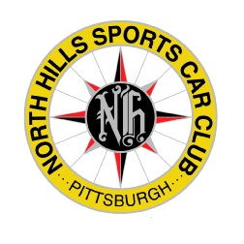
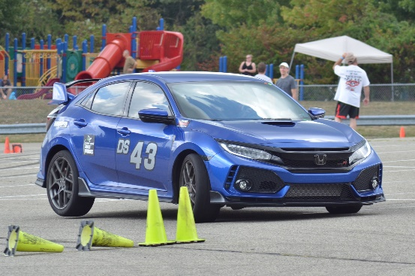
The North Hills Sports Car Club (NHSCC) is hosting an “introduction to autocross” event on April 24th at the North Park swimming pool parking lot. This non-competitive event is designed for anyone interested in getting started in the sport of autocross, or anyone looking to see what their car is capable of in a safe, controlled environment. We will cover everything you need to know - from car prep to driving skills - so you can have fun and enjoy your car in a safe, controlled environment.
We will begin by covering the basics of participating in autocross with the NHSCC, including registration, work assignments, and a typical event day schedule. We will also cover the basics of autocross driving and how to improve your driving skills and make the most of your car’s capabilities.
After the club provides lunch, it’s time to put theory into practice. You’ll be paired with an experienced club member as you take your car through common elements found in an autocross course. You’ll receive feedback as you practice to improve your driving skills, gain confidence and build speed.
The day culminates in a full-course session, with multiple runs to practice and set your personal best time. You’ll come away from the day ready to not only participate in autocross events with confidence, but also to be competitive.
Introduction to Autocross is open to anyone, all you need is a street-legal vehicle and a helmet. You don’t need a sports car, only vehicles with a higher center of gravity such as SUV’s are prohibited. Complete vehicle eligibility listings are available at https://www.scca.com/pages/solo-cars-and-rules. The club has some loaner helmets available, but we do recommend having your own (SNELL 2010 or newer) helmet, especially if you plan to run more events. Many models are available for under $200.
Please note, this is a non-competitive event and is limited to event participants only. We will not be holding a regular competition event on this day and no points will be awarded to drivers. Season points will be awarded to volunteers who work the event.
Registration: More Information:
https://www.motorsportreg.com/ www.NHSCC.com
Questions: Cost:
Contact David Schneider at dtelschneider(at)me.com Members: $35.00
Non-Members: $40.00
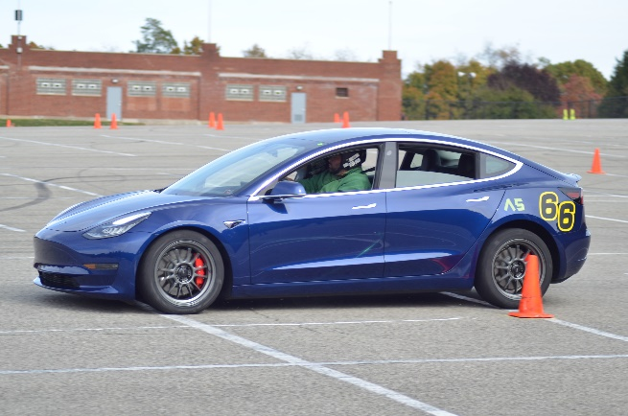
Schedule:
7:03 – 8:30 Course Setup
(participants are invited to assist)
8:30 – 10:00 Driver Registration and
Vehicle Inspection
10:00 - 12:00 Classroom Session
12:00 – 1:00 Lunch
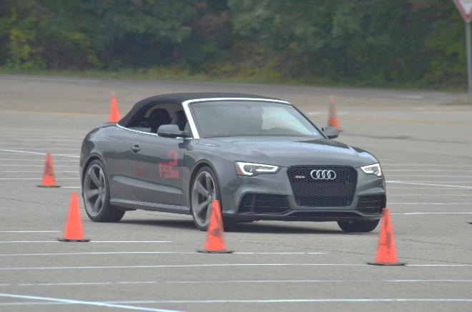
1:00 – 1:45 Session 1 (½ cars on each course)
1:45 – 2:00 Session 1 Review
2:00 - 2:45 Session 2 (cars switch courses)
2:45 – 3:00 Session 2 Review
3:00 – 4:00 Session 3 – Full Course

FAQ:
Q: Can Autocross damage my car?
A: Highly unlikely. Speeds are low and the only thing you can hit is a traffic cone. One event is no more wear and tear than sitting in rush-hour traffic or taking a spirited drive on a back road.
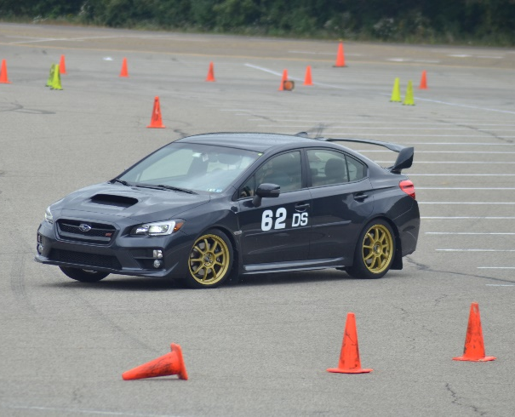
Q: Do I need any special equipment?
A: No, but helpful items include something to check and adjust tire pressures, a torque wrench to tighten wheel nuts, chalk for marking tires and painter’s masking tape for making numbers.
Note: The Club will have all of these on hand just in case.
Q: What do I wear?
A: We run rain or shine, hot or cold, and you will be outside for a large portion of any event, so dress for the
weather and be ready to stand outside for an hour in whatever Pittsburgh throws at us.
Q: What if I suck at this?
A: Who cares? This event is all about learning how to autocross and having fun with your car. You won’t be a national-level competitor by day’s end, but you will be much better than when you started and you’ll be smiling for days.
Q: Is Autocross addictive?
A: Highly. Driving is fun, competing is fun, talking cars with like-minded people is fun and these factors make autocrossing highly addictive. Be prepared to spend your Sundays with us every spring and fall.

