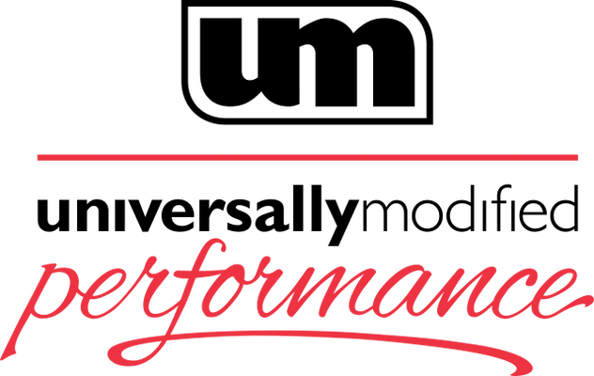
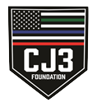
Memorial Day Charity Track Day and Car Show
Presented by Universally Modified Performance and the CJ3 Foundation
May 27, 2022
Summit Point Motorsports Park

Group 1 - Novice: Lead/follow and Instructor coaching sessions. Focus on learning the racing line, and high-speed car control. Classroom sessions included. No previous track experience required. No passing allowed. No passengers (other than instructor) allowed.

Group 2 - Intermediate: Solo drivers with some prior HPDE experience. Passing allowed in designated sections with a point-by. Classroom sessions included. Instructors on track to observe group performance. No passengers allowed

Group 3 - Advanced: Solo drivers with HPDE, TrackCross, or Autocross experience. Class placement subject to approval. Passing allowed anywhere on track with a point-by. One passenger with a safety helmet. Passenger seat and belts must be the same as the driver’s seat and belts.

Group 4 - Pro/Instructors: Licensed instructors and competition licensed drivers only (SCCA, NASA, PCA, etc.) Passing allowed anywhere on track without a point-by.

Car Requirements Groups 1-3
- Street cars allowed (no trucks, SUVs, minivans etc.) with DOT tires. Helmet Required. No open toe shoes. Windows must be rolled down or removed

Car Requirements Group 4
- Competition prepped cars. Racing slicks allowed. Cars must meet the safety regulations of the sanctioning body raced in.
8:00 AM | Driver Check-in and Inspection
8:30 AM | Drivers Meeting
9:00 AM | Group 1 - Novice Lead-Follow session
9:30 AM | Group 3 - Advanced Track Session  Groups 1&2 - Classroom Session 1
10:00 AM | Group 2 - Intermediate Track Session
10:30 AM | Group 4 - Pro/Instructors
11:00 AM | Group 1 - Novice Track Session
11:30 AM | Group 3 - Advanced Track Session  Groups 1&2 - Classroom Session 2
12:00 PM | Lunch Break
1:00 PM | Group 2 - Intermediate Track Session
1:30 PM | Group 4 - Pro/Instructors
2:00 PM | Group 1 - Novice Track Session
2:30 PM | Group 3 - Advanced Track Session  Groups 1&2 - Classroom Session 3
3:00 PM | Group 2 - Intermediate Track Session
3:30 PM | Group 4 - Pro/Instructors
4:00 PM | Group 1 - Novice Track Session
4:00 PM - 8:30 PM | Car show begins - Shenandoah Paddock - Parking along the track wall. HPDE drivers and guests are welcome to join! Food and beverages will be available.
4:30 PM | Group 3 - Advanced Track Session  Groups 1&2 - Classroom Session 4
5:00 PM | Group 2 - Intermediate Track Session
5:30 PM | Group 4 - Pro/Instructors
6:00 PM | Track Closed

