Spring Mountain –Driver's Meeting Notes
General Information:
COVID-19 Information: You must wear a face covering when you are in a common space (i.e. the paddock, restrooms, classroom). There are NO passengers/coaches/instructors allowed during the weekend. The classroom is large enough to seat the Racers Clinic attendees with social distancing.
There is a dinner on Saturday evening at the Spring Mountain Club House. If you have not signed up via MSReg and want to attend, please let one of the board members know.
Everyone needs to complete the SpeedWaiver (link https://porsheownersclub.speedwaiver.com/swgkw or use the QR code below), including those who are not driving. You will show the SpeedWaiver when you pick up your wristband and window sticker at the classroom location (see map below). Please have tech inspection completed before requesting your wristband and window sticker.
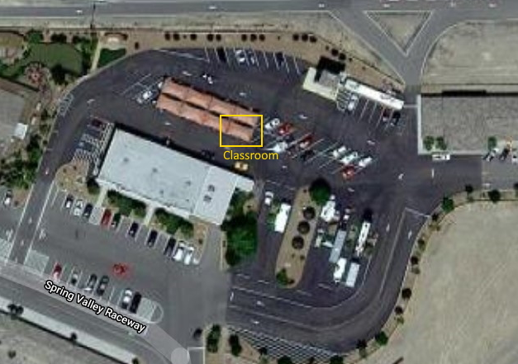
SpeedWaiver QR Code
You may park in the lower paddock (1) or upper paddock (2) as shown in the map below. Please do not park in the East skid pad. Due to social distancing rules, Spring Mountain staff will assist with parking to ensure that parking complies with their COVID-19 guidelines.
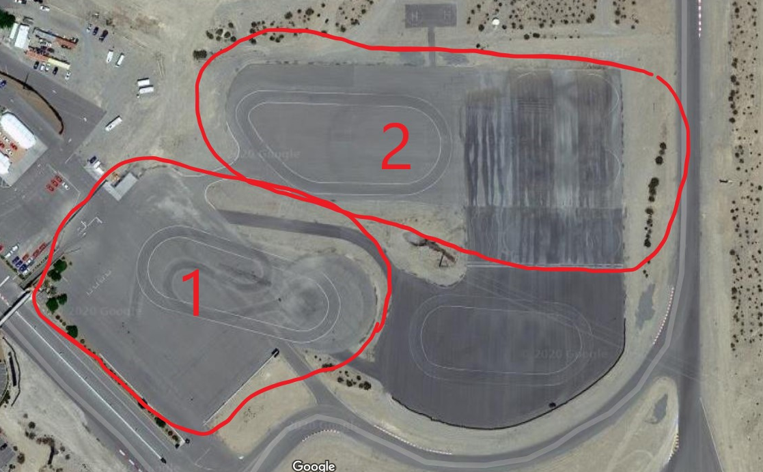
Tech Inspection will be handled by both Pro Motorsports and Vali Motorsports. Both are located out in the paddock. The fee is $20 payable to the POC.
Vali Motorsports is available for tire services. If you need something specific, please arrange for this ahead of the event.
Spring Mountain members may participate in our PDS and Time Trial sessions as well as Cup Racing practice sessions. So, you may have members in your sessions.
The schedule for the weekend is linked at the MSReg registration page as well as Race Hero (both the app and the web page). Any significant updates to the schedule will be communicated via text and will be updated in Race Hero. Hopefully, we will not need any changes.
Racers and Time Trial:
If you run in a different class (e.g. a car that can run in GT2 or GT3) please mark your car for the class that you are running in. We encourage drivers not to race cars that are not in their class.
For all cars running in GT classes, you will receive an email if you are missing your Appendix D. In addition, we will send out a link to a list of all the current Appendix D information for all participants. If you have made any changes to your car that affect your Appendix D (off track weight or dyno sheet) please get a new Appendix D submitted. Scales are available in the paddock. Please check with John Momeyer for the location.
Reminder - racers must have the following available: stamped vehicle logbook, Appendix D if running in a GT class and off-track weight labeled in their doorjamb.
Racers, if you are delinquent on medical forms please get those up to date. You should have received an email reminder. You may be excluded from ana event if your medical is not up to date.
Boxster Spec drivers, please make your tires available for stamping. Do not wait until 5 minutes before qualifying and please coordinate with one of the Boxster Spec representatives (Branimir Kovac or Andrew Weyman).
Please remember that there is a gentleman's agreement for GT3 and GT4 that only one set of new tires will be introduced per weekend. The Board of Directors and Comp Committee are going to use this season to prepare the formal GCR rules (similar to BSR rules) for 2021.
We are posting session times and grid sheets in Race Hero. Racers need to know their grid position for the races and not rely on grid workers. There will be no paper time sheets or grid sheets available.
We will have split qualifying in both race groups. Please check the number of laps in each race and fuel accordingly.
Split starts are planned for GT1/GT2 and GT3/GT4 in Red. SCRs will start first in Orange followed by the BSRs and then GT5s and GT7s. These start groups may be modified depending on the cars registered. Stay in line for starts and don’t jump the start. We will be watching for either violation and you can be black flagged for jumping the start or being too far out of line. No weaving or tire scrubbing once your group forms up. There will be a pace car for the starts and for full course caution.
We tend to have issues in turns 1 and 2 on the first lap. Please use some discretion and don’t get added to the list of “I had bad judgement in Turn 1 club.”
Racers need to know their grid position for the races and not rely on grid workers. Grid positions will be posted on Race Hero only, no paper grid sheets this weekend. Please be on time to the grid. If you are late to the grid you will start DFL. The grid closes at 1 minute. You should be there no later than the 5-minute call. When you grid, please put your grid number in your left outside mirror. Of course, if you want to start DFL you can. We will grid for the races in the area that we stage for practice and qualifying (and stage PDS and Time Trial). We will not grid in the hot pit lane as the narrow pit lane has caused issues with traffic jamming the grid in prior years (see map below).
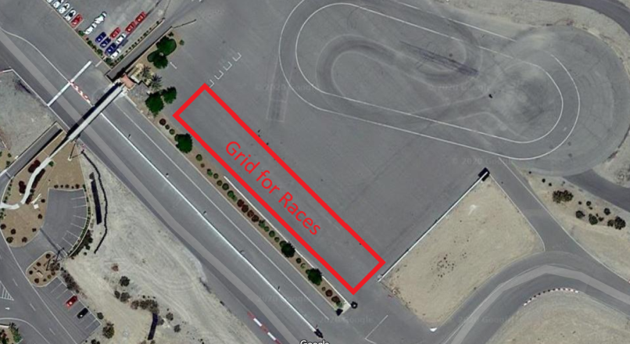
Under full course caution the overall race leader needs to slow to 55 mph. If you do not slow to 55 mph you will be black flagged, and we will see if the new leader can slow to 55 mph.
A reminder about the impound process this weekend. After the races, there will not be a normal impound of parking cars and interaction. Unless you need to go to scales, please proceed directly back to your pit area. The top three GT2, GT4, GT5, GT6, GT7, SCR, and top five BSR and GT3 cars should proceed directly to the scales then your pit. Competition Committee members should be near the track exit with signs reminding you to go to scales. It is your responsibility to get weighed after the race if you fall in the top three or top five of the classes listed previously. Failure to do so will result in a DQ.

Lastly, for everyone, if you have an incident/contact with another car during the weekend, you need you to bring your video to John Momeyer and fill out an incident report. Alternatively, you may text or email the details of the incident to John instead of filling out the incident report, but you still need to provide your video. Failure to report contact is an automatic 13/13. MAKE SURE YOUR FORWARD-FACING CAMERAS ARE WORKING RACERS!” If you have questions contact our Competition Director: John Momeyer (661) 478-9561 or cd@porscheclub.com.

PDS Drivers:
PDS drivers, please remember to make a full point by for each car passing. Please put your whole arm out the window, not just your finger. If you have a car consistently behind you, they are faster, and you should provide a point by. Passing 1-4 zones are shown on the track diagram below.
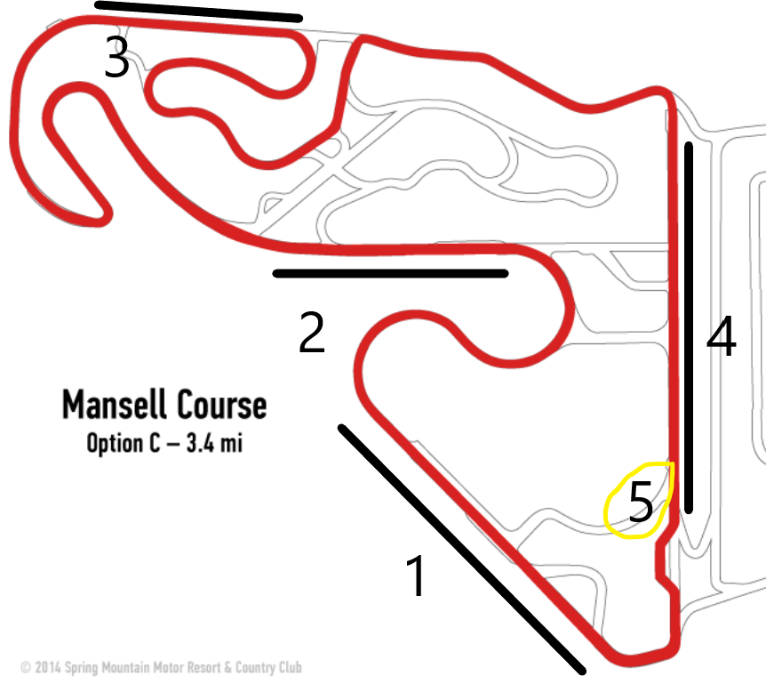
Don Matz will have a PDS meeting prior to the first session for any new drivers.
Safety Notes and Basic Reminders:
Speed in the paddock is 10 mph. Be very mindful of children, pets and people distracted by the cars.
When entering the track from the hot pit lane stay to the right through turn 1, cars may be approaching during the session at well over 100mph. When exiting the track during a session, exit at the exit marked “5” on the map above or via the pit lane. At the end of a session or race exit at the exit marked “5” on the map above.
If you spin and go off never reenter a hot track without being directed by a corner worker or without having a clear view of the track. We have recently issued a 13/13 for not re-entering safely so do not let that be you. Please, when you spin whether on or off track get your feet on the pedals hard to keep from rolling backwards, perhaps in front of oncoming traffic. Remember If you can't see a worker and you can't safely position to see any oncoming traffic then you must stay put until the end of the session. A tow vehicle will be on its way.
If you see smoke from your car or suspect any issue based on your gauges or car behavior, get off the racing line and pull into a safe location off track. If we cover the track with fluids it takes time to clean and we will have a messed-up schedule.
If you need to stop off track for any reason (mechanical, post contact, etc.) tap the roof of your car to let the corner workers know that you are ok (assuming that you are ok).
Reminder to turn in your volunteer activities. No more Blue cards! Fill out the form at http://www.porscheclub.com/spr to get credit. Please fill out the form within 7 days of the race weekend to get your service points and POC bucks. Remember that you need service points to be eligible for a championship or any year end awards.

Results will be posted after the event on the POC results page (https://results.porscheclub.com/)
Please ensure that you are familiar with the flags and hand signals described in the GCRs.
Flags
All drivers must fully understand and adhere to the following flags:
Green: The Green Flag means go; course is open and clear.
Yellow: Stationary Yellow Flag means reduce speed enough to respond to unusual hazard(s).
Waving Yellow Flag means the course may be blocked ahead, be prepared to stop, however, do not stop unless necessary and always be aware of vehicles close around you. NO PASSING. The prohibition on passing starts at the line on the racetrack perpendicular to the point of the first displayed yellow flag(s); The pass must be completed by this point. However, in cases where the incident is clearly visible as being in close proximity to the yellow flag(s), such that passing on approach to the yellow flag(s) would put someone in danger, passing on approach to the yellow flag(s) will be considered dangerous/reckless driving and will incur a one lap penalty or possible 13/13, at the discretion of the Competition Committee.
Once past the yellow flag(s) a pass may not be INITIATED until you are completely past the incident(s) and you have a clear view of an incident‐free track between you and the next manned flag station, and it is clear that that flag station is not displaying a yellow flag. Timing a pass such that it occurs at or immediately after an incident and therefore requires accelerating adjacent to the incident will be considered dangerous/reckless driving and will incur a one lap penalty or possible 13/13, at the discretion of the Competition Committee.
Double Yellow ‐ NO PASSING. Reduce speed enough to respond to hazard(s) on the course. The overall leader of the race will slow to 55 MPH or less and collect the entire field. There will no split starts after a double yellow and all cars should collect together in a single file line. Racing will only resume with a green flag at the start/finish line. If the leader of the race does not slow to 55 MPH, they will be black flagged, and the next car will take over the leader's responsibility of collecting the field.
Red: Red Flag indicates an emergency situation. Look in mirror(s), pull safely to trackside and stop in view of nearest corner worker. Remain stopped until instructed otherwise.
Blue with Yellow Diagonal Stripe: This is the “Passing Flag” warning of potentially faster cars behind you. Look in mirror(s) and allow faster car(s) to safely pass in designated areas.
Red with Yellow Stripes: This flag warns of debris, slippery fluids and/or any changing track conditions requiring caution and reduced speed.
Black with Orange Dot: Your vehicle reportedly has a mechanical problem. Using the designated track exit, proceed to the Black Flag Station with extreme caution. If your car is dropping fluid, drive off of the track surface.
Black: You have been identified as having made an infraction. If the Black flag is furled, then the driver must discontinue his present driving or face an open Black Flag. An open Black Flag signals that the driver must proceed immediately to the pits via the designated course exit and report to the Black Flag Station. Full course Black Flags signifies that all drivers are to discontinue racing (no passing), slow down and proceed single file using the designated track exit to the Black Flag Station. Any racer who ignores a Black Flag during a race shall be assessed a one‐minute penalty for each Black Flag passed. During a race, any driver passing under Black Flag All will be assessed a stop and go penalty under green flag conditions. If the infraction occurs on the last lap or two and it is not possible to assess the stop and go penalty or video evidence of the infraction is provided after the race, the racer shall be penalized one lap.
White: The White Flag warns of a service vehicle on course. Proceed with caution. You may not pass a service vehicle unless instructed to do so. The White Flag may be displayed at the Starter stand as an indication of the last lap before the Checkered Flag.
Checkered: The Checkered Flag announces you have completed your final lap. Proceed to the pits using the designated track exit.
Passing Under Yellow/Double Yellow: Any driver in a non‐race event who passes under a Yellow Flag condition and does not give the position(s) back to the car(s) passed, will be black flagged and removed from the track for the remainder of that session. During a race, any driver who passes under yellow and does not give the position(s) back to the car(s) passed safely will be black flagged and assessed a stop and go penalty. If the infraction occurs on the last lap or two and it is not possible to assess the stop and go penalty or video evidence of the infraction is provided after the race, the racer shall be penalized one lap.

