The Freedom Sprints
SCCA U.S. Majors Tour / Regional Races / Time Trials
SANCTION NUMBERS: TBD – Hosted and Sanctioned by the Colorado Region SCCA
High Plains Raceway
July 1 & 2,2023

Schedule
Meetings

Workers Muster
Sat & Sun. 7:15 am
Pavilion

Drivers Meeting – At tech after each qualifying session

Tech Hours

Fri. 6:30 pm – 8:30 pm

Registration / Classroom Building

Sat., & Sun. 7:00 am – track cold

North / West Side of Paddock

Registration Hours

Fri. 6:30 pm – 8:30 pm

Sat & Sun. 7:00 am – 12:00 pm

Registration / Classroom Building

Race Groups

Group 1: Time Trials – Intermediate/Advanced
Group 2: Time Trials – Novice
Group 3: Majors Closed Wheel: EP, FP, HP, GTL, SM
Group 4: Majors Open Wheel: F6, FF, FV, SRF3
Group 5: Majors Big Bore: AS, GT1, GT2, GT3, GTX, T1, T2
Group 6: Majors Wings & Things: FA, FC, FE2, FX, P1, P2
Group 7: Majors Closed Wheel: T3, T4, STU, STL, B Spec, C Spec
Group 8: Regional Closed Wheel: AS, GT1, GT2, GT3, GTL, T1, T2, T3, T4, EP, FP, HP, STL, STU, B Spec, C Spec, RSM, SM, Spec M3, ITA, ITB, ITC, ITE-O, ITE-U, ITR, ITS, Spec 944, Spec E30, GTX, S7, PRO7
Group 9: Regional Open Wheel: FA, FC, CC, FE, FE2, FX, ASR, P1, P2, FS, FST, F6, SRF, SRF3, CF, CV, FF, FV, RF

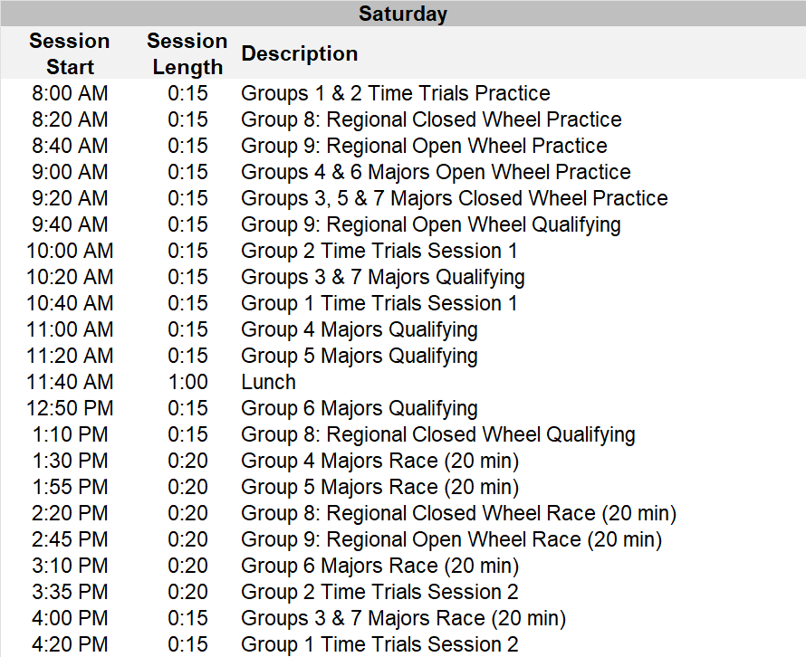
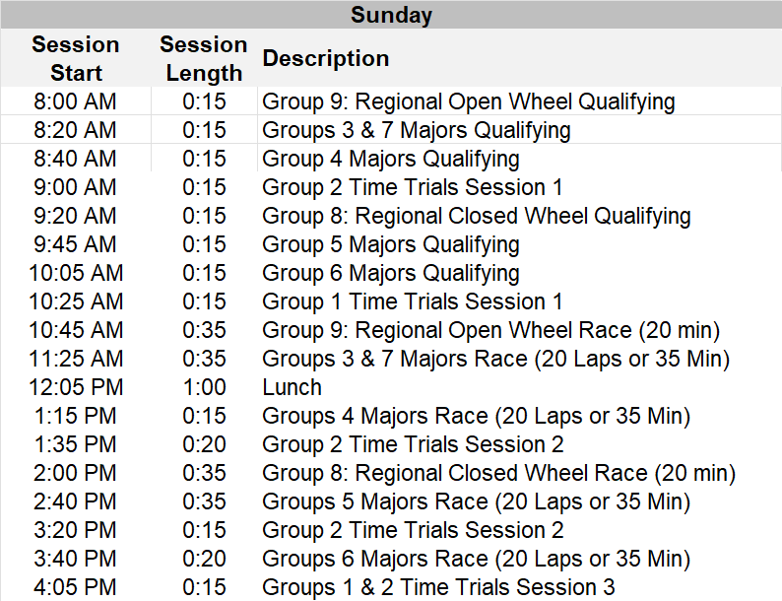

Saturday Night Dinner Party will start serving at approximately 5:15pm at the Pavilion.

GENERAL
Event Facility: High Plains Raceway Phone: 303-769-4771
93301 East Highway 36
Deer Trail, CO 80105

Length of the Racetrack: 2.55 mile, road course
Direction of the Race: Clockwise
Pole Position: Chosen by Pole Sitter
Location of Race Control: Tower
Start Line: On the Front Straight
Finish Line: On the Front Straight

ADDITIONAL REGULATIONS

This event is governed by the current General Competition Rules (GCR) and Category Specifications, as amended by FasTrack

Name of the Event: The Freedom Sprints Hosted and Sanctioned by the Colorado Region SCCA
Close of Entries: Tuesday, June 27, 2023, or as extended by registration officials
Early Bird Discount: Early Bird Discounts available on MsReg through June 6

ENTRY FEES:
- Majors Entry $495.00 / Event Weekend Entry
- Regional Entry $395.00 / Weekend
$275.00 / Single Day
- Double Dip
  - Majors $400.00
  - Regional $300.00

- Double Dip
  - A driver wishing to register with additional cars or in multiple classes will be eligible for a discounted price.
  - Driver agrees to comply with the published groupings and group order.
  - Please use the appropriate double dip option at the time of pre-registration.
- Additional compliance fees will be charged per SCCA guidelines: SRF, SRF3, FE, FE2 - $30/weekend, SM - $20/weekend.
- Runoffs‐eligible class fee of $20/entry for the runoffs appearance fund is included in the entry fee.

REGISTRATION: Online registration is held at http://coloradoscca.motorsportreg.com. Acceptable payment includes Visa, MC, Discover, Check, or PayPal. If you need help registering, please contact the race chair or the registrar.
- Online registration will close at midnight of the Tuesday prior to the event, unless extended by registration officials.
- Event payments will be processed the Wednesday prior to the event. A $50.00 late fee will be assessed after registration closes. A $50.00 fee will be assessed on returned checks/bankcards.
- Cancellations may be made through the Chief Registrar prior to the event. Cancellations made after payment processing shall incur a $50 processing fee. Refund requests without prior notice must be made to the region treasurer teri.massey@comcast.net within 7 calendar days following the event.
- Refunds due to mechanical failure will be considered by the Chief Registrar for cars that have not been on the racing surface as verified by the Chief of T & S. Requests must be submitted to the Chief Registrar before the end of the event.
- Approved refunds will be issued via MotorsportReg.
- Registration check-in will be held in Registration/Hospitality, located in classroom building. All drivers, volunteers, and officials must check-in to complete registration and receive credentials, even if you have signed an annual SCCA waiver.
- Only members who hold a current SCCA membership may be credentialed for the hot areas. Weekend memberships can be purchased at Registration, during posted hours, for a fee of $15.00.
- Time Trials Drivers should register on MSReg at: http://msreg.com/FreedomSprints-TT23

DRIVER ELIGIBILITY: Each driver must be a current SCCA member with a current full SCCA Competition License to participate in the Majors portion of this event. Additional licenses accepted for the Regional portion of the event include an SCCA Pro, SCCA Novice Permit, or any organization’s license that is currently approved by SCCA for competition as listed in the GCR, Appendix C, 2.8.B (pages 114 & 115). Download GCR. Proper credentials must be presented at check-in.

CAR ELIGIBILITY: This competition is open to all cars conforming to the GCR, as amended.
- The Majors portion of the event is open to all Runoffs-eligible classes plus GTX and FX.
- Regional and Spec Classes specific to the Rocky Mountain Division are included as follows: Club Ford (CF), Club Formula Continental (CC), Club Vee (CV), ITE Everything (ITE-0, ITE-U), Spec RX-7 (S7), Spec 7 with 13B (Pro 7), Spec 944(S944), Spec E30 (SE30), Regional Spec Miata (RSM), Regional Formula F & Spec M3. Rocky Mountain Division Championship rules and Class rules can be found at http://www.coloradoscca.org/rulesforms.php.

PREFERRED NUMBERS: Majors Conference Preferred Numbers will be honored until 14 days prior to the event. If two drivers holding the same Preferred Number request that number for the same run group, the number will be assigned to the driver with the earliest request. In all regional and/or vintage classes, preference will be given to numbers assigned through the Rocky Mountain Division numbering program. Unreserved numbers are on a first-come, first-served basis. All numbering assignments are subject to race group configurations.

TECH: Tech inspection hours are posted on the event schedule.
- Express Tech is available for drivers with both a current annual tech and a current year helmet sticker. Drivers should bring their vehicle logbook and registration credential to get their event stickers.
- Drivers without a current year helmet sticker must present all driver gear as required by the GCR, vehicle logbook, and registration credential to Tech. If your car requires an annual tech, you must also bring the car to tech. An event tech sticker will be issued after everything is examined and approved.
- The order of inspection at the track will be:
  - Express Tech
  - Re-inspection, logbook notation
  - Annual inspection
  - Cars with no logbook (new or lost logbooks)
- Competitors needing Annual inspections or New Logbooks must make prior arrangements with the Chief of Tech to have these items performed by tech personnel at the track.

SPEC MIATA COMPLIANCE: At post-race inspection, Spec Miata participants may be directed by the designated Class Compliance Chief (CCC)
to remove parts, including but not limited to the cylinder head, for disassembly and/or inspection. Competitors are responsible for performing
required disassembly and/or reassembly, as well as any resulting expenses incurred. The CCC will report any findings of non-compliance to the
Race Director, who will then determine the need for a Chief Steward’s Action (CSA) or Request for Action (RFA).

SCALES: Scales will be available each day from 8:00am until the end of competition, except during impound. Driving on or off the scales is prohibited
unless otherwise instructed by Tech personnel. Motors must be turned off and competitors and/or crew must push cars on and off scales.

EVENT SCHEDULE / RUN GROUPS: The event schedule, configuration, or run groups may be changed at the discretion of the Race Director or chief
steward, in cooperation with the Region’s representative. If changes are made, as much notice as possible will be given to all competitors. Schedule times
are provided for planning purposes and are approximate. The PA system may be difficult to hear in some areas of the paddock, so please monitor the PA
system and pay attention to what is happening on track.
- Saturday Majors races are 20 minutes, Sunday Majors races are 18 laps or 35 minutes, whichever comes first.
- Regional Races will be timed.
- The clock for practice and qualifying starts with cars on course, per the session start times indicated on the schedule. The official clock for races starts when the first car crosses the start/finish line at the end of the pace lap.

TIMING AND SCORING: All cars are required to use fully operational AMB transponders, and the driver is responsible for providing correct information
during registration. Unless otherwise announced, live timing will be available via the Race Monitor App available for iPhone and Android.
- Non-operational transponders or missing transponder information may not be scored for the event.
  - A limited number of transponders may be available for rent at the rate of $30 per day, along with a $500 retainer on a valid
credit card.
  - A competitor needing a rental unit should make those arrangements at the time of entry submission.
- The clock will continue to run during all flag conditions, except for the red flag.
- Personal timing beacons are not allowed within 20 feet of the T & S system, or across track from start/finish.

GRID: Starting positions for the Saturday Races will be determined by the fastest time recorded for each car during the preceding qualifying session.
Starting positions for the Sunday races will be determined by the fastest time recorded for each car during any of the preceding qualifying session(s) or the
fastest lap during the Saturday race. Cars arriving at the grid after their group has been dispatched on track may, at the discretion of the Operating Steward,
be held at pit out and released at the end of the pack after the field has completed the pace lap.
- Crew / Guests must leave the grid at the one-minute warning.
- Drivers are prohibited from scrubbing tires in the paddock, grid, pit out and hot pit lane. In addition, drivers are only permitted to scrub tires on the course, while under control of the pace car or if no pace car is being used, during a full course yellow status on the course.

SPLIT STARTS: The Race Director or chief steward will consider requests for split starts and may authorize such based on qualifying times.

IMPOUND: The top three competitors in each class shall report to impound immediately following the completion of their race. Trophy presentations and photos will occur in the Victory Circle area following the races. Other competitors are strongly encouraged to attend the podium festivities following the races.

DESIGNATED INCIDENT INVESTIGATION SITE
- If a driver is involved in significant body contact, the driver and car shall stop at the designated incident investigation site for review of the incident by the stewards before going to their paddock area. Significant body contact includes but is not limited to: Contact resulting in 2 or 4 wheels off course, spins, loss of position, or repairs to suspension or bodywork.
- The designated incident investigation site for High Plains Raceway is in tech.

VICTORY LAPS: Winners of Majors races will be awarded a checkered flag for Sunday’s Race. Following the cool down lap, designated winners will receive a flag and be directed on course for a single Victory Lap. Drivers need not wear their helmet or gloves during the lap and passengers are
permitted in accordance with GCR 6.11.7. Drivers shall maintain a safe speed and be aware of safety vehicles that may be on course.

RESULTS: Qualifying, provisional, and final results will be posted at Registration / Hospitality. Additionally, final results will be posted to the Colorado Region and SCCA Majors websites no later than 7 days following the completion of the event.

AWARDS: Trophies for all races will be awarded in accordance with the GCR. Trophies may be picked up at the event. Majors points will be awarded for all races in accordance with the GCR.

FLAGGING:
- GCR 6.1.1 flag rules apply to all sessions
- BLACK FLAG station is at corner station 9
- For practice sessions, a CHECKERED FLAG signaling the end of the session may be displayed at BOTH Start/Finish AND Corner 9. Cars receiving the Checkered Flag at Corner 9 must proceed directly to the pit lane/paddock.
- Last lap will be indicated by a waving white flag at start/finish.
- HPR lights will be regarded as the equivalent of the respective flags. Lights and flags will be used at this event.

PACE / SAFETY CAR: In the event of a pace car; In addition to GCR 6.6.2., the field shall follow the pace/safety car as long as its emergency lights are flashing, even if it varies from the normal race course. In the event a full course yellow results in dispatch of the safety car, the safety car will enter the racing surface at pit out.

DISABLED CARS: Disabled or damaged cars may be removed from the course and delivered to a central location. If the car has sustained body/chassis damage it will be taken to impound and will be released to the driver/crew after tech has made appropriate notations in the vehicle log book. Cars disabled due to a mechanical failure will be released to the driver/crew immediately. If the car requires wrecker support to return to its paddock location, there may be a delay depending on the availability of wreckers or flat tows.

SOUND CONTROL: A maximum of 103dB is in effect for this event. Sound will be located on the back straight and readings will be posted at Hospitality.

RADIO FREQUENCIES: The region frequencies below shall not be used for communications by any participant.

451.2875 | 451.3125 | 451.3375 | 451.3625 | 451.3875 | 461.5125
463.2625 | 466.2125 | 466.5875 | 468.3125 | 469.1250

PADDOCK
- Access ways for general paddock traffic and Emergency Vehicles must be kept clear at all times or vehicles will be towed.
- You must have a valid motor vehicle license to operate any 2, 3, or 4-wheeled motorized or non-motorized vehicles in the paddock.
- Skateboards, skates, rollerblades, and one-wheel electric boards are prohibited.
- The paddock speed limit is 10 M.P.H. Vehicles in the paddock must be operated in a safe manner.
- Entrants are responsible for the conduct of their crew, guests, minors, and pets. All minors must be under direct adult supervision at all times. Pets in the paddock must be leashed and under direct supervision of an adult at all times.
- Minors and non-members must remain behind any barrier paralleling the Hot Pit lane. No one will be allowed to view from in front of the Race Control and Timing structure.

GENERAL: Participants must display proper credentials at all times.
- The organizers reserve the right to postpone, abandon or cancel the event, or any part of the event. Entry fees will be refunded to those offered no opportunity to compete.
- Any test day or session not on the official schedule is NOT sanctioned by SCCA and is NOT covered by SCCA Insurance.
- Vendors wishing to display or sell any items must obtain prior approval from the race chair.
- The consumption of alcohol is prohibited until after the daily on track activities are concluded. In addition, GCR 2.3.1.B shall be in effect as it relates to Narcotics and Dangerous Drugs.
- The organizers reserve the right to refuse entry and/or issuance of credentials to the premises or event for any reason except race, color, creed, sex, or national origin.
- Unmanned aerial vehicles, also known as drones, shall not be used anywhere in the airspace over the property.
- All on track body contact (including contact during drafting) that causes a car to act erratically and results in a change of position or a car leaving the course will be investigated.
- Club racing penalty guidelines can be found online at Penalty Guidelines

EVENT OFFICIALS:
Race Director | Costa Dunias  303-978-1799  cdunias@msn.com | Chief of Pit / Grid | Teri Massey  303-913-1142  Teri.massey@comcast.net
Event Chief Steward | loria | Chief of Timing/Scoring | Carolyn Rasband  801-915-1092  cjrasband@gmail.com
Chairman of SOM |  | Chief of F & C | Christy Hopkins  303-709-7461  christy_hopkins@q.com
Regional Executive | David Muramoto  303-304-4025  nissan7gt3@comcast.net | Chief of ES | William Carter  303-827-8721  Turnandburn86@gmail.com
Race Chair | Michelle McColl  303-898-2597  mccollteam@comcast.net | Chief Starter | Leah Street  208-360-0448  moonstonelvs@gmail.com
Chief Registrar | Annita Braun  812-298-4301  Annita.braun09@gmail.com | Chief of Sound Control | Nancy Foster  303-304-6661  nlfradioqueen1@comcast.net
Chief of Tech | Bill Pichardo  303-522-5991  quattroboy@yahoo.com | Chief of Course | Ed Shuler  303-910-0147  eshuler@icloud.com
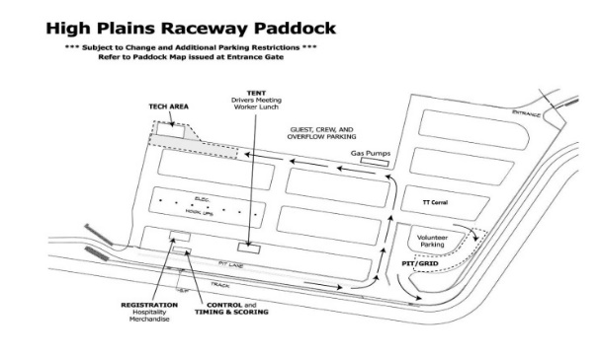
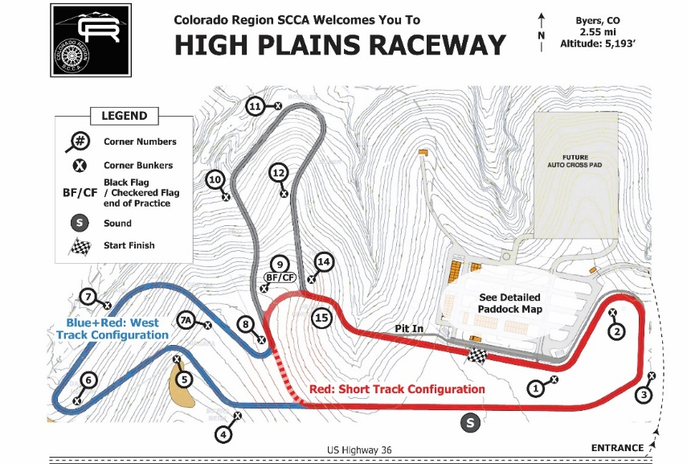

ADDITIONAL EVENT INFORMATION:

Open lapping for testing on Friday before thisevent is NOT part of the Official Schedule, is NOT sanctioned by SCCA, and is NOT covered by SCCA insurance. Go to open-lapping-days-registration. Contact trackmanager@highplainsraceway.com to schedule other exclusive/semi-exclusive track test day rentals.

Directions to High Plains Raceway: I-70 to Byers, (Exit 316). Go 17 miles east on U.S. Highway 36. Track entrance is on the north side of the highway.

Race Fuel: HPR has a credit card operated fueling station that accepts Visa and MasterCard.
Sunoco 260 GT 100 octane unleaded street legal 3.3% oxygen,
Sunoco 260 GTX 98 octane unleaded not street legal 0.0% oxygen
Sunoco Standard 110 octane leaded not street legal 0.0% oxygen

Concessions: Track concessions will be open Friday, Saturday & Sunday.
On-Site Tire Services: Please bring what you need, as there may not be tire services at the track.

Accommodations at or near HPR:

Overnight Camping is available at the track – electrical hookups and Carports are available at https://www.highplainsraceway.com/rv-carport-rental-information/

Budget Host Longhorn Motel – 17 Miles West
Closest to HPR – 303-822-5205
456 Main St. Byers, CO 80103

Country Inn & Suites – 49 miles West
4343 N. Airport Way Denver, CO 80230
303-375-1105

Strasburg KOA – 23 miles West
Campsites, Lodge and Cabins – 303-622-9274
1312 Monroe St. Strasburg, CO 80136

Willow Tree B & B – 30 miles West
49990 E. 64th Ave. Bennett, CO 80102
303-644-5551

Country Manor Motel – 38 miles West
32681 E. Colfax Ave. Watkins, CO 80137
303-261-9650

Courtyard by Marriott – 47 miles West
6901 Tower Rd. Denver, CO 80249
303-371-0300

Gaylord Rockies Resort – 47 Miles West
6700 N Gaylord Rockies Blvd, Aurora, CO 80019
720-452-6900

Holiday Inn Express – 42 Miles East
803 Hwy 24 Limon, CO 80828
877-863-4780

Econolodge – 42 miles East
985 Hwy 24 Limon, CO 80828
719-775-

Volunteer Incentives: Volunteers are required to pre-register on MSReg, so arrangements can be made for lunches, Saturday night dinner, etc. If you need help with registration, please contact the race chair or registrar.
- A lunch ticket will be given to each volunteer for each day worked.
- Volunteers are invited to participate in one Free TT session on Saturday and Sunday. Sessions should be coordinated with the workers specialty chief and the TT Event Leader.
- Volunteers will receive a gas card for $25/weekend.

