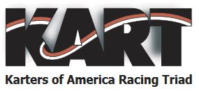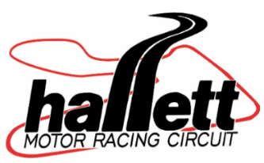

Welcome, KART MARRS to
Hallett Motor Racing Circuitfor your
season opening eventonApril 12-14, 2024!

Friday Test & Tune participants Gates open: Thursday night 5-10pm, then open Friday 6am. Pit pass fee for Friday is $10/person, $5 if < age 7.
Click here to pre-register online or register at check-in on 1st floor of tower.
Sat/Sun participants Gates open: Fri/Sat 6am-10pm, Sunday 6am-5pm.
Finish Line Café (by Sarah’s Dynasty Catering): breakfast and lunch all three days 7am –4pm. Use your cellphone camera on this QR code for the Finish Line Café menu.
Sunoco fuel: available at facility just north of the HMRC Tower: 93 and 98 unleaded racing fuel
110 leaded racing fuel available with credit card pay at pump.(NOTE: KART OFFICIALS MAY CLOSE ACCESS TO FUELS TESTED AS ILLEGAL FOR KART RACERS, BUT IF NEEDED FOR OTHER USES SEE TOWER)
Raceports/RVspots/Golf Carts: HMRC has 28 covered raceports (FULL),8 RVspots with full hookup, 6 RV spots with electric only, and 8 rental golf carts available to reserve online with Friday test day link above then click on “Book Paddock Spaces”.Other open-area paddock spots with electric hookup are also available as first come, first served.Call office to be added to waitlist if any cancellations if we are FULL.
Electric usage: If you choose to plug into Hallett’s30amp or 50amp electric on poles around the facility, please purchase your electric usage sticker on 1st Floorprior to plugging in.
Air: At small garage west of tower.
Hallett Souvenir Store: Gifts and Hallett apparel on the ground floor of the Tower (hoodies, shirts, hats, decals,coffee mugs, track maps, sunscreen, bug spray, jewelry, etc).
Hallett Foto Shoppe: Order ALL yourfull resolution digital photos from our professional track photographer on1stfloor of the Towerfor$50.
TIP: Purchase early so he will be watching for you on track!
Need a bed? Call HMRC partnerHoliday Inn in Stillwater @ call 405-332-5603 for HMRC discount. OR click here for RV Share to book rental RV delivered to track!
Restaurant partners: Little Venice Italian Restaurant, Sand Springs AND Steer Inn, Mannforddon't miss the Friday night prime rib buffet!
Looking forward to a great event with GREAT people!

Hallett Motor Racing Circuit (HMRC)
59901 E. 5500 Rd
Jennings, OK 74038
918-356-4814
www.hallettracing.net

