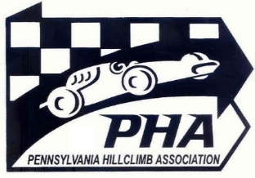

PENNSYLVANIA HILLCLIMB ASSOCIATION
2022 AWARDS BANQUET
NOVEMBER 12, 2022
PROGRAM ADVERTISING REQUEST

The PHA Banquet program gives you the chance to get your product before the PHA drivers, crews and family, or to showcase your car or racing team. Proceeds from the program allow us to provide the volunteer workers with a complimentary meal at the banquet.

All advertising requests and corresponding ad copy must be received by October 31, 2022

FULL PAGE: $100.00
HALF PAGE: $50.00
BACK COVER: $160.00
INSIDE COVER PAGE, FRONT OR REAR: $140.00
FRONT COVER: Open for bids starting at $200.00 The winning bidder’s cover design must include PHA and SCCA logos.

Advertiser ____________________________________________________________________
Address ____________________________________________________________________
____________________________________________________________________
Phone No ____________________________________________________________________

Send your ad, completed form and payment to Grace Huntzinger. Make checks payable to Pennsylvania Hilclimb Association.

172 Glover Road
Mullica Hill, NJ 08062

phabanquet@sinbadco.com
(609) 970-7443

Note that for the ad copy, we prefer a high resolution image file in electronic form.

Please contact Grace Huntzinger if you have any questions.

