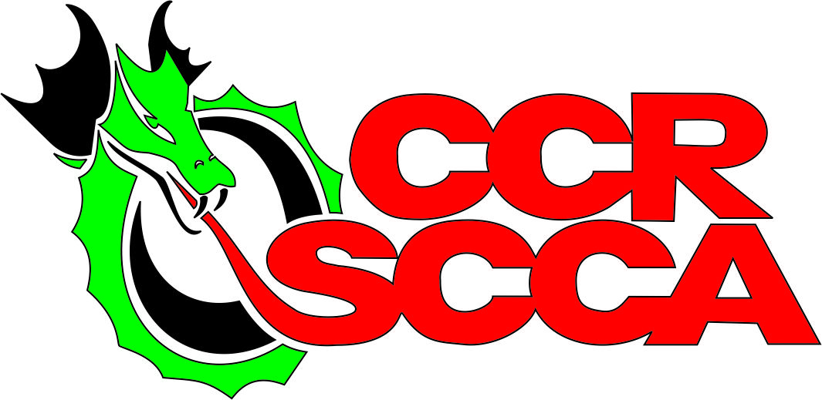

July 25/26th, 2026 SCCA Dragon Hillclimb 20
Graham County – Robbinsville, NC
Sanction #26-HC-
Sanctioned by the Central Carolina Region SCCA and Appalachian Hillclimb Series

EVENT OFFICIALS
Co-Event Chair – Robert McManus
Co-Event Chair – Steve Eckerich
Safety Steward – Karyn Hudson
Asst. Safety Steward – Chad Summey
Registrar – Vicki Eckerich
Chief of Tech – Mark Seiler
Chief of Timing – Rich Mesick
Chief of Flagging –Chris Polhamus
Chief Starter – Rick Mitchell
Chief of Communications
Medical Steward – Graham County EMS
HILLCLIMB SANCTION NUMBER
#26-HC-
Prepaid Registration is now open for Entrants/Drivers on www.motorsport.reg.com, Entries after July11th will increase to $425

#See the Entry Form for Important Details
Entry Fees: Single Driver/Both Days $350
.
Add $25 per driver for non-SCCA members

Event Held – July 25/27th, 2025
Maple Springs Rd. at the entrance to Joyce Kilmer Memorial Park – Robbinsville, NC
www.CCRSCCA.com

Sponsored and Presented with the assistance of:

Graham County Tourism Chamber of Commerce
United States Forest Service Graham County Transit
Graham County EMS & Rescue Squad

…and the Merchants and Residents of Graham County and Robbinsville, NC

EVENT SITE: Santeetlah Road / Maple Springs Rd (SR 1127), Robbinsville, NC (Go straight when you see the entrance to Joyce Kilmer National Park on your left. The Hillclimb site road is also known as Maple Springs Gap Road. Event signs will be visible all the way from town to site.)


HILLCLIMB EVENT SCHEDULE

FRIDAY, July 24th, 2026
8:00am - 5:00pm Course set-up Want to help? Email; vlanning98@charter.net
3pm Until 8:00 pm Registration and Tech Inspection – Hillclimb Start Area

Tech Inspection will be a roving tech on Friday. On Saturday morning, you are responsible for finding Tech Inspector at Start to get approved to race. Race cars will not be tech inspected until driver is registered. Event Paddock Parking is First come, First served.

NOVICE Workers Flagging Chief Chris Polhamus will be happy to assist with any questions. Cpolhamus74@gmail.com

9:00 PM Hillclimb site road closed. No overnight camping on the hill but several campgrounds are nearby.

SATURDAY, July 25th, 2026
7:00am - 8:00am. Road opens and late registration open in the paddock.
7:00am - 8:30am Roving Tech (Please see Mark Seiler or ask registrar for his location)
8:00am - Worker Meeting - gravel parking area at TOP of hill. Workers must stop by registration to sign waiver and collect dinner tickets.
8:15am - Driver Meeting gravel parking area near start gate.
8:00am – Drivers may drive course (NOT at speed – both lanes in use!)
9:00am - 12:00 Course goes Green - Event Chair determines official timed runs for all classes. Between groups, expect traffic on course, course workers rotate stations per directions of Worker Chief.
Approx. 12:00 - 12:45pm Stop runs for worker lunch
(Lunch provided for workers)
1:00pm - 5:00pm Resume timed runs.
6:00pm - 7:00 am No Race Engines

6:30 PM Worker dinner Details to be provided by event.
Driver/Worker Social across from Quality Inn sponsored by the town of Robbinsville.

SUNDAY, July 26th, 2026
7:00am - 8:30am Roving Tech (Please see Mark Seiler)
7:30am Worker Meeting
7:45am Driver Meeting
8:15am - 10:30am Official Timed Runs begin
10:30am - 12:00pm Stop runs for worker lunch (lunch provided for workers at Start gate).
NOTE: Mandatory “Quiet Time”, NO RACE ENGINES FROM 11:00 AM to 12:30 PM
12:30pm - 3:30pm Official Timed Runs
3:30pm – 4:30pm DRAGON SLAYER Awards Approximately 30 minutes after last car on track.
Trophy presentation procedures will be announced at the Driver’s meeting. If you want your trophy, either be there to accept or make arrangements with the Event Chair to have someone accept your award. We will award a KING of the Hill and a QUEEN of the Hill Dragon Slayer sword for fastest times of weekend.

Event Sponsors: Summit Racing,

CAMPING/HOTELS/LODGING in Robbinsville, NC Area:
Call early and let them know you are a driver/worker/spectator with the SCCA Hillclimb event!

All camping and lodging information can be found at Contact for www.grahamcountytravel.com for hotels, motels and camping in the area:
Graham County Travel and Tourism 1-800-470-3790

PARKING ADVISORY:
Parking on this course is limited. Please respect marked parking areas and understand that it is VITALLY important that we keep free lanes to move emergency vehicles in or out of the course. This is important for the safety of drivers, course workers and spectators and is a requirement of the Department of Transportation of NC and the Park Forestry Commission. They can stop the event if they see a problem. Your trailer, vehicle, tow vehicle and equipment must be COMPLETELY outside the white lines on the side of the road. Please honor the Forest Law Enforcement Services request as this is a requirement for use of the site. Consider it a blend line… don’t violate it.

The road we are racing on is a 4.2 mile dead end road. The spectator parking will be on the side of the road for the first mile. Our drivers/entrants will be parking their vehicles on the side of the road beginning at the gravel area close to the pit area (100 yards from the start gate.) First come, first serve on spaces. Open Trailers will be stored in a gravel parking area where spectator parking ends and shuttle buses pick up spectators. We realize the parking is not ideal and we will work together, share tents and space to make it work. Event managers will work with park and community to improve paddock and parking. Thank you for cooperation and working through this minor obstacle in return for a great event site.

Overnight camping is not allowed in the paddock or on the event road. Rattlers Ford campground is located just outside the entrance.

Sanction #26-HC-

This event will be held under the 2026 SCCA General Competition Rules (GCR) as amended by the 2025 SCCA Hill Climb Rules and as further amended by the 2026 "FASTTRACK" as amended by the SEDIV Hillclimb Rules.. The SEDiv on-line version of the Rules supplemental is the official version. Also, see rules regarding Novice Hillclimb Program on the www.sediv.com site under rules section. Further amendments may also be published in these Supplemental Regulations.

ENTRIES: The Prepaid single driver Entry fee will be $350 (Add $25 for non-SCCA members)

Open to the first 100 qualified entrants (event chairs may add additional entries at their discretion). We are expecting a larger field this year. Your spot will only be reserved IF you send in your entry fee in advance. Prepaid entries canceled before July 11th will receive a full refund.

Licensing: Drivers should meet one of the following:
- Those who hold a SCCA TRACK/Hill Climb Competition license, or
- Those who hold a SCCA Hill Climb Novice permit, or
- Those who hold a SCCA Competition License (Novice or Full), or
- Those who hold a racing license from a recognized motorsports organization.
All drivers aged 15 to 17 must contact event officials before the event and provide a completed SCCA Official minor waiver (Form 1068). Current SCCA membership (weekend memberships are acceptable) is required. FIA, NASA RR/TT/RALLY and Rally USA Comp License Allowed) SCCA Time Trial Novice licenses will be allowed for this event as a part of the SEDIV Time Trial Novice Hillclimb Program but attendance at the Novice instruction and working with Mentor is mandatory.
1. Needed at Registration: Valid Government issued Driver’s License, Competition License or Application

SAFETY REQUIREMENTS: : https://timetrials.scca.com/pages/hillclimb-safety-rules

APPALACHIAN HILLCLIMB CLASSING: https://www.appalachianhillclimb.com/rules-and-classes.html

DRIVER ELIGIBILITY: All drivers must be current SCCA members in good standing or obtain a Weekend Membership ($30) at the event. Holders of current SCCA Novice or Full Competition License, Hill Climb Novice or Competition Licenses, NASA TT or Comp license, FIA License (if SCCA member) may compete in this event. There will be no calls to the SCCA National Headquarters, and no substitute drivers. If you are running in the Hillclimb Novice Program, you may apply for licensing to generate one. It is your responsibility to have licensing completed before proceeding to Tech. If you have questions, do not wait until the event to ask.

VEHICLE ELIGIBILITY: Open to all vehicles conforming to the GCR, TTR, and Solo Rules (Street Prepared), as amended and to all currently recognized SEDIV classes (including TT Vintage). We are also adding a Rally Class for this event. SEDIV Regional Only classes will compete under the SEDIV approved rules. SEDIV Time Trial reserved numbers will be upheld. Please see numbers taken on the SEDIV website in advance. www.sediv.com. see the Forms section. Otherwise, numbers will be issued
on a first come, first served basis. For two driver cars, add the numeral "1" to the primary driver's number (e.g., 1st driver 59, second driver 159).
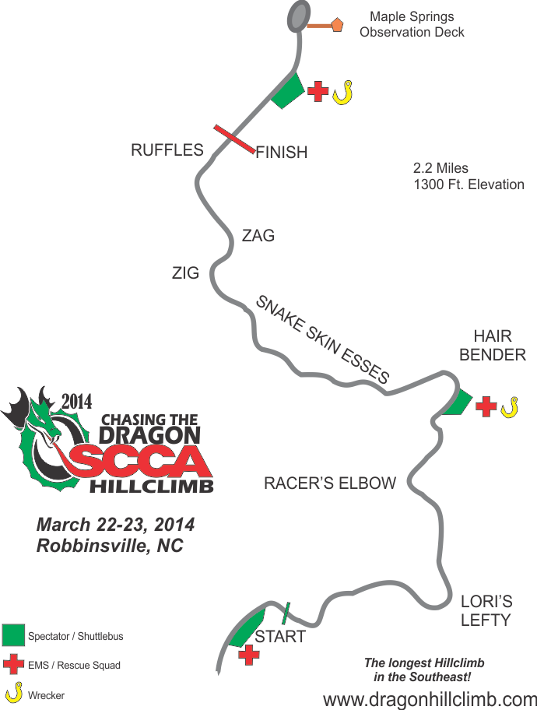

GENERAL INFO

Sanction #26-HC-

This event will be held under the 2026 SCCA General Competition Rules (GCR) as amended by the 2026 SCCA Hill Climb Rules and as further amended by the 2026 "FASTTRACK" as amended by the SEDIV Hillclimb Rules.. The SEDiv on-line version of the Rules supplemental is the official version. Also, see rules regarding Novice Hillclimb Program on the www.sediv.com site under rules section. Further amendments may also be published in these Supplemental Regulations.

ENTRIES: The Prepaid single driver Entry fee will be $350 (Add $25 for non-SCCA members)

Open to the first 90 qualified entrants (event chairs may add additional entries at their discretion). We are expecting a larger field this year. Your spot will only be reserved IF you send in your entry fee in advance. Prepaid entries canceled before July 11th will receive a full refund.

Licensing: Drivers should meet one of the following:
- Those who hold a SCCA TRACK/Hill Climb Competition license, or
- Those who hold a SCCA Hill Climb Novice permit, or
- Those who hold a SCCA Competition License (Novice or Full), or
- Those who hold a racing license from a recognized motorsports organization.
All drivers aged 15 to 17 must contact event officials before the event and provide a completed SCCA Official minor waiver (Form 1068). Current SCCA membership (weekend memberships are acceptable) is required. FIA, NASA RR/TT/RALLY and Rally USA Comp License Allowed) SCCA Time Trial Novice licenses will be allowed for this event as a part of the SEDIV Time Trial Novice Hillclimb Program but attendance at the Novice instruction and working with Mentor is mandatory.
1. Needed at Registration: Valid Government issued Driver’s License, Competition License or Application

SAFETY REQUIREMENTS: : https://timetrials.scca.com/pages/hillclimb-safety-rules

APPALACHIAN HILLCLIMB CLASSING: https://www.appalachianhillclimb.com/rules-and-classes.html

DRIVER ELIGIBILITY: All drivers must be current SCCA members in good standing or obtain a Weekend Membership ($30) at the event. Holders of current SCCA Novice or Full Competition License, Hill Climb Novice or Competition Licenses, NASA TT or Comp license, FIA License (if SCCA member) may compete in this event. There will be no calls to the SCCA National Headquarters, and no substitute drivers. If you are running in the Hillclimb Novice Program, you may apply for licensing to generate one. It is your responsibility to have licensing completed before proceeding to Tech. If you have questions, do not wait until the event to ask.

MANDATORY DRIVER'S MEETING: You must attend the driver's meetings (Start Line). If you run late and are not able to make the driver's meeting, you will be required to see the Chief Steward or Event Chair before being allowed to compete. Refunds WILL NOT be issued to drivers who miss the driver's meeting and refuse to meet with the Chief Steward or Event Chair. Track time/runs for late drivers WILL NOT be made up.

FUEL is not available at the site and limited within 12 miles of course… BYOG (Bring your own gas.)
You will be required to have an extinguisher (10 lb. ABC) with you at any time gas is being poured (whether from container to container or container to tank. This is a park REQUIREMENT and grounds for being ejected from the event without warning or second chance.

CONCESSIONS: Vendors will be on site for food. Lunch is provided for event staff.

WAIVERS: It will be mandatory to sign a waiver / minor waiver, and wear a wrist band. Annual SCCA waivers will be accepted.

TECH: Tech will be conducted in locations defined in the schedule.

LOG BOOKS: All cars will need an SCCA Log Book - either Road Race or Time Trial. If you need a TT log book, make arrangements before the event if possible to avoid delays in registration. Contact Steve Eckerich on logbook at seckerich@stampcometal.com If you have an annual inspection stamp in your logbook please bring it to registration.

SAFETY REQUIREMENTS: All driver and vehicle safety equipment must meet current GCR and HCR specifications. Driver's head/helmet must NOT protrude above the vehicle roll cage, (Roll Bar, HC Minimum Requirement) or roll hoop during any part of the competition. Cars must be re-inspected by the Chief of Tech if involved in an incident or if the vehicle is reported as leaking any fluids. All entrants must have a vehicle log book complete with pictures and log book number. Please fill in the date and event name prior to visiting tech. If you will be presenting a new car to tech for its annual inspection, or if you have tech questions, please contact the Chief of Tech as soon as possible. Arm restraints are required on all open cars. Please note that seat belt expiration date has been dropped for TT. Belts must be in good condition.

HELMETS: All helmets must be SA2015 or SA2020. RUNS:

We will try to give as many runs per day as possible. Actual count depends on how many participants and event flow. We will do our best to get you as many runs as possible. You do your best to not holdup the event. While event management will do all we can to notify drivers, it is the driver’s responsibility to know when his/her group is on call.

TIMING: DO NOT bother the people in the timing trailer! We will have a digital timing system for everyone to see their times. There will only be one set of official results, and they will be on a computer print out. We will try to make copies available. In the case of an obviously incorrect time, officials will take corrective action.

INSURANCE: Participant insurance will be provided in the amount required by SCCA.

PADDOCK: Event paddock parking is under the direction of the paddock or event officials. If your car is brought in on an open trailer, you will be provided space on side of the road for a support vehicle and your race car (tent, etc.) Open Trailers must be stored at the lower gravel parking lot just above spectator parking area after car has been unloaded. If you car is brought in on an enclosed trailer, you will be provided a space on the side of the road for one support vehicle (tow vehicle) or your closed trailer and your race car. (All on the grass). You will not be able to park a race car or place an awning on the pavement beside your trailer as this will restrict the main road. You may park it behind the trailer and use cover if you wish. When you first enter the paddock section of our hill, you will drive up to gravel start/spectator area, you will turn around and drive back down to unload and proceed to the trailer parking area. This will allow less congestion when you are ready to leave. A pit and paddock speed limit of 5 mph will be strictly enforced as spectators will be in the area. If a car/driver is seen going faster than that or burning rubber in the paddock, it will result in disqualification. Procedures for entering and exiting the course will be detailed in the mandatory driver's meeting. Anyone driving a wheeled vehicle in the paddock must have a valid state driver’s license. Competitors are responsible for behavior of their crew and guests. Pets must be on leashes at all times and are not allowed at Spectator Area #2 or #3. Children must be under an adult’s supervision at all times. NOTE: RULE FROM PARK MANAGEMENT; NO ATVs, 4 wheelers, minibikes without state registration and tag to be used in the paddock area roadway.
EMERGENCY LANES must be clear at all times for emergency traffic.

INTOXICANTS: In respect to our hosts, NO ALCOHOL may be consumed at the event site. This is a National Park. Use of intoxicants at any time while on the event site grounds is strictly prohibited. Anyone found to be using intoxicants during the event, or illegal drugs at any time while on the property, will be ejected from the property and forfeit their weekend. Drivers are responsible for their crew and guests.

GENERAL RULES: There will be no sound limit for the event but we do expect restraint in high revving of engines in paddock for the sake of our spectators. Do not dump oil, gas or coolant on the pavement or non-paved areas of the track. No Fluid recycling facilities are available, so please take it home with you. No Race engines to be run during Sunday lunch break or before 7:00am and after each event day beyond 7:00pm. An entrant may elect to waive SEDIV Time Trial Series points by checking the appropriate box on the entry form. Passengers are NOT permitted in any racing vehicle other than rally navigators – this includes coming down the mountain on return parade lap.

RULES OF THE EVENT: The requirements of conduct and sportsmanlike behavior, as defined in the GCR, will be strictly enforced. The penalty for a breach of these rules may include immediate expulsion from the event and/or a permanent ban from the event. All participants, crew, officials, workers and guests: will adhere to all applicable city, county, state and federal laws and regulations; will follow all rules and regulations defined herein or posted at the event; and shall not engage in any illegal, immoral or un-safe activities or business while on the event premises. Failure to abide by these rules may result in immediate expulsion from the event premises by any event official or the organizing region.

RAIN OR SHINE – Event Chair and Chief Steward will make a call if the weather is too inhospitable for racecars or workers and may need to delay or stop runs until a time that it is deemed safe. No refunds for bad weather.

ADDITIONAL NOTES:
1. We need workers to run the event. If you know anyone that would want to help, please let us know.
2. We need to show the workers our appreciation and would welcome any perks you can think of to give them or would like to donate for them. Please contact: Chris Polohumus if you would like to donate anything for workers.
3. Weather can vary greatly by the hour. Please bring appropriate clothing and supplies. You are responsible for any tents or canopies erected.
4. This event is sanctioned by Central Carolinas Region – SCCA.
5. Trophies will not be mailed so please attend awards presentation, or make arrangements to have someone pick yours up. We would like to recognize our winners before the course workers and spectators who came out to watch.

Submit Entry Forms and check made out to SCCA – CCR and mail to:
Registrar
SCCA – CCR
PO Box 1044
Fletcher, NC 28732

We will only guarantee spots for the first 100 drivers responding. Reserve your entry spot TODAY!

PROGRAM INFORMATION: Please fill out your Driver Bio in order to be included in the EVENT PROGRAM and for our announcer at the event. We will use these to select drivers for on air interviews this year at the event.

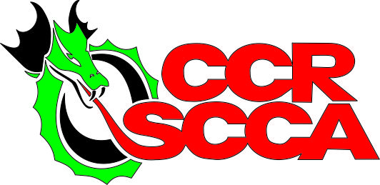
HILLCLIMB DRIVER BIO

Name:

Car Class / Car Number:

Year/Make / Model of Race car:

Car Weight / Horsepower (not required):

Racecar Top Speed (not required):

Name of Home Town

Relatives or crew with you at this event:

First Hillclimb at the Dragon: Yes __ No__ Number of Years of Race Experience:

Sponsor(s) Announcer will mention them on air if you post them here:

Why you are here:
_______________________________________________________________________

_______________________________________________________________________

_______________________________________________________________________

_______________________________________________________________________

Anything else you would like the announcer to tell about you?
_______________________________________________________________________

_______________________________________________________________________

_______________________________________________________________________

_______________________________________________________________________

_______________________________________________________________________
_____________________________________________________________________
Note: This information will be mentioned on the intercom while you are competing so spectators can know a little something about you. However, if you do not provide any information, the announcer is “free” to make up anything about you that he/she wishes!

