Please complete this form and bring with you to tech inspection prior to the drivers meeting.

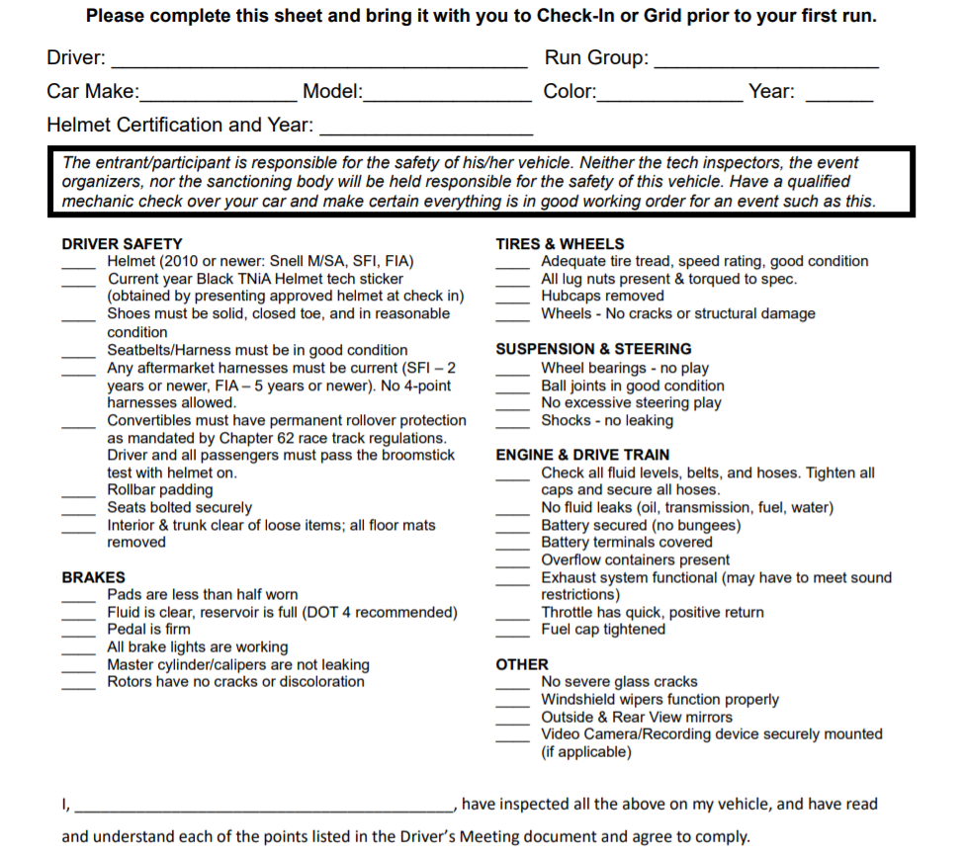

I _______________________________________________, have inspected all of the above on my vehicle and acknowledge that safe condition and operation of my car is ultimately and entirely my responsibility. I take full and sole responsibility for any vehicle issues, malfunctions, or damage that may occur in connection with the operation or performance of my car prior to, during, and subsequent to the event. I acknowledge that the inspector is not liable for the safety of this vehicle.

**DRIVER SAFETY**

Helmet (2015 or newer, Snell M/SA, SFI FIA)

**Tow hook(s)- OEM or Aftermarket**

**Oil filter tightened**



**Signature**: ____________________________________________________  **Date**:_________________



