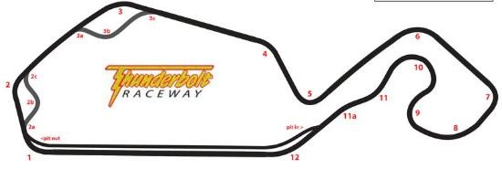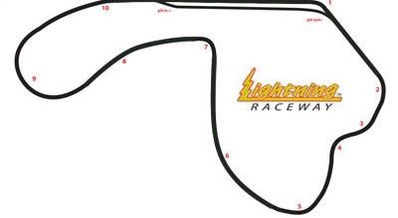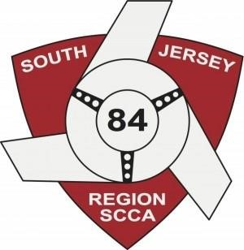
2018 Season

Track Day Events
Rule Book

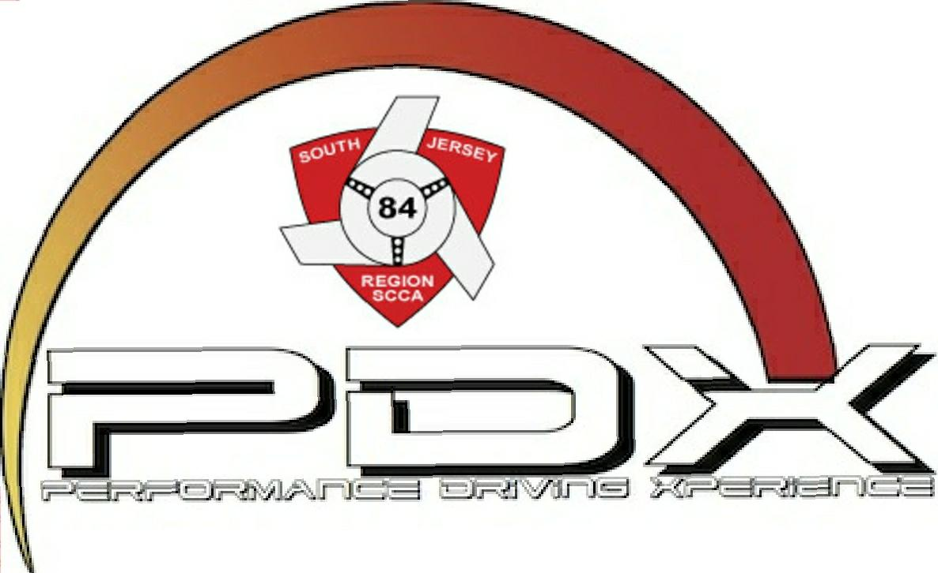

PDX is an instructional driving event. It is designed to provide a safe and controlled environment for drivers to participate in on track driving without a competitive element. Drivers are required to operate their vehicles within the rules that will be given at the event, and within the limits of their automobiles, the track, and the tracks current conditions. Racing within the PDX groups will not be tolerated. SCCA provides run groups for beginner, intermediate and advanced drivers.
Safety is the primary focus of every track event hosted by the SCCA. The following rules reflect what is thought to be the bare minimum needed for safety for all participants in any of the PDX events. Meeting or exceeding the rules is a requirement for all PDX events. If adhered to, the events will be a fun and quality experience for all Involved.

ALL DRIVERS MUST

● Be at least 18 years old
● Hold a current valid state driver’s license
● Attend all required meetings: drivers meetings, classroom sessions, etc.
● Pass a safety (tech) inspection on site
● Have the proper safety equipment
● Pay the event registration fee
● Follow the rules set forth in this document, along with any rules given before or during the event by the event organizers
● Submit and sign the required waivers and tech inspection form prior to driving in the event
● Abide by any and all rules of the event.

BE ADVISED

No driver, entrant, or crew may consume alcohol until all practice, racing, or track time for his group is finished for the day. Anyone who has consumed any alcohol on the day of an event, other than following the conclusion of his activities, shall not participate on that day, may be excluded from the balance of the event, and may be penalized. Alcohol may not be consumed in the pits until after all the days on track activities are concluded. Performance impairing substances are prohibited at all times.

Take proper care to not damage the track facilities in any way possible. In the pits and paddock, all jack stands should have solid bottoms (plates welded to them to disperse the load to the entire surface underneath the jack stand), or be placed on wood as to not damage or sink into the asphalt. Spilling fuel or other fluids that damages asphalt surfaces should be absolutely avoided with the use of drip pans or other measures. Contact to the walls, berms, or tire walls of the racetrack or paddock that cause damage deemed to need repair (by the track management) will result in the driver of the car causing the damage to reimburse the track for expenses.
TRACK SURFACE CONDITIONS ARE CONSTANTLY CHANGING
Driving within the limits of the car/track surface is the responsibility of the driver. Going off track because of changing track conditions or debris/fluid on the track is not an excuse, and unacceptable. Track surfaces cannot be guaranteed in any circumstance, drivers must use their best judgement in all situations, in every session, and in all aspects of the event.
CLOTHING
1. Non synthetic fabric clothing (i.e. Cotton)
2. Long pants only, no shorts on track.
3. Long-sleeved shirts are highly encouraged on track, as are racing suits / fireproof suits.
4. Shoes must be closed toe. No sandals.
5. No tank tops.
6. A proper fitting Snell SA or M - 2010 or 2015 helmet.
- Open cars MUST have full-faced helmet with visor down at all times.
- Open-faced helmets are permitted in closed cars with working factory airbags.

PDX RUN GROUPS
What PDX group do I belong in?

PDX 1 (Novice & Intermediate)
This is where you start. You will receive guidance from our experienced Instructors, as you learn to control your car and yourself. You will learn how to approach a turn, the fast way around it, how to brake, and how to exit. PDX 1 offers in car instruction for those who needs it, corner instruction and mandatory classroom instruction.

PDX 2 (Advanced)
You should have 5+ events under your belt and be comfortable navigating the track at high speeds without instruction.

Those that wish to can petition to apply for a competition license.

CHANGING RUN GROUPS
● If a participant believes they are in the wrong run group during the event, they should contact the Lead Instructor or management.
● If a participant in a novice run group would like an instructor, they should contact the Lead Instructor or management.
● The Lead Instructor and management reserve the right to change group and instructor assignments based on instructor and student feedback, other driver feedback, as well as feedback from track staff.
ON TRACK CONDUCT FOR PDX
All drivers must have an understanding of the following:
1. Track Flags Vary per facility. ( to be covered at drivers meeting)
2. Passing Signals
a. DO NOT, in any situation during track day activities, pass another car without receiving a passing signal.
b. The passing flag from a corner worker is not a passing signal, you must receive a point by signal from the car being passed.
c. A separate point (“point by”) must be given for EACH car that you intend to let by.
d. Typically, the car giving the point by stays on line, and tells the car doing the passing which side to pass on via signals (arm extended with a point straight out for drivers side pass; arm extended with a point over the roof for passenger side pass)
e. fully extend your arm when giving a passing signal.
f. SLOW DOWN when giving a passing signal and remove your foot from the gas if necessary. Drag racing to the corner will not be tolerated. Do not use the brake unless absolutely necessary. If drivers on track drive in a manner that suggest a lack of understanding to any of these items, they will be brought in off the track to discuss with the lead instructor.
g. Passing zones and procedures will be defined by the operating officials and communicated to the participants during the drivers' meeting, classroom session.

DRIVERS MUST:

1. Allow faster cars to pass as soon as possible, politely and safely
2. Leave a safe distance when they are behind a slower car
3. Use proper and safe speed on the grid and in the paddock (walking/light jog pace)
4. When entering the track, DO NOT CROSS THE BLEND LINE
5. Pay attention to and follow the flags. Flags and their meanings will be demonstrated at the driver’s meetings
6. Driver and passenger arms and hands must remain inside the vehicle at all times unless giving a passing signal. Only the driver is allowed to give the passing signal.
7. Do not exit the vehicle on track at any time unless instructed to do so by a corner worker, or if the car is on fire. FIRE IS THE ONLY ACCEPTABLE REASON TO EXIT YOUR CAR ON TRACK. ​If fire happens, run away from the track surface (as cars might still be driving the track at speed), or toward a corner worker station if possible without crossing the track itself.
8. If a driver notices something is wrong with their car while on track, every effort should be made to pull off the track immediately, in a safe and predictable manner. DO NOT EXIT THE VEHICLE UNLESS IT IS ON FIRE, or unless instructed to do so by corner workers or emergency personnel.
9. Going off track accidentally or spinning off the racing surface, including flat spins without exiting the racing surface, are highly discouraged.
10. ​Any and all unsafe and reckless/out of control driving that is seen by participants is asked to be reported to grid workers or staff.

VEHICLE PREP

TECH INSPECTION
1. Onsite tech inspection is REQUIRED, it is recommends all participants have a qualified mechanic inspect their car prior to the event, however, tech inspection will still be required for all cars before the event. Failure to go through tech will result in forfeiting track time.

TECH INSPECTION REQUIREMENTS
1. Participants shall bring their car to tech as it will be driven on track. This includes the tires and pads they will use on track. All loose items should be out of the car, and helmet and any device that will be secured to the car during the event should be present and installed (camera mounts, etc.) Participants must demonstrate that any device that will be attached to the car (inside or out) is secured properly. Any device secured to the outside of the car should also be tethered to the vehicle. Floor mats must be removed, and glove boxes and storage areas must be emptied. If an item isn’t tied down, it should not be in the car.

Below is a basic list of issues that should be addressed prior to going to tech, or going on track. Please check for these issues throughout the event and correct them if they appear on a vehicle:
● Corded tires, or tires rubbing on suspension arms/fenders
● Loose lug nuts
● Brake lights not working
● Excessive play in the brake or clutch pedal
● Loose throttle cable
● Play in the steering wheel
● Loose bolts please torque ALL bolts to spec before going through tech
● Warped or cracked rotors
● Loose/bad wheel bearings or ball joints
● Fluid leaks of any kind​(windshield washer fluid, oil, coolant, brake fluid, power steering fluid)
● Hoses that can rub on sheet metal, causing damage or cuts in the hoses.
● Brake pad thickness less than the recommended minimum thickness
● Loose body panels/wings
● Loose objects in the car
● Loose dipstick tube
● Low oil pressure, high coolant/water temperature
● Engine / rod knocking
● Frayed belts
● Loose/missing gas cap
● Excessive valve train noise
● Battery not tied down properly. TIE DOWNS MUST BE OEM OR BETTER QUALITY. Rubber or ratchet straps are not acceptable.
● Exposed wiring, or wiring that can potentially rub on sheet metal in a damaging way to the wiring. General wiring, especially under hood, must be neat and secure in layout.
● ECU not properly secured
● Low tire pressure
● Low oil levels
● Noise level (if the track has a decibel limit)
● Lack of exhaust Running open header at these events is not allowed. You must have an exhaust, or at minimum, a b pipe with a turn down. Excessively loud vehicles can and will be refused track time. If you think your car is excessively loud, it very well might be. Please correct this with the use of a muffler or resonator.
TIRES
It is strongly encouraged that beginner and intermediate drivers refrain from using R compound tires (DOT race tires such as Hoosier R6/A6/A7/R7, Toyo RR, etc.) If used, beginner and intermediate drivers will be closely watched and a zero ¬tolerance for spins and off track issues will be instituted for those participants. Non¬ DOT racing slicks are not allowed for beginner and intermediate run groups. Advanced and instructors are allowed to run any good condition tire they chose. Tires with cords or steel belts showing or obvious leaks and/or punctures are not allowed on track.

FUELING AND FLUIDS
Fueling of cars should be done in proper areas, with adequate measures for safety and from approved containers. Fire extinguishers shall be present and in a readily accessible location during any refueling from containers. Oil from fluid changes must be disposed of properly. Only approved fuels may be used. Fuels with octane rating 112 or below and E85 may be used.

CLASS NUMBERS
Numbers shall be at least 8 inches high, with a 1.5 inch stroke on a contrasting background. Metallic (reflective) numbers and class letters are prohibited. The distance between 2 numbers shall be at least as wide as the stroke of the numbers.

SEAT BELTS AND HARNESSES
1. OEM seat belts are recommended.
2. Harnesses must be in working condition without frays or tears.
3. The release mechanism must be in proper working condition.
5. Harnesses must be name brand, quality pieces. Non labeled (SFI , FIA, etc.) “knock off”, or “show car only” harnesses will not be allowed.
6. Harnesses must be used with a proper height back seat and a roll bar or cage. Harnesses used without a roll bar or cage will result in a failure at tech, and will not be allowed. ​No exceptions to this rule will be made, and harness bars and harness combos without a proper roll bar at minimum, will not be allowed.

ROLL BARS AND CAGES
Roll bars and roll cages are recommended for all vehicles, but not required for closed cars. ALL CONVERTIBLES MUST HAVE A ROLLBAR. All roll bars/cages must be quality, professional­ level, and fully welded around all joints to be allowed on track. All roll cage surfaces that may come in contact with the driver should be padded with high density SFI rated padding.

CONVERTIBLES
1. A roll bar is REQUIRED for convertibles without factory rollover protection. Pop up roll over protection is not acceptable. All convertibles must pass the broomstick test. Driver’s head, with helmet, must be 1” below the line “created” from the top of the windshield to the top of the rollover protection. It is highly encouraged that all convertibles add aftermarket rollover protection.
2. The top of the driver’s helmet must be below the top of all bars of the halo in a roll cage. For a roll bar, the broomstick test may be used as a guide to determine if the driver is properly protected.
3. Full closed face helmet required for all open top cars.
4. Convertible tops must be in the full open position.
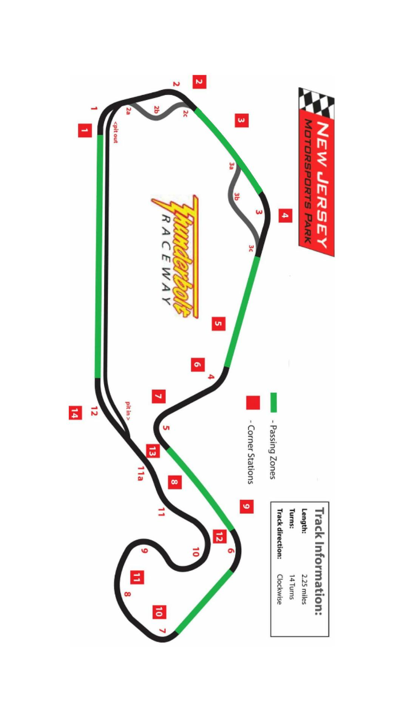
PASSING ZONES
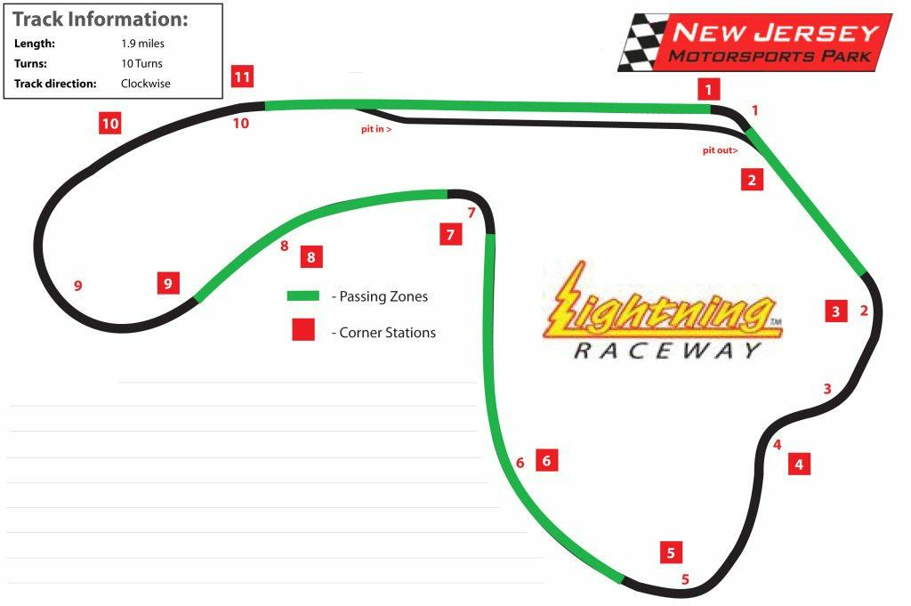

CONTACT INFORMATION

2018 Schedule

March 24 & 25
NJMP Lightning

June 1
NJMP Lightning

August 10
NJMP Thunderbolt

September 21
NJMP Thunderbolt

PDX Director
Joshua Kuehne
Email: iforgeIron88@gmail.com
PDX Secretary
Britney Troth
Email: britneytroth@gmail.com
Regional Executive
Nick DiMeo
Nick@competition-marketing.com
Lead Instructor
Michael Lamaina
Michael@cornerstonecfp.com
Lead Tech Inspector
Matt Wojtkowiak
Tech@sjr-scca.org

