Tour

A

Schedule

Group

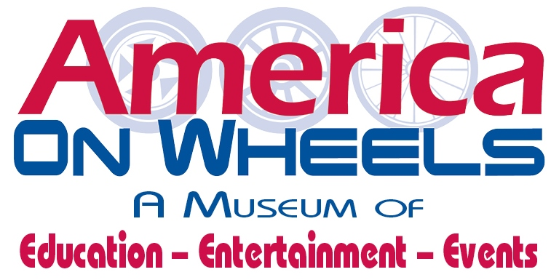

**TOUR PACKAGES**

**(Include Tour Guides)**

***Child (Ages 4-12)***

* *Tour Packages consist of groups of 10 or more*

**TOUR ONLY - Adults/$15– Students (6-16) $8**

**TOUR & ICE CREAM - Adults/$25 – Students/$12**

**\*ROADSIDE TREATS - Adults/$32– Students/$15**

**Includes- Tour, Hot Dog or Pizza (pre-ordered and delivered, Chips, Soda/Water, Scoop Ice Cream**

**\*THE WHEEL OF TRANSPORTATION**

**Adults/$40– Students/$20**

**Includes: Tour, Sandwich Tray, (Potato Chips, Soda/Water, Ice Cream, Sweets Tray, Choice of one for group Macaroni, Potato or Pasta Salad**

**\*Sundays Unavailable**

FOR RESERVATIONS AND/OR FURTHER INFORMATION PLEASE CALL LIZ HAHN AT 610-432-4200 X10 or EMAIL

AT [**fund_development@americaonwheels.org**](mailto:fund_development@americaonwheels.org)

**5 North Front Street, Allentown, PA 18102 – www.americaonwheels.org**

**5**

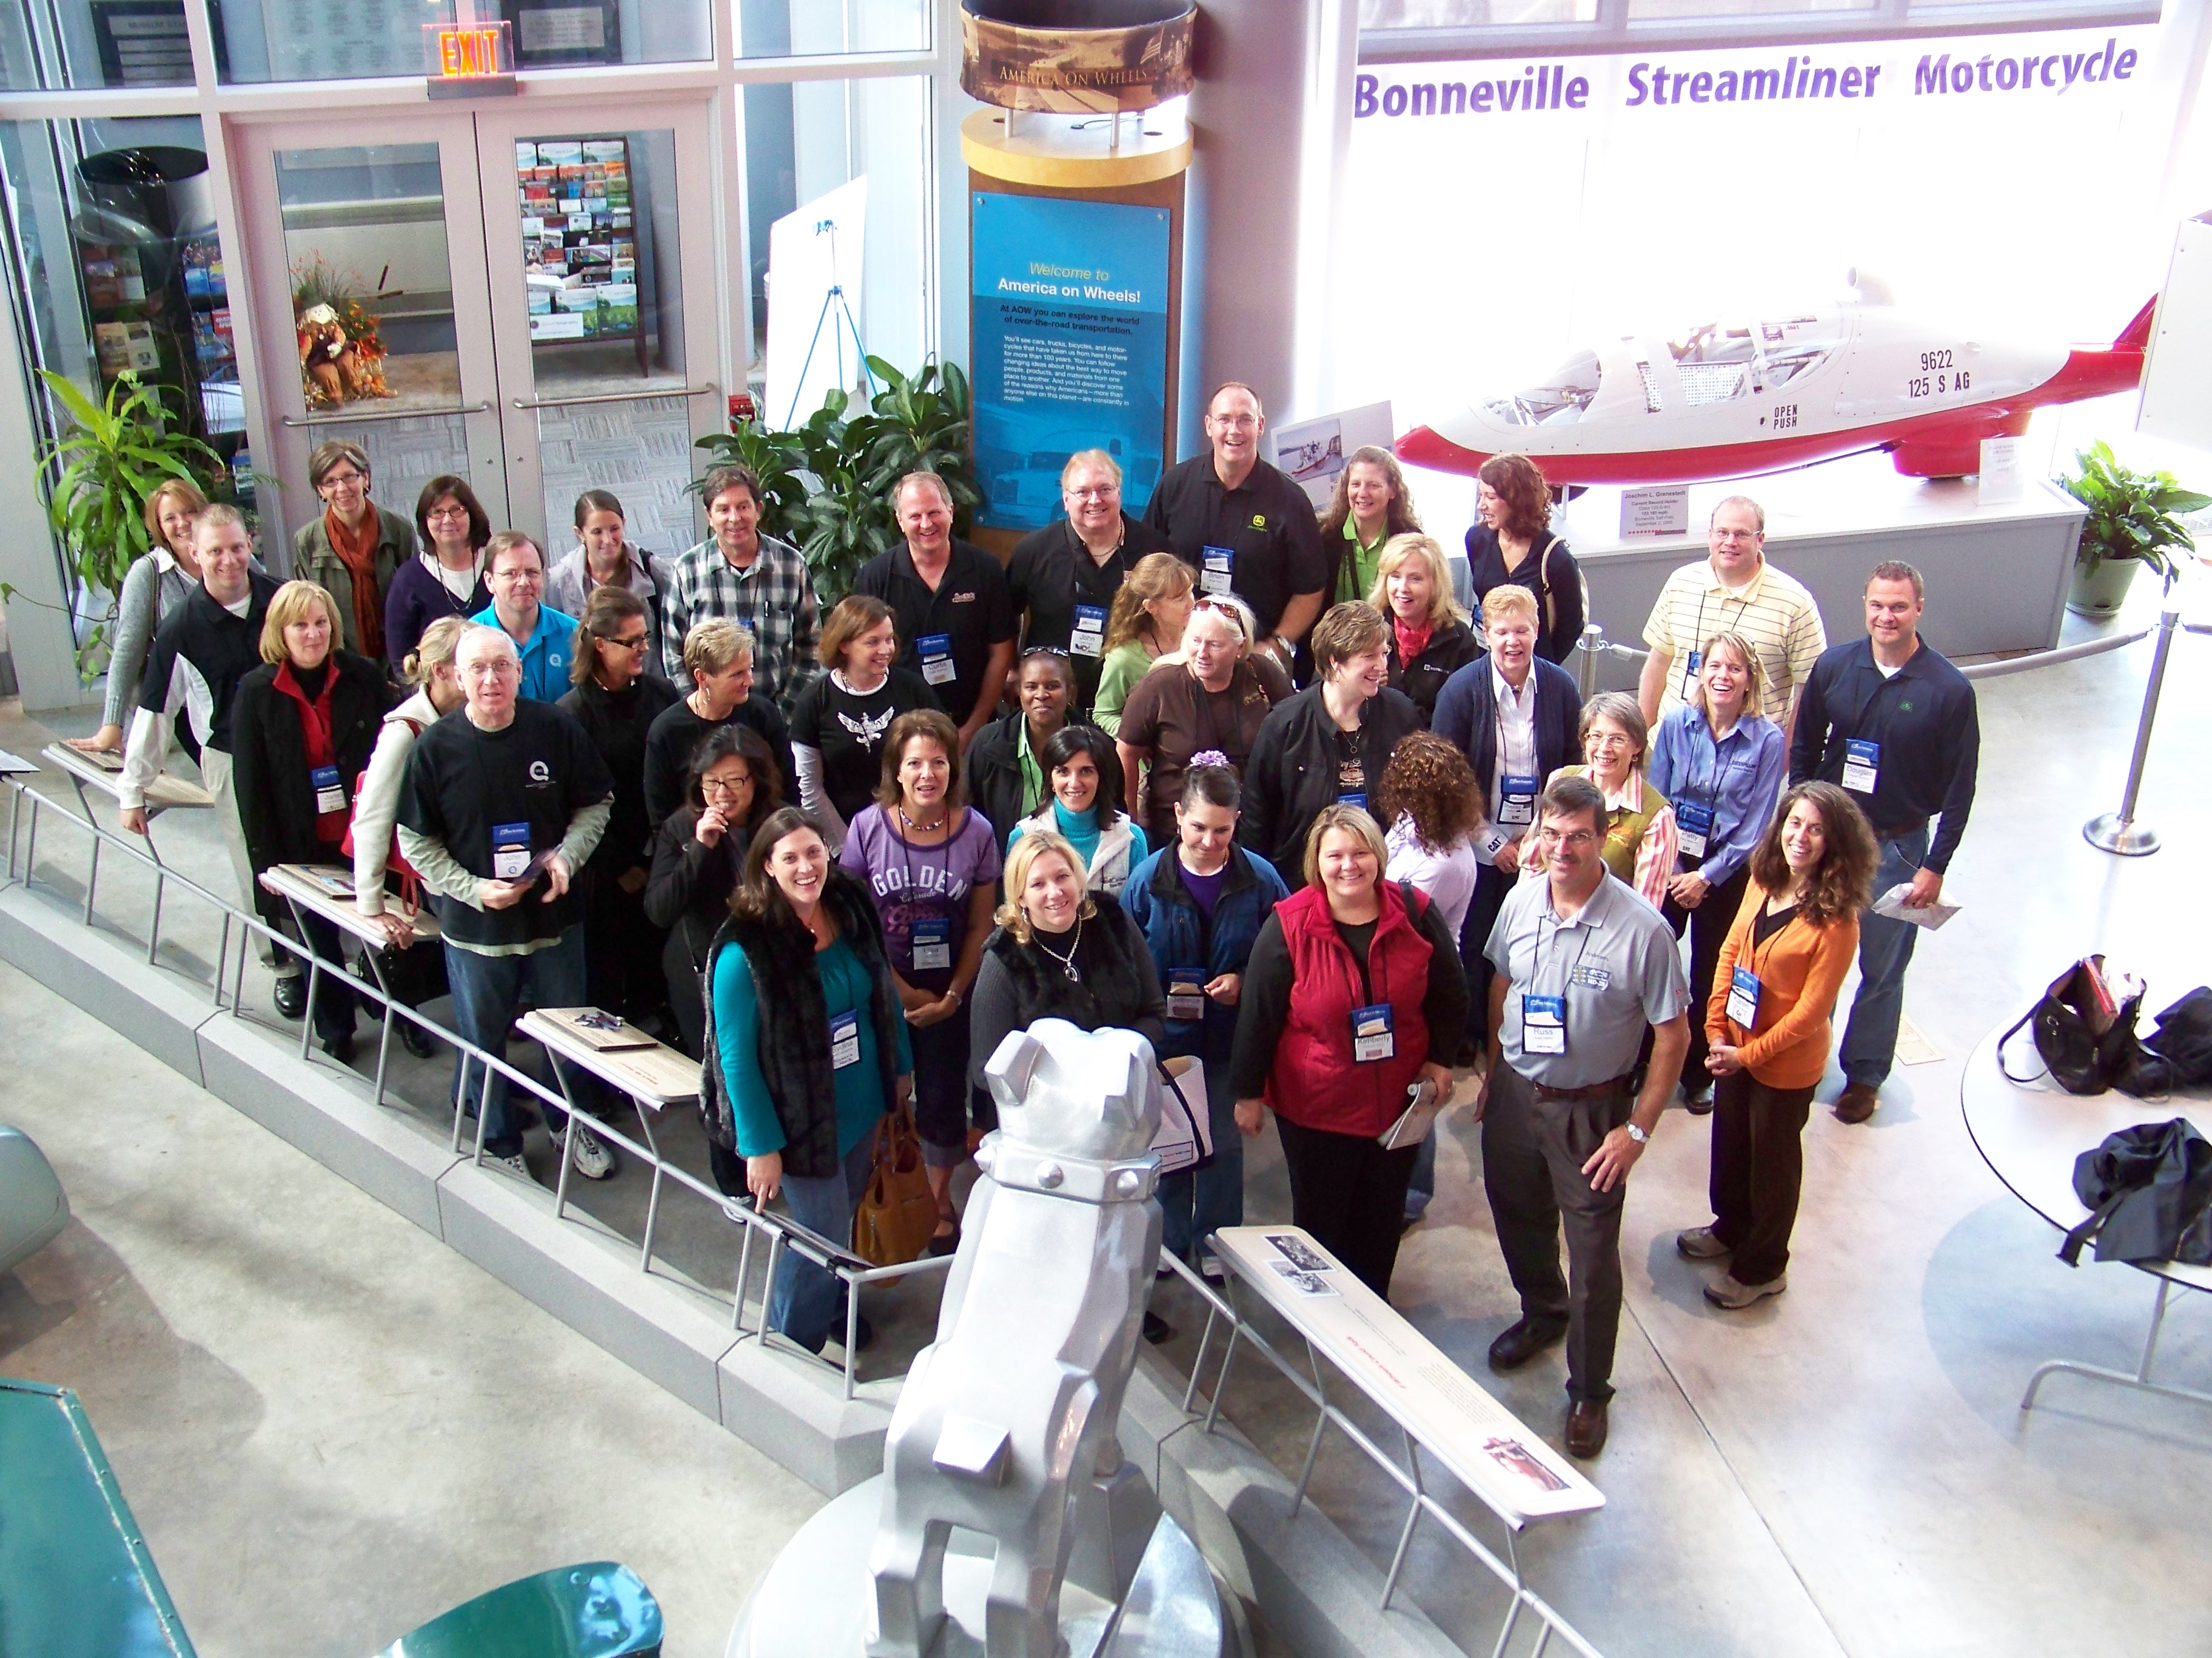

**FREE PARKING**

Bus Parking Available

America On Wheels is Handicap Accessible

**GROUP RATES (10 or MORE)**

**\*Prices, exhibits, hours and days of operations**

**subject to change\***

**HOURS**

**(January through March)**

Wed. thru Sat. 10am-3pm/Sunday Noon – 3pm

**(June, July, August)**

Tues. thru Sat. 10am-4pm/Sunday Noon – 4pm

*Last Ticket Sales/Admittance at 3pm*

**(September, October, November)**

Wed. thru Sat. 10am-3pm/Sunday Noon – 3pm

**(December – Holiday Trains included**

Wed. thru Sat. 10am-4pm/Sunday Noon – 4pm

Please reserve your tour at least two weeks in advance by calling

America On Wheels at 610.432.4200 x 10 or email fund_development@americaonwheels.org

**HOW TO SCHEDULE A VISIT**

**GROUP TOURS** are available to any group of 10 or more

* Guided Tour

(Docent for every 10-15 people)

* Self-Guided Tour