Time Trials – Freedom Sprints
RMTT Season Points Series Event
SANCTION NUMBER – TBD, Sanctioned by Colorado Region
High Plains Raceway
July 1 & 2, 2023
TT Drivers Meeting

Sat. 7:45am
Sun. 7:45am

TT Corral –
Paddock East
Run Groups
Group 1: TT- Intermediate / Advanced
Group 2: TT - Novice

Group 3, 4, 5, 6, 7 – Majors Groups
Group 8, 9 – Regional Groups

Registration Hours
Fri. 6:30pm – 8:30pm
Sat. 7:00am – 12:00pm
Sun. 7:00 am – 12:00pm

Classroom
Tech Hours

Sat. 7:00 am – 7:45 am
Sun. 7:00 am – 7:45 am

TT Corral –
Paddock East

Schedule

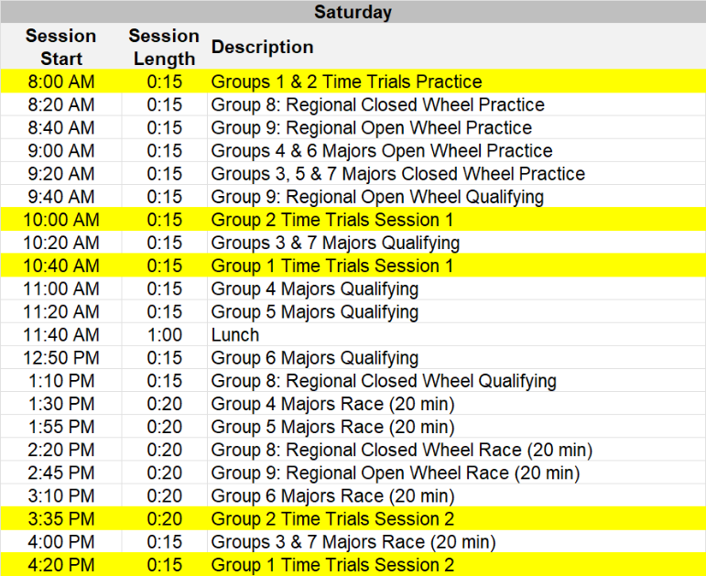

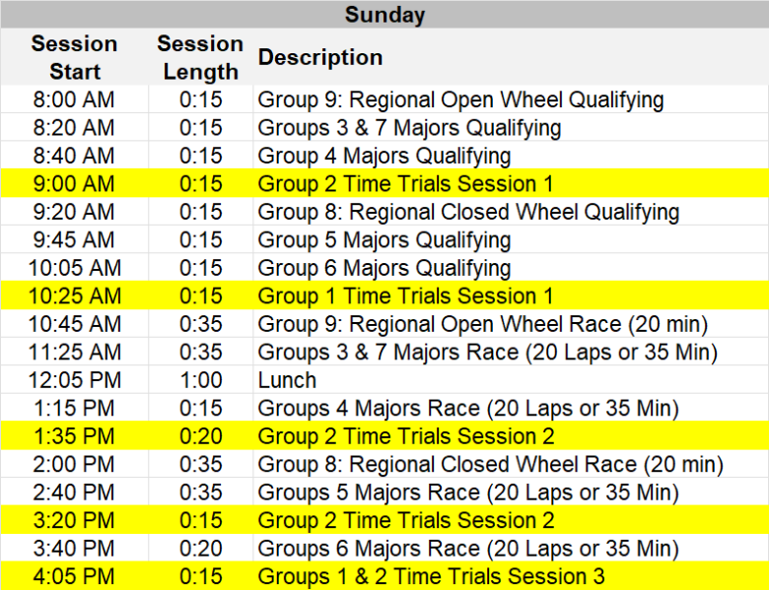

GENERAL

Event Facility: High Plains Raceway Phone: 303-769-4771
93301 East Highway 36
Deer Trail, CO 80105

Length of the Racetrack: 2.55 Road Course Direction of the Race: Clockwise
Pole Position: Chosen by Pole Sitter Location of Race Control: Tower
Start Line: On the Front Straight Finish Line: On the Front Straight

ADDITIONAL REGULATIONS

This Event is held under the SCCA Time Trials Rules. Rules, Car Classing, and information can be found at https://timetrials.scca.com.
Name of the Event: The Freedom Sprints – 2023 Season Points Series Event
Close of Entries: Tuesday June 27, or as extended by registration officials
Early Bird Discount: Early Bird Discounts available on MSReg through June 6

ENTRY FEE: Single Day Time Trials (Saturday or Sunday) - $150.00
Weekend Time Trials (Saturday and Sunday) - $225.00

REGISTRATION: Online registration is required at http://coloradoscca.motorsportreg.com. Please be sure to populate your preferred method of payment. Online registration will close at midnight of the Tuesday prior to the event, unless extended by registration officials.
- Event payments will be processed the Wednesday prior to the event.
- Cancellations may be made through the Chief Registrar prior to the event. If you are sick, we respectfully ask that you not attend the event. Please contact the Chief Registrar for a full refund.
- In the event of mechanical failure, you will be offered a refund or credit only if you have not been on the racing surface. See the Event Lead.
- Approved refunds or credits will be issued via MotorsportReg.
- Registration check-in will be held in the Registration/Hospitality building in the paddock. All drivers, volunteers, and officials must check-in to receive credentials, even if you have signed an annual SCCA waiver.
- Only members who hold a current SCCA membership may be allowed in hot areas. Weekend memberships must be purchased online at http://coloradoscca.motorsportreg.com for a fee of $15.00.
- Volunteers for this event should register at: http://msreg.com/FREEDOM23. Volunteers can participate in one FREE TT – any session, commiserate with skill level, during the event as coordinated with their chief of specialty and the TT Event Lead. Other volunteer incentives (incentives, meal plans, etc. can be found over at this link to the regional and competition school portions of this event).

DRIVER ELEGIBILITY: Participants are required to have a valid driver license and either an Annual or Weekend SCCA membership prior to taking part in the event. Weekend memberships will be available during online registration. Annual memberships can be purchased through www.scca.com.

CAR ELEGIBILITY: A signed TT Tech Form is required before your car can go on track. If you have not already done so, please see the Time Trial Event Lead to have your car inspected during the TT Tech times and location as listed on the schedule. Download the SCCA Tech Form here: https://timetrials.scca.com/downloads/43136-scca-tt-tech-form-19-2

MEETINGS: Participants must attend the Mandatory Time Trials Driver Meeting at the time and location listed on the schedule. In addition, drivers will attend a short debrief with the group’s Designated Driver Coach after each on track session.

EVENT SCHEDULE / RUN GROUPS: The course configuration for this event will be Clockwise. The event schedule is published for planning purposes. Session start times may vary from the published schedule as the event progresses. Run groups may be changed at the discretion of the TT Event Lead. If changes are made, as much notice as possible will be given to all competitors.

TIMING AND SCORING: All cars are required to use fully operational AMB transponders. It is the driver’s responsibility to make sure their transponder is working AND that the correct transponder number has been provided in the registration system or to the registrar. A vehicle without a working transponder or with a missing transponder number may not be scored.
- There are a limited number of transponders available for rent at the rate of $30 per day, along with a $500 retainer on a valid credit card. The retainer will not be charged unless damage or loss of the transponder occurs. These are available on a first-come, first-served basis and should be reserved during the online registration process.
- Personal timing beacons are not allowed within 20 feet on either side of the T & S system, or across track from Start/Finish.

GRID: Starting positions will be determined by the group’s Designated Driver Coach. Drivers are prohibited from scrubbing tires in the paddock, grid, pit out to the course and hot pit lane.

RESULTS & AWARDS: Results and trophies will be available in the hospitality area. Trophies not picked up will be considered forfeited unless prior arrangements have been made with the Event Lead. Only participants with an Annual SCCA membership will be eligible for points towards any Annual Championship Series.

FLAGGING: GCR 6.1.1 flag rules apply to all sessions. The BLACK FLAG station is at corner station 9.

DISABLED CARS: Disabled or damaged cars may be removed from the course and delivered to a central location. If the car requires wrecker support to return to its paddock location, there may be a delay depending on the availability of wreckers or flat tows.

RADIO FREQUENCIES: The region frequencies below shall not be used for communications by any participant.

451.2875 | 451.3125 | 451.3375 | 451.3625 | 451.3875 | 461.5125
463.2625 | 466.2125 | 466.5875 | 468.3125 | 469.1250

PADDOCK: Time Trials and Performance Driving participants should paddock in the parking lot just south of the gas pumps.
Access ways for general paddock traffic and Emergency Vehicles must be always kept clear or vehicles will be towed. You must have a valid motor vehicle license to operate any 2, 3, or 4-wheeled motorized or non-motorized vehicles in the paddock.
- Skateboards, skates, rollerblades and one-wheel electric boards are prohibited.
- The paddock speed limit is 10 M.P.H. Vehicles in the paddock must be operated in a safe manner.
- Entrants are responsible for the conduct of their crew, guests, minors, and pets. All minors must be always under direct adult supervision. Pets in the paddock must be always leashed and under direct supervision of an adult.
- Minors and non-members must remain behind any barrier paralleling the Hot Pit lane. No one will be allowed to view from in front of the Race Control and Timing structure.

GENERAL: Participants must always display proper credentials.
- The organizers reserve the right to postpone, abandon or cancel the event, or any part of the event. Entry fees will be refunded to those offered no opportunity to compete.
- Vendors wishing to display or sell any items must obtain prior approval from the race chair or Event Lead.
- The consumption of alcohol is prohibited until after the daily on track activities are concluded. In addition, GCR 2.3.1.B shall be in effect as it relates to Narcotics and Dangerous Drugs.
- The organizers reserve the right to refuse entry and/or issuance of credentials to the premises or event for any reason except race, color, creed, sex, or national origin.
- Unmanned aerial vehicles, also known as drones, shall not be used anywhere in the airspace over the property.

EVENT OFFICIALS:

TT Competition Director & Chief Instructor | Kevin Carter  720-999-2439  ftokev1@yahoo.com | Race Chair | Michelle McColl  303-898-2597  mccollteam@comcast.net
TT Event Lead &  TT Chair | Kevin Carter  720-999-2439  ftokev1@yahoo.com | Chief Registrar | Annita Braun  812-298-4301  Annita.braun09@gmail.com

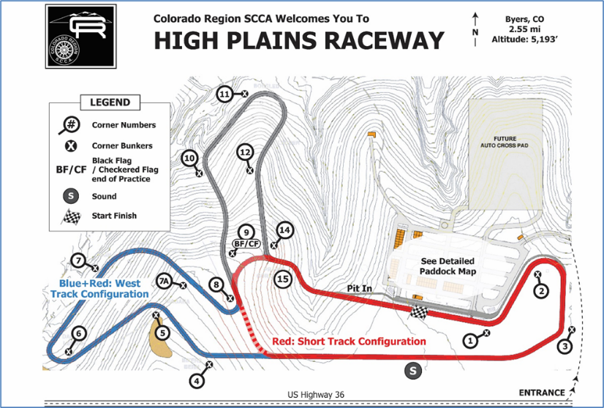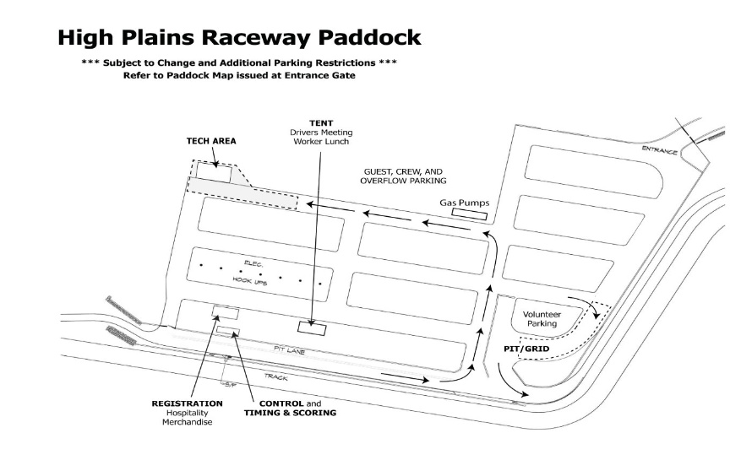
ADDITIONAL EVENT INFORMATION:

The track will be open for testing on Friday before the event. This day is NOT part of the Official Schedule, is NOT sanctioned by SCCA, and is NOT covered by SCCA insurance. Go to: open-lapping-days-registration to pay online. To schedule other exclusive/semi-exclusive track test day rentals go to: https://www.highplainsraceway.com/vip-track-days/.

Directions to High Plains Raceway:
Take I-70 to Byers, (Exit 316). Go 17 miles east on U.S. Highway 36. Track entrance is on the north side of the highway.
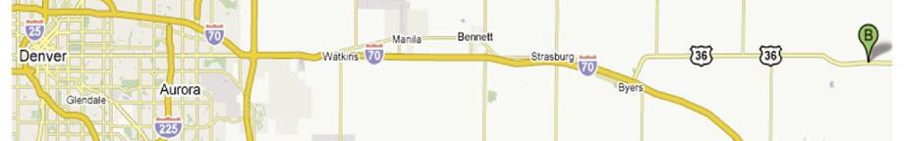

Race Fuel: HPR has a credit card operated fueling station that accepts Visa and MasterCard. Fuels available are:

Sunoco 260 GT 100 octane unleaded street legal 3.3% oxygen,
Sunoco 260 GTX 98 octane unleaded not street legal 0.0% oxygen
Sunoco Standard 110 octane leaded not street legal 0.0% oxygen

On-Site Tire Services: Please bring what you need, as there may not be tire services at the track.

Concessions: Track concessions will be open Friday, Saturday & Sunday.

Accommodations: RVs may be parked overnight at the track. A limited number of electrical hookups and Carports are available. Rental policy and

reservation procedure are available at https://www.highplainsraceway.com/rv-carport-rental-information/

Other accommodations near High Plains Raceway:

Budget Host Longhorn Motel – 17 Miles West
Closest to HPR – 303-822-5205
456 Main St. Byers, CO 80103

Country Inn & Suites – 49 miles West
4343 N. Airport Way Denver, CO 80230
303-375-1105

Strasburg KOA – 23 miles West
Campsites, Lodge and Cabins – 303-622-9274
1312 Monroe St. Strasburg, CO 80136

Willow Tree B & B – 30 miles West
49990 E. 64th Ave. Bennett, CO 80102
303-644-5551

Country Manor Motel – 38 miles West
32681 E. Colfax Ave. Watkins, CO 80137
303-261-9650

Courtyard by Mariott – 47 miles West
6901 Tower Rd. Denver, CO 80249
303-371-0300

Gaylord Rockies Resort – 47 Miles West
6700 N Gaylord Rockies Blvd, Aurora, CO 80019
720-452-6900

Holiday Inn Express – 42 Miles East
803 Hwy 24 Limon, CO 80828
877-863-4780

Volunteers: Volunteers are required to pre-register on MSReg using this link: http://msreg.com/FREEDOM23

