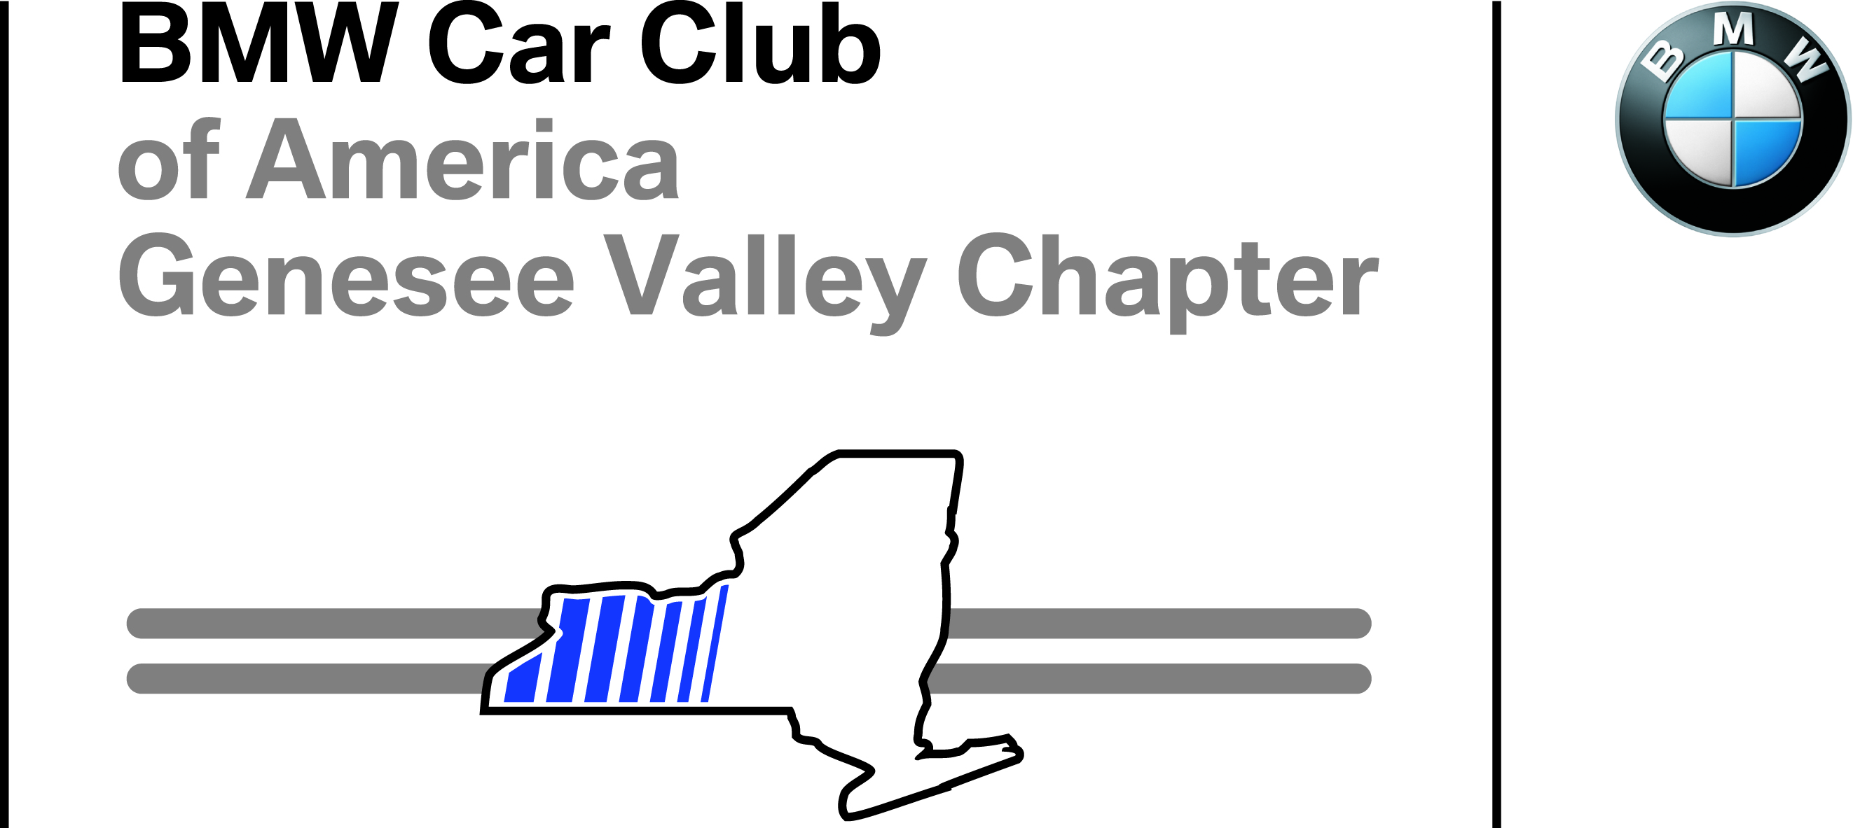 GVC Ultimate Driver’s School

Pre-Event Technical Inspection Form
This form is for mechanical inspection of vehicles being used in GVC High-performance driving events. The form must be completed, signed, and presented at event check-in. Tech inspection should be performed within one month of the date of the event.
The participant assumes full responsibility for the safety of this participating vehicle and for knowing the condition of each item listed below. Inspection by a professional mechanic familiar with high-performance driving schools is MANDATORY FOR ALL NOVICE DRIVERS, and VERY STRONGLY ADVISED FOR ALL OTHERS. Vehicles not professionally inspected, particularly those self-inspected by the owner, will undergo particularly close scrutiny by GVC tech staff at check-in.

Date of Inspection: _________________Event: _____________________________________ Event Date: ___________

Driver: __________________________________________ Licensed? Y / N State/Prov:________________________

Emer. Contact: _____________________________________________________________Phone_____________________________ At event? (Y/N) _______

Co-Driver: ______________________________________ Licensed? Y / N State/Prov:________________________

Emer. Contact: _____________________________________________________________Phone_____________________________ At event? (Y/N) _______

Make: ___________________________________ Model: _____________________________________Year: ________________

NO CONVERTIBLES PERMITTED (soft or hard-top; see footnote)

Street Car: Plate # _________________State/Province _______; Race Car: Comp. Number_________
Tech Inspectors: Please write “Y” or “N”, “P” or “F”, to indicate pass/fail. Please add comments as necessary.
Tires | P = Pass F = Fail
 | LF | RF | LR | RR
Brand, Model, UTQG rating
Speed Rating: H or higher
Size
Tread: > 3/32”; evenly worn
Condition (P/F): NO Patches, plugs, exposed cord, cuts, dry-rot, etc.

Wheels and Bearings | P | F | Comments
Wheels: proper offset, not cracked, bent, out of balance; bolts/nuts ok, torqued to spec.
Bearings: not loose, binding, whining, leaking.
Brakes  Note: Must be mounted on vehicle at track check-in | P | F | Comments
Pads: minimum thickness >50% required (all types)
Rotors/drums: no deep scoring, pitting, cracks. Exceed min. thickness
Brake lines: no cracks, kinks, leaks, swelling
Fluid: DOT per mfr. specs. Fresh within 6 mo. of event |  |  | Date of last flush/refill:
Suspension | P | F | Comments
Shocks/struts: straight, no leaks, in good condition
Springs: not sagging, cracked
Bushings/bearings: in good condition
Steering and Driveline | P | F | Comments
Steering: no excessive play, binding, vibration, shimmy
Tie rod ends: no play, good condition
Power steering lines: good overall condition, no leaks |  |  | E36 & E46 BMW 3-series: Please see tech note regarding power steering line failures
CV joints in good condition, no cracked/leaking boots
Driveshaft: balanced, no excessive play
Fluids | P | F | Comments
No coolant, fuel, oil, brake fluid, or PS leaks
Topped-up, good condition
Fuel cap: NO leaks
Seats, Belts, Harnesses**  Please consult tech note on page 6 prior to completing this section. | P | F | Aftermarket installations of passenger safety equipment must be installed per mfr. specifications. Pre- inspection by a technician knowledgeable about proper installation is very strongly advised.
DOT belts: 3- or 4 pt.
Racing harnesses (5, 6, 7 pt.): SFI or FIA approved; no damage or fading. |  |  | Brand:  SFI - Expiration date:  FIA - Manufacture date:
Equivalent restraints for driver and passenger |  |  | Restraints should be same type both sides, though not necessarily same brand
Seats: secure, good condition; appropriate for restraints, seat backs support shoulder straps
Roll cage/bar or harness bar: SFI padding in head area, both driver and passenger |  |  | Closed cell foam roll-cage padding is not adequate protection in the head area.
Body and Interior | P | F | Comments
Windshield/windows: no major cracks
Wipers: good condition, functional
Mirrors: rear-view mirror mandatory; securely mounted
Pedals: Free movement; firm brake pedal
No loose trim, panels, bumpers, fenders
Sun/moon roof closes and secures
No sharp edges, exposed door panels, loose carpeting
Brake Lights | P | F | Comments
Mandatory and functional
Motor | P | F | Comments
Condition: Running well, no excessive smoking (oil or otherwise)
Mounts: not broken, cracked, excessively worn
Belts: properly tensioned, in top condition, no cracks or fraying
Hoses: in top condition, supple, properly clamped
Throttle: no binding, full travel, returns freely
Exhaust/headers | P | F | Comments
No cracks, leaks; securely mounted
Battery | P | F | Comments
Securely mounted, properly vented
Structurally sound, no leaks, excessive corrosion
Positive terminal, all “hot” binding posts: covered
Helmet | P | F | Comments
Snell 2005*, 2010, or 2015  (SA or M);  SFI 31.1, FIA 8860 |  |  | Snell rating (circle): 2005* 2010 2015  *accepted through 2016

INSPECTORS ARE NOT LIABLE FOR THE SAFETY OF THIS VEHICLE

Inspector (Print) ________________________ Inspector (Sign) ____________________ Date _________

Drivers/Owners:
your signature on this form indicates your acceptance of the following terms

I acknowledge that the technical inspection performed on my automobile is solely for the purpose of meeting the driving school minimum standards for car preparations, and that no representation is made by the inspectors, or any other person selected by me, as to the vehicle’s roadworthiness for street or track. No warranties are implied or expressed in passing or failing the inspection performed. I release the inspectors from any and all liability arising from their inspection. I acknowledge that I remain solely responsible at all times for the safety and roadworthiness of my vehicle and am not relying on the solely on the inspection in deciding whether or not to drive my automobile.

The Genesee Valley Chapter of BMW CCA reserves the right to exclude any vehicle from the event for failing this safety inspection, or for any other reason pertinent to the safety of the school and its participants.

The Genesee Valley Chapter, BMW CCA, the event organizers, instructors, the facility and its personnel, shall not be held liable for any incident involving you or your vehicle causing damage and/or injury.

Owner (Print)___________________________ (Sign)_______________________________ Date______________

Bring this completed and signed form to registration

Tech Inspection Shops
Below is a list of suggested independent shops and new car dealers in the GVC geographic region with the experience and expertise to inspect your vehicle for a GVC Ultimate Driving School. All novice drivers (D students) MUST have their car inspected by a professional shop. All other drivers are STRONGLY encouraged to do the same. You may choose one of the shops listed below, or other shops of your choosing with similar expertise.

Unless otherwise noted, pre-tech inspections are free, but repairs are charged at the normal shop rate.

Drivers/owners are solely responsible for ensuring that the pre-technical inspection is performed adequately, that all problems identified during inspection have been corrected, and that the vehicle is safely prepared for a high-performance driving event

Eksten Autoworks
78 Bennington Dr.
Rochester, NY 14616
585-621-8200
www.ekstenautoworks.com

The Little Speed Shop
500 Lee Rd.
Rochester, NY 14606
585-647-0339
www.thelittlespeedshop.com

Berg Racing
1660 Boulter Industrial Pkwy.
Webster, NY 14580
585-545-4265
bergracing@gmail.com
www.berg-racing.com

Mr. Best Wrench
2401 Bedell Rd.
Grand Island, NY 14072
716-773-2989
www.mrbestwrench.com

Towne BMW/MINI
8215 Main St.
Williamsville, NY 14221
716-505-2100
www.townebmw.com
www.townemini.com

BMW of Rochester
4250 W. Henrietta Rd. (NY Rt 15)
Rochester, NY 14623
585-359-7373
www.bmwrochester.com
Inquire about charge for inspection

MINI of Rochester
3875 W. Henrietta Rd.
Rochester, NY 14623
585-334-6464
www.miniofrochester.com
Inquire about charge for inspection

Gault Auto Sport BMW
2507 North St.
Endicott, NY 13760
607-785-5028
www.gaultautosportbmw.com
Inquire about charge for inspection

Burdick BMW
5947 E. Circle Drive
Cicero, NY 13039
315-459-6050
www.burdickbmw.com
Inquire about charge for inspection

Technical Note: RACING HARNESSES, SEATS, AND
ROLL-BAR/ROLL CAGE INSTALLATIONS

HARNESSES

- We reserve the right to fail tech for cars with OEM or competition restraints in poor condition due to material failure, excessive age, or improper installation.
- All aftermarket restraints must be installed following the manufacturer‘s specifications for safe installation.
- Seats must be compatible with the installed harnesses. Seats must provide routing slots to prevent shoulder belts from slipping off the shoulders in an accident. The bottom edge of slots should allow belts to ride directly on shoulder or HANS device. Seat bottoms must have routing slots that allow installation of anti-submarine belts according to manufacturer specifications when using 5-, 6-, or 7-point harnesses.
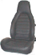
It is strongly recommended that cars equipped with 5-, 6-, or 7 point harnesses have seats designed for their use. We DO NOT permit the use of such harnesses with seats that have sloping seat backs lacking openings for shoulder belts, such as the OEM seats found in many Porsches (shown on the left) and older Corvettes. Unsupported shoulder harnesses will fall off the shoulders in an accident, rendering the entire restraint useless. Three-point DOT harnesses installed by the manufacturer are the only belts approved for use with such seats.
- All non-DOT approved racing harnesses must carry an SFI or FIA rating. Belts past expiration date are okay IF judged to be in good condition.
- Belts worn in accidents involving significant impacts are assumed to be damaged and MUST be replaced, whether or not that damage is visible.
- Equal Restraint Rule: Harnesses and seats must be functionally equivalent (but not necessarily identical) for both driver and passenger. If the driver uses a racing harness, a racing harness must also be available for the passenger. If the passenger only has 3-point belts, the driver must also use 3-point belts.

ROLL-OVER BARS, ROLL CAGES, HARNESS BARS

- Roll-over bars, cages, or harness bars must be securely and safely installed in the vehicle.
- It is critical to prevent/minimize contact with the bar/cage structure in an accident.
  - Roll hoops and other structural supports should be far enough from the helmeted head of both driver and passenger to prevent/minimize contact in the event of an accident.
  - Roll bars must be covered with closed-cell, SFI-approved padding in the area around the driver’s and passenger‘s heads, and is highly recommended anywhere that the belted occupants might contact the bar/cage in an accident.
- Harnesses:
  - Racing harnesses are MANDATORY in cars with roll-bars or cages.
  - Shoulder harnesses must be attached to the roll cage, harness bar, or chassis behind the driver and passenger, and all belts must be mounted as specified by the harness manufacturer.
  - Shoulder harness attachment must be constrained to prevent belts from sliding side-to-side when wrapped around a roll or harness bar.
- Roll bar/cage structure must support seat backs in the case of seat back failure.
THE GENESEE VALLEY CHAPTER OF BMW CCA RESERVES THE RIGHT TO EXCLUDE FROM OUR EVENTS ANY VEHICLE THAT, IN OUR JUDGEMENT, DOES NOT MEET OUR MINIMUM SAFETY STANDARDS

Open-top vehicles permitted are those with fixed, built-in rollover protection (e.g., Lotus Elise/Exige, Ferrari Spyder, Porsche Targa, T-top ‘Vettes and pony cars). Folding hard-tops with factory or aftermarket rollover bars not permitted.

