How to Log into MotorsportReg (MSR) for Publicly Posted Events on MSR

Publicly Posted Events on MSR – that means searchable from the MSR website.

- If you have an existing MotorsportReg account:
  - Sign into your account
  - Search for an event by title, date, club, etc.
  - Click on the event’s link where it says Register now and fill in the blanks
Note: some have had issues with clicking on the wrong Register now so just make sure to scroll to the bottom before you click. It will look similar to this:

- If you have an existing Hagerty account (i.e. Hagerty Insurance, Hagerty Media, Hagerty Drivers Club, or any combination of those) please follow these steps to create your MotorsportReg account:
  - Type in the same email address for your new MSR account that you are currently using for your existing Hagerty account(s). It should then indicate that this email address already has an account associated with it and will request your password to login.
  - Login with your current password for your existing Hagerty account. You should then get a response that asks you to reset your password
  - Follow the instructions to reset it
  - Login with a new password that you create. This new password will then become your password for ALL your Hagerty accounts.
  - Now you can continue with the MSR account set up process below and will likely find that some of the information boxes have been pre-filled for you with information from your existing Hagerty account, which will enable the process to go quickly from this point.

- If you’ve never registered with MotorsportReg, now’s the time to Create an MSR Account of your very own! It’s not hard, and no one will ask for Social Security number, or birthday, but you will be asked to fill in basic vehicle info and enter a credit card on file to pay for events.
Best news: it’s once and done forever! Please be patient, grab a coffee, YOU CAN DO IT!!
  - Click here: MotorsportReg.com
  - Then click on Create Free Account in the upper right corner
  - Follow the prompts to establish your account
    - You are only required to enter info that is marked with an “*” (a red asterisk) plus your mobile/cell number. Everything else is optional. Here’s the first page:
    - Fill in all five boxes and then click on Continue▸
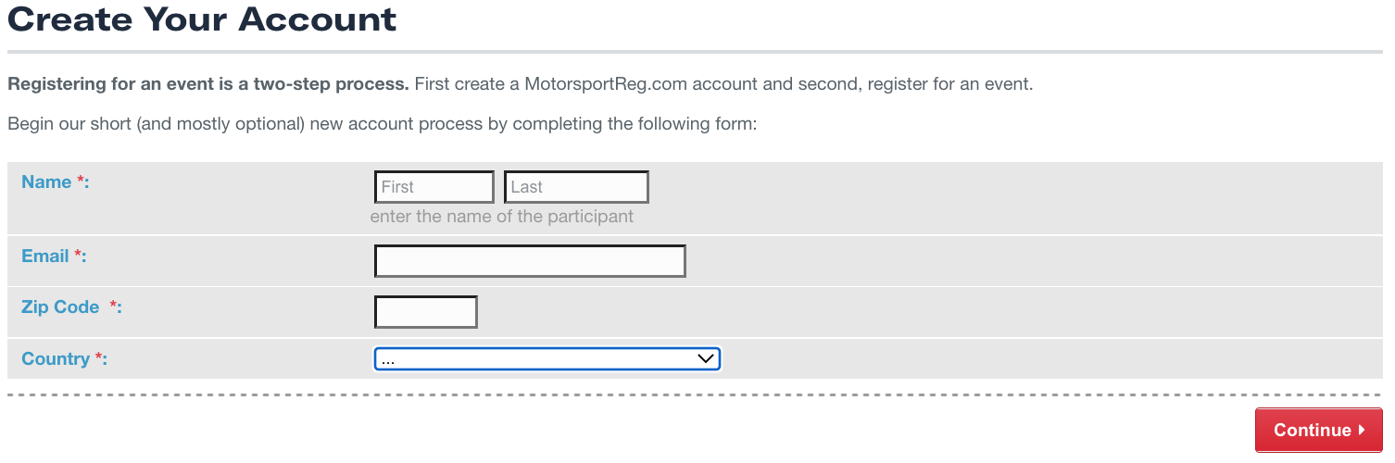

Here’s most of the second page:
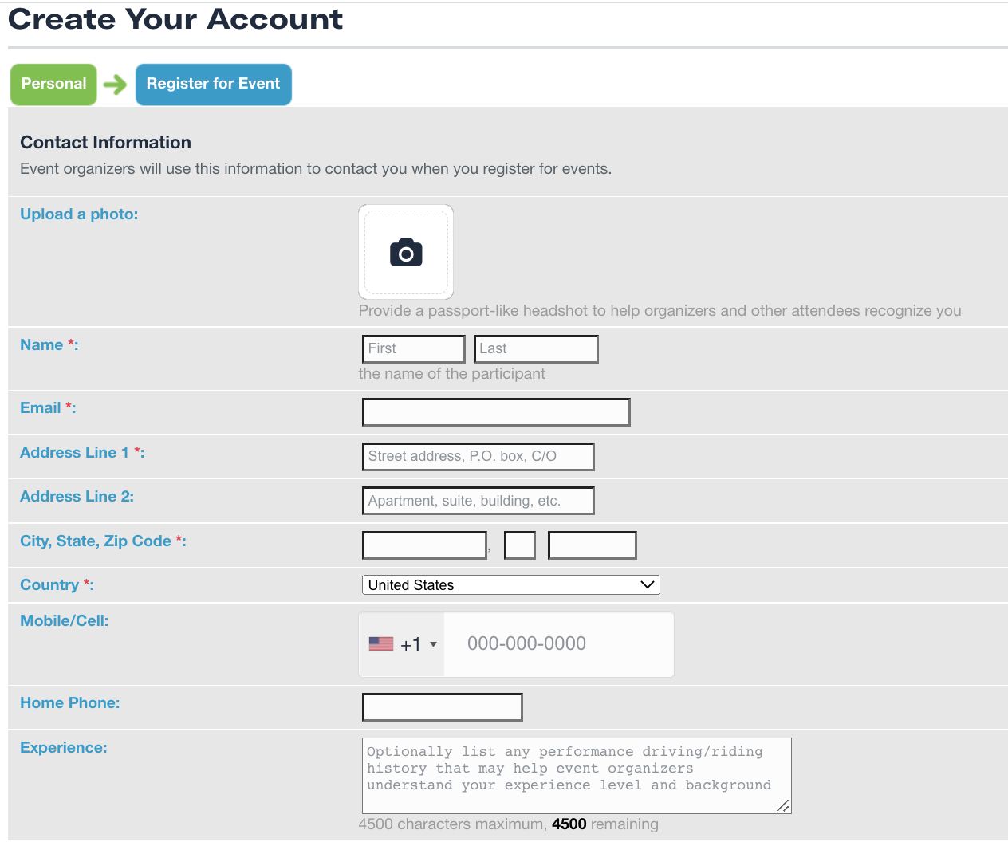
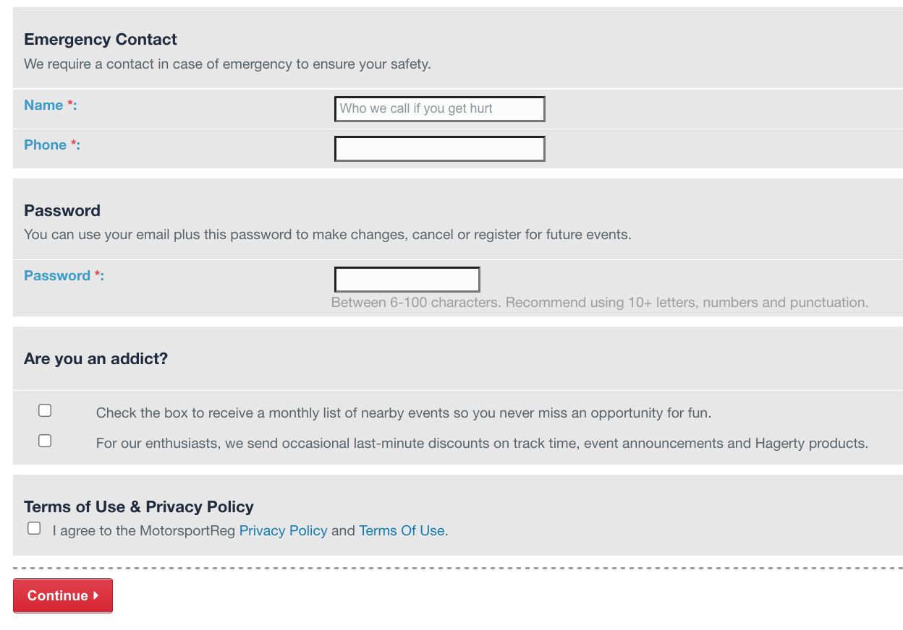

And the bottom of the second page: You will have to click on the “Terms of Use” box.
Then click on Continue▸

    - Once created, click My Account ➟ (optionally select a Profile) ➟ Club Memberships
    - Click to Add Club Memberships
    - Select “Add clubs to Account” ➟ Search for your club ➟ Add
  - Sign into your account
  - Search for an event by title, date, club, etc.
  - Click on the event’s link where it says Register now and fill in the blanks
Note: some have had issues with clicking on the wrong Register now so just make sure to scroll to the bottom before you click. It will look similar to this:

All done!! Congrats! Simple, right? Best news: you won’t have to do this again!!!

If you’re still having troubles you can contact me, Charlie Brown, III @ registrar@rsp.pca.org or 734.358.2393 or contact the MSR Support folks – they’ve been a GREAT help to me as a rookie registrar! If you’ve got the event page open find and click on this button to contact MSR:

How to Log into MotorsportReg (MSR) for Privately Posted Events on MSR

Privately Posted Events on MSR – that means only accessible from a link sent to you.

- If you have an existing MotorsportReg account:
  - Click on the Private event link, generally in an enews@enews.pca.org E-mail blast.
  - Click on the event’s link where it says Register now and fill in the blanks
Note: some have had issues with clicking on the wrong Register now so just make sure to scroll to the bottom before you click. . It will look similar to this:
c. It will take you to your new My Account page. Choose your Profile, click on Register now ▸ and follow the prompts.

- If you have an existing Hagerty account (i.e. Hagerty Insurance, Hagerty Media, Hagerty Drivers Club, or any combination of those) please follow these steps to create your MotorsportReg account:
  - Type in the same email address for your new MSR account that you are currently using for your existing Hagerty account(s). It should then indicate that this email address already has an account associated with it and will request your password to login.
  - Login with your current password for your existing Hagerty account. You should then get a response that asks you to reset your password
  - Follow the instructions to reset it
  - Login with a new password that you create. This new password will then become your password for ALL your Hagerty accounts.
  - Now you can continue with the MSR account set up process below and will likely find that some of the information boxes have been pre-filled for you with information from your existing Hagerty account, which will enable the process to go quickly from this point.

- If you’ve never registered with MotorsportReg, now’s the time to Create an MSR Account of your very own! It’s not hard, and no one will ask for Social Security number, or birthday, but you will be asked to fill in basic vehicle info and enter a credit card on file to pay for events. Best news: it’s once and done forever! Please be patient – YOU CAN DO IT!!
  - Click here: MotorsportReg.com
  - Then click on Create Free Account in the upper right corner
  - Follow the prompts to establish your account
    - You are only required to enter info that is marked with an “*” (a red asterisk) and your mobile/cell number. Everything else is optional. Here’s the top half of your first fill-in-the-blank page:
    - Fill in all five boxes and then click on Continue▸
Here’s most of the second page:

And the bottom of the second page: You will have to click on the “Terms of Use” box.
Then click on Continue▸

    - Once created, click My Account ➟ (optionally select a Profile) ➟ Club Memberships
    - Click to Add Club Memberships
    - Select “Add clubs to Account” ➟ Search for your club ➟ Add
  - Click on the Private event link, generally in an enews@enews.pca.org E-mail blast.
  - Click on the event’s link where it says Register now and fill in the blanks
Note: some have had issues with clicking on the wrong Register now so just make sure to scroll to the bottom before you click. . It will look similar to this:
  - It will take you to your new My Account page. Choose your Profile, click on Register now ▸ and follow the prompts.

All done!! Congrats! Simple, right? Best news: you won’t have to do this again!!!

If you’re still having troubles you can contact me, Charlie Brown, III @ registrar@rsp.pca.org or 734.358.2393 or contact the MSR Support folks – they’ve been a GREAT help to me as a rookie registrar! If you’ve got the event page open find and click on this button to contact MSR:

