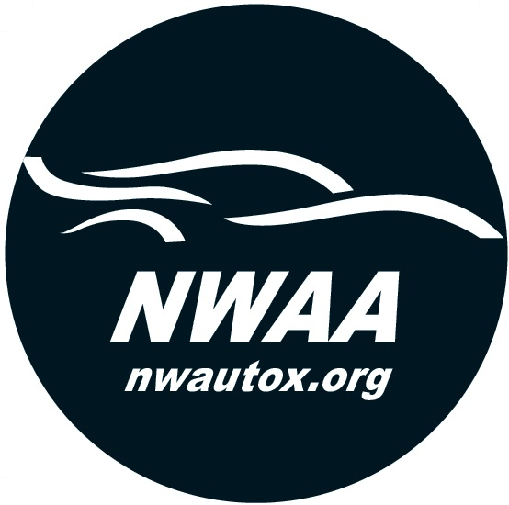
Technical Inspection and Equipment Checklist 2021

Driver Name _______________________________________
Car Year, Make, and Model____________________________
Register Car Number ________________________________

Body Suspension
[ ] Functional brake lights [ ] Wheel bearings properly adjusted, no play
[ ] Hood, doors, trunk and body panels secured [ ] No excessive suspension deflection
[ ] Windshield has no major cracks. [ ] Brake system bled, adjusted and level
Windows must be way all the way up or all the down. between Min and Max
[ ] Gas cap intact and tightened [ ] No excessive steering play
[ ] Numbers clearly affixed on both sides of vehicle
Interior [ ] No frayed or leaking hydraulic brake,
[ ] Seats well secured steering, or, clutch lines
[ ] Seat belts required in good working order and condition [ ] 50 % or greater remaining brake [ ] All loose items (including floor mats) removed from lining/pad required
cockpit, glove box, console, trunk, etc. [ ] Shock absorbers in good working order
[ ] Pedals have free return and in good operating condition
Firm brake pedal Engine and Drivetrain Driver Equipment
[ ] No fluid leaks of any kind (gas, oil or coolant) [ ] M/SA/K Snell 2005 or later. DOT only not [ ] Battery properly secured (NO Bungees) allowed
[ ] All hoses, oil, fuel, and water,with no visible signs [ ] Goggles/face shields (eye protection) for
of damage. Securely clamped/tightened open cars
[ ] Exhaust system securely attached [ ] Proper footwear, no sandals or opened
[ ] Throttle return is safe and positive toe shoes
[ ] Radiator secure, proper overflow container
Wheels and Tires Exhaust
[ ] Tires properly inflated and defect free [ ] 98 db rule strictly enforced. One chance for [ ] Street tires 2/32” average tread depth, no cord repair/modification. If it fails, vehicle will not
visible. Competition tires (slicks) allowed be allowed to run any more. [ ] All lug nuts/knockoffs torqued to spec,
hubcaps, trim rings, center caps, removed
[ ] No visible cracks in wheels
CERTIFICATION
I hereby certify that I have personally performed the inspections and completed the above Technical Inspection and Equipment Checklist. I have found, or corrected, each item to be in compliance with applicable standards.I further certify that I have read and understand all rules and regulations relating to this event and agree to abide with. I understand that completion of these checklists is a minimum requirement of the event, but in no way assures the safety of my vehicle and that the preparation of my vehicle is the responsibility of myself and/or the driver/owner. I further understand that the ruling of the NWAA Event Chair, in regards to participation in this event, will be final.

Driver’s Name(Printed) ________________________________ Date_____________________
Driver’s Signature (Signed)_____________________________
NWWA Staff Signature (Signed)__________________________

