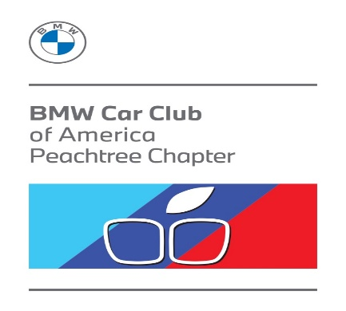
Driver’s Meeting Checklist For Club Sponsored Drives
We urge you to read these instructions carefully.
They are not meant to take the fun away from the drive, but rather to assure that it will be a
pleasant event by making sure everyone is driving in a consciously safe manner.
Pre-Departure Topics
Have you and everyone in your party signed the waivers? This includes drivers, passengers, guests, adults, children (anyone under the age of 18 must sign the Minor Waiver as well). If it is human and is in your car, it must sign the waiver, which will be available prior to departure.
Is your FRS radio set on Channel 2 sub-channel 3? This is our chapter’s default channel for communicating during the drive.
Do you have a full tank of gas? Make sure your tank is full before you drive to the meeting place.
Are you by yourself? If so, let the group lead driver know, in which case you can follow immediately behind a lead car,between cars with navigators or immediately in front of the tail car. This is to minimize distracted driving by feeling the need to check the map or instructions. Just follow the leader!
Switch the headlamps on so we can spot our group members from a distance, especially when driving on a major road.
Post-Departure Topics
Bear in mind that it is impossible to keep everyone together when we drive in traffic. Cars will get stopped at traffic lights and will get separated from the rest of the group. Do not run a light just to keep together. If you are a lead driver for, pull off further ahead in a safe area and wait for the group to re-gather. Just make sure there’s enough room for everyone to stop behind you.
Do not follow too close to the car in front of you but try to keep the group together. When you get a line of cars traveling
together, you will end up having a so-called accordion effect meaning that when the first car takes off, everyone else will try to catch up and when they do they will hit the brakes. By the time the last car in line sees the brake lights they usually will have to slam on their brakes.
Keep a safe distance at all times. If you have not driven the route before, you are probably unfamiliar with blind hills, blind turns and unexpected stops. The last thing we want is a car accident to happen on our road trip.
Remember this is a tour, not a race. At no time does the club endorse or encourage anyone to drive over the speed limit or disrespect traffic signs. We are fortunate to have a liability policy that protects the organizers of the events and the club, but it will take only one incident to put an end to it. You are representing the BMW CCA, a club comprised of drivers and enthusiasts that should be expected to be better drivers than the general public.
Don’t give people a reason to hate BMWs and their drivers or label us as aggressive drivers.
At any time you are free to pull off and do some sightseeing or shopping, but if you have a 2-way radio make sure you inform everybody before you stop or leave the group, so everyone knows there is nothing wrong with you or your car.
If you do not have a radio, make sure to signal to the car behind that you don’t have a mechanical issue and that the group should continue.
If you experience a mechanical problem, pull off and open the hood, so the group will know that you need assistance. If you have a 2-way radio, make sure to inform the group about your situation.
If you are assigned, or become, the tail driver, please inform the lead driver when all cars have made it through a stop light, stop sign, or turn.
Remember to always follow all posted road signs and signals
** Enjoy the Ride! **

