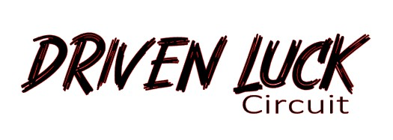

550 Brewers Point Court . Bryant, Alabama 35958 . drivenluck@gmail.com

Technical Inspection Sheet

INSTRUCTION: Drivers must arrive 30 minutes prior to Driver’s Meeting for inspection. Wait with your vehicle. . A Tech Inspector will come to your pit. Please have this form available for him or her. The inspector must fill out the form and no changes shall be made to equipment. If changes are made, you will need to have further inspection.

Date of Event: _______________________ Name of Driver:_____________________________________

Vehicle Year, Make/ Model: ________________________________________________________________

Vehicle Color: ____________________________ Vehicle Number: _______________________________

Check Item:
Modifications
- Hub Spacer/ Adapter
- Engine
- Suspension
- Tires

Brakes
- Properly bled, linkages are in good order and free of wear
- Brake pads have more than 25% of useful life
- Brakes are free of fluid leaks
- Brake lamps (including hazards) are in good working order

Body and Suspension
- Tires have a minimum tread, no exposed belts and have a wear rating of 180 or higher (no spares)
- Lug nuts torque to specifications
- Steering system is in good working order
- Suspension system in working order
- All body panels must be attached.

Engine
- Battery secured properly, positive terminal covered
- Air cleaner secured
- Oils and fluids filled to specifications – no leaks

Engine Continued from Page 1

- Throttle action smooth/ return spring to specifications
- Ignition system and fuel system: Cars with relocated batteries, fuel cells or both, should have an externally mounted kill switch installed on the vehicle that disables the entire electrical system. Driver’s Initial if not: ______________
- Power Steering Reservoir should be covered with reservoir sock, cover or rag in case of a spill.
- Wiring harness secured
- Exhaust system secured

Safety
- Snell certified helmet (2015 or newer)
- Seatbelts in proper locations and secured according to 4-points from unibody or harness bar and worn at all times.
- All convertibles, open top, soft top cars must have properly installed and approved roll bar
- Tow hooks or straps must be present on at least one location on the vehicle and clearly marked. Driver’s Initial, if not: _______________
- Remove floor mats or loose items
- Fire Extinguishers are mandatory and must be properly secured within driver’s reach.

Driver Acknowledgement: I hereby acknowledge that the technical inspections performed on my vehicle are solely for the purpose of meeting minimum standards for this event. I release the inspector, sanctioning body and any affiliated hosting parties from liabilities and issues arising from their inspection of my vehicle, including failure or omission of the items listed on this inspection form.

Driver’s Name (print): ______________________________________________________________________

Driver’s Signature: ___________________________________________ Date: _______________________

Internal Use Only

Inspector’s Signature: _______________________________________ Date: ________________________

