The SCCA strives to ensure that ALL participants in its events and activities enjoy a welcoming environment. The SCCA supports equality of opportunity and treatment for all participants and will make every effort to maintain an environment that is free of harassment, discrimination, and any behavior that interferes with a safe, fun, and exciting experience. A commitment to a welcoming environment and the SCCA Values is expected of all its members and attendees, including drivers, workers, crew, guests, staff, contractors and exhibitors, and other participants at SCCA activities, sessions and social events and when representing the SCCA in print or electronic media.
SUPPLEMENTAL REGULATIONS
This event is governed by the current SCCA Time Trials Rules and these Supplemental Regulations
- Quick Description:
This event will include Time Attack track sessions all day using the PittRace Full Track with access through the South Track Paddock area. There will be two run groups.
- Advanced- Open passing on the straights and passing with a point by in the corners.
- Intermediate + Novice- Passing on the straights only, always with a point by.
- On-site Check-In is open Sunday from 8:00 am to 11:00 am. Mandatory Drivers Meeting to begin when Registration closes at 11:00am.

- REGISTRATION and FEES
- Time Trial Event: Steel Cities Region will hold a Time Trial Event on Friday, May 4th, 2025. Additional information is available on MotorsportsReg. The Time Trial is a SCCA sanctioned event. Participants in the Time Trial event does not have to be entered in the Majors, they do however have the appropriate license to run in any of the race car groups.

- Self Tech form submissions take place Sunday at Check-In. Any car with advanced safety will need to be reviewed by the event lead.

- The event shall have a 66-car cap, 33-cars were group.

- EVENT OFFICIALS
- Event Lead: Dan Dennehy-Rodriguez
  - Contact Info: dandennehy86@gmail.com
- Registrar: Amanda Haines
  - Contact Info: amanda643@yahoo.com
- Time Trials Safety Steward: Gene Kern
  - Contact Info: gene.kern@verizon.net
- Driver Coaches: Chris Carlisle
  - Contact Info: habib_88@yahoo.com
- Rick Terrill
  - Contact Info: rterrill4@comcast.net

- ENTRY FEES: The entry fee is $295.00 per entry.

- PAYMENTS & REFUNDS: Register online at MotorsportsReg. Drivers without internet access may request a paper entry form and mail it with their entry fees to the Registrar.
- Payment Options: There are three (3) ways to pay your entry fee:
  - By credit card via MSR. All entries will not be charged until they register for either the Track event or the Majors. If you are at the track and qualify for a refund see the registrar. There will be no refunds once a wheel is turned on track in any session.
  - Mail a check to Beth Anselm, 6334 Helen St, South Park, PA 15129 at least 1 week before the event. If paid by check, contact the registrar for a refund.
  - Pay at the track (cash or check)

- PADDOCK AND GARAGE RESERVATION: Garages and Electric Spots:
  - A limited number of enclosed garages and paddock spots with electrical connections are available for rent on a first come/first serve basis.
    - Rentals are for the duration of the event weekend (Thursday at 6:00 pm through Sunday Evening).
    - For 2025, Steel Cities Region is managing the purchase of these spaces within MSR registration for the event.
  - General Camping at the track is included with purchase of electric spot rentals.
    - These rentals are non-refundable.
  - North Track Paddock Spot Reservation:
    - A limited number of North Track Paddock Spots are available for reservation.
  - General Camping at the track is available with a $10 fee, see track map for available locations.
  - Rental Pricing (per spot for duration of the weekend)
    - Garage: $350
    - Electric: $155
    - North Track Paddock Spot Reservation: $35
    - General Camping: $10
  - NOTE: Payment for rentals and reservations will be charged with event fees at the time of MSR registration submission!

- PADDOCK/PARKING INFORMATION: PittRace is a multiple use facility. Paddock parking for this event is areas 1B, 1C, 2A, 2B, 2C, 4A and 4B as shown on the attached track map.

- DRIVER INFORMATION
- DRIVER ELIGIBILITY: Each driver must be a current member of the SCCA and hold a valid drivers license. Holding a SCCA Time Trial license in addition is encouraged but not required.

CAR ELIGIBILITY: This event shall utilize the National Classing Structure which can be reviewed here: https://timetrials.scca.com/pages/classmycar
  - All car classes listed in the National Time Trial Car Class Rules (the “Rules”) are allowed.
  - All cars must meet the SCCA National Time Trials Vehicle Eligibility requirements to participate in this event.
  - Vehicles that are listed as “not eligible” per the SCCA Time Trials Vehicle Eligibility including open wheel vehicles will NOT be allowed.
  - If you need clarification about your vehicle’s eligibility, review the SCCA Time Trials Vehicle Eligibility requirements or contact the Event Lead.
  - All cars must display a car number and class on both sides of the car. Numbers should be 8 inches high in a color that contrasts with the car’s paint. Class markings should be a minimum of 4 inches high. Masking tape numbers are acceptable as long as they are readable.

- TIMING & SCORING: All cars are required to use fully operational MyLaps (formerly AMB) transponders, and the driver is responsible for providing correct information to Timing & Scoring. Make sure your transponder is on and functioning for ALL SESSIONS. Information gathered from personal timing and data collection systems is unofficial and will not be used by race officials. Cars without working Transponders will not receive times. A rental transponder will be available.

- COURSE: The track length is 2.78 miles for the Full Course (the North and South combined circuits in a Clockwise Direction).
- BLACK FLAG: The Black Flag stations are Driver’s left at Stations 7 and 12 and the Start/Finish. When you are black flagged, report to the Black Flag (SOC) Pit (Pit #1) and wait for an official to clear you to resume driving.
- SOUND CONTROL: Sound control microphone is located driver’s left, approximately across from Station 18. The sound limit is 103 db. Sound readings may be posted at driver information.
- GENERAL

- RESULTS: Scoring will be determined by each driver’s single best-timed lap from the event. Live timing information is neither official nor subject to protest. There will be no hard-copy distribution of results. Results will be available online on the Steel Cities website.

  - Any driver registered but unable to complete a timed lap during a timed session will be credited with a 3:00 (three minute) lap for the event.

- CLOTHING: Safe apparel must be worn in the pits at all times including sleeved shirts, pants (long pants are strongly recommended), and closed toe shoes during the Majors event. Crew members on pit lane must display their event credentials at all times while on pit lane.

- PIT LANE: Drivers are to maintain a safe speed on Pit Lane with absolutely no racing.
- TIRE VENDOR: Stupid Fast Tires: rasrboy@hotmail.com

- FUEL PROVIDER: Facility pay-at-the-pump station. There is a Sunoco mandated security program in place that will limit you to three transactions on the same card in one day. If you think you will need more fuel, bring more than one card.
  - Leaded 110 Octane
  - Unleaded 100 Octane
  - Premium Unleaded 93 Octane (There are two pumps with 93 octane. They are dispensed from different tanks but are the same fuel)

- TRACK RULES

- All persons entering the track must use the SmartWaiver process prior to arriving at the track. Please use the waiver process for all attendees. The waiver link will be sent out 14 days prior to the event.
- All participants are subject to the PittRace Track Rules and Regulations. Copies of the current Track Rules are available at www.pittrace.com and are posted at the track. Violation of PittRace Rules and Regulations will be considered as violations of these supplemental regulations.
- QUIET HOURS: Running of un-muffled or loud engines is prohibited between 8PM and 8AM
- FACILITY DAMAGE: Damage to PittRace not covered by SCCA Insurance will be billed to the entrant by the region.
- UAV/DRONES: UAV/DRONE use is prohibited at PittRace.
- CAMPING: Camping is permitted at the track. Please see the PittRace policy Section I.
- PETS: Pets are permitted only in designated areas and must be leashed at all times. All pets must be kept under the control of their owner. Owners are required to pick up immediately after their pets and to dispose of waste in receptacles located throughout the facility.
- PARKING: No parking on the grass or in no parking zones.
- PAVED PADDOCK: All paved surfaces must be protected. All participants must use flat blocks or wood squares to absorb weight beneath any equipment that may cause damage to the surface, such as jack stands and kart stands. No holes will be permitted in any asphalt surface, including but not limited to the racing surface, pit area, VDA, and paddock area.
- WASTE PRODUCT DISPOSAL: All trash must be placed in proper containers. Do not place any petroleum products in trash containers. Oil disposal site is near the rear of tech garage. Participants must use properly marked containers for all refuse. Tires must not be left at the track Costs incurred by PIRC to handle or dispose of tires or trash left at the Facility will be billed to the entrant.
- VEHICLE TESTING: Vehicle testing, brake bedding, shift point checks, etc... on paddock roads is prohibited.
- FIRES: No open fires are allowed. Grills and like heating equipment may be used only in designated areas.

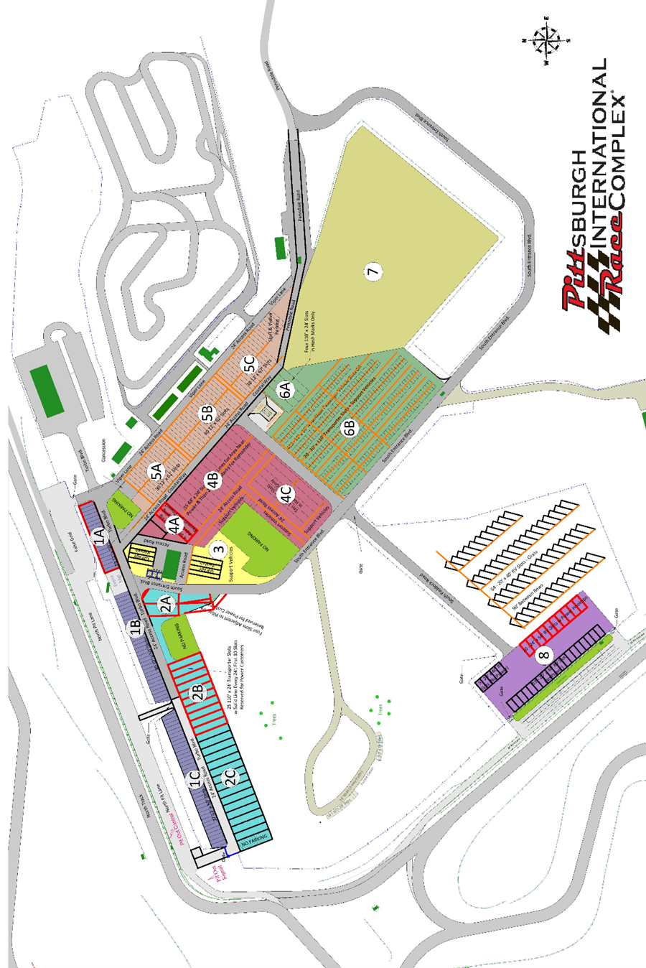
NEDiv Majors Event Schedule
Times are cars on course

Sunday, May 6, 2025

7:00 AM – 11:00 AM |  | Registration
7:30 AM – 11:30 AM |  | Tech Inspection/Scales
7:45 AM |  | Flag Meeting at the garage.
8:30 AM* | 20 Minute Qualifying 2, Group 6 |  | 2:30 PM | Time Trial Group 1 (20-minute session)
 | 16 lap Race 2 (35-minute max), Group 1 |  | 2:50 PM | Time Trial Group 2 (20-minute session)
 | 16 lap Race 2 (35-minute max), Group 2 |  | 3:10 PM | Time Trial Group 1 (20-minute session)
 | 16 lap Race 2 (35-minute max), Group 3 |  | 3:30 PM | Time Trial Group 2 (20-minute session)
 | 16 lap Race 2 (35-minute max), Group 4 |  | 3:50 PM | Time Trial Group 1 (20-minute session)
12:00 PM | LUNCH (1 Hour) |  | 4:10 PM | Time Trial Group 2 (20-minute session)
1:00 PM* | 16 lap Race 2 (35-minute max), Group 5 |  | 4:30 PM | Time Trial Group 1 (20-minute session)
 | 16 lap Race 2 (35-minute max), Group 6 |  | 4:50 PM | Time Trial Group 2 (20-minute session)

