###### 

###### SCCA OFFICIALS

Chief Steward Bob Neff

Chief Instructor/Event Chair Brad Flack

Chief Safety/Tech Tim Boesche

Chief of Grid Allison Flack

Chiefs of Timing Phil Adams

Taylor Burnidge

**Finish Line Texaco @ Track**

VP Pump & VP Leaded & Unleaded Race Fuel

**Motorsports Ranch:**

[www.motorsportranch.com](http://www.motorsportranch.com)

(817) 512-3162

**Race Supplies:**

**Performance Speed Tech**

215 Performance Ln., Bldg. i

Cresson, TX 76035

877-512-5180

[www.performancespeedtech.com](http://www.performancespeedtech.com)

**You may bring your own gasoline in five gallon Containers only. No drums permitted.**

**Event Registrar:**

Sherrie Ledbetter

1937 Autumn Drive

Keller, TX 76262

solodays9@gmail.com

**Club Trial Registration:** [**www.motorsportreg.com**](http://www.motorsportreg.com)

**Pre-registration is required, and entries are limited.**

**Entry Limits:**

**TE – maximum of 18**

**CT – maximum of 64**

**Held under the 2017 SCCA Time Trials Rules**

**SCCA Sanction Numbers:**

**17-TE-xxxx-S; 17-CT-xxxx-S**

**Area Hotels:**

**Best Western Granbury Inn**

1517 Plaza Drive

Grandbury TX 76048

817-573-4239

**Quality Suites Inn**

800 Harbor Lakes Drive

Granbury TX 76048

817-573-4411

**Knights Inn-Cresson**

9120 E Hwy 377

Cresson TX 76035

817-396-4480

**Motor Sport Ranch 1.3mile CCW**

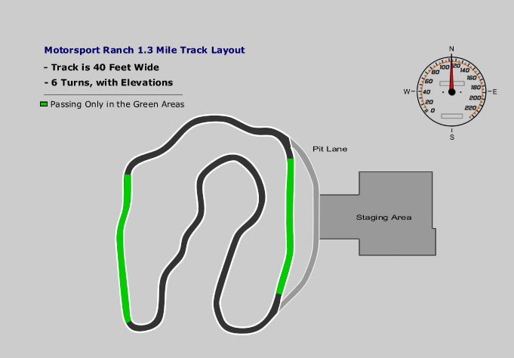

**Event Schedule**

**Saturday, Aug. 246, 2019**

6:30am Track gate opens

7:00am-7:45am Check-In/Registration in Club House

7:45am-8:30am Mandatory Drivers Meeting in Club House

8:30am Group 1 Instructors on track, 20 min Groups 2-3 TE in upstairs classroom

8:50am Group 2 CT on track, 20 min session

9:10am Group 4 CT on track, 20 min session

9:30am Group 3 TE on track, 20 min

9:50am Group 1 Instructors on track, Groups 3 in upstairs classroom

10:10am Group 2 CT on track, 20 min session

10:30am Group 4 CT on track, 20 min session

10:50am Group 3 TE on track, 20 min session

12:10 Lunch (Workers/Instructors Lunch Provided)

1:00pm Group 1 Instructors on track, 20 min session

Groups 3 in upstairs classroom

1:20pm Group 2 TE on track, 20 min session

1:40pm Group 4 CT on track, 20 min session

2:00pm Group 3 TE on track, 20 min session

2:20pm Group 1 Instructors on track, 20 min session

Groups 3 in upstairs classroom

2:40pm Group 2 CT on track, 20 min session

3:00pm Group 4 CT on track, 20 min session

3:20pm Group 3 TE on track, 20 min session

3:40pm Group 1 Instructors on track, Groups 3 TE in upstairs classroom

4:00pm Group 2 CT on track, 20 min session

4:20pm Group 4 CT on track, 20 min session

4:40pm Group 3 TE on track, 20 min session

**RACE GROUPS**

1. Instructors CT Group 1
2. Club Trials Street Classes Group 2
3. TE Group 3
4. Club Trials SM/Prepared Classes Group 4

Race Groups may be revised by the Chief Steward.



**MSR 1.3-mile Course Counter Clockwise**

**Notice:** Race Control uses FM frequency 88.9. All cars should tune their FM radios to that frequency.