Memorial Monster Time Trials
A SEDiv Time Trials Championship Event & PDX
Hosted by Central Carolinas Region, Sports Car Club of America
Carolina Motorsports Park, Kershaw, SC – May 30, 2016
This event will be held in conjunction with the SCCA Club Racing events occurring Saturday and Sunday, May 28-29. It is to be governed under the 2016 SCCA General Competition Rules (GCR) and the 2016 SCCA Time Trial Rules and SEDiv TT Class Rules. Further Amendments may also be published in these Supplemental Regulations.
SANCTION # 16-PDX-4285-S and SANCTION #16-TT-4286-S
GCR Classes: FA, FB, FC, FE, FF, FS, FST, FV, FM, F5, ASR, P1, P2, SRF, LC, STU, STL, GT1, GT2, AS, EP, HP, T1, T2, T3, T4, ITA, ITB, ITC, ITR, ITS, Spec Miata, SM5, B Spec.
Regional/TT Classes: SPECIAL (SP), VO, VC, CF, SPO, SPU, GTA, IT7, IT7R, ITO, SU
SOLO Classes: SSP, ASP, BSP, CSP, ESP, FSP
SUNDAY, May 29
5:00 pm – 8:00 pm: Registration & Tech under the covered garage.
MONDAY, May 30
7:00am – 9:00am: Registration and Tech under the Tech shed.
7:15am– 7:45am: Worker meeting behind the Timing Tower.
7:15 am – 7:30 am: Mandatory PDX Drivers meeting in front of the Timing Tower.
7:30 am – 8:00 am: Mandatory Drivers meeting in front of Timing Tower.
If inclement weather, workers meet inside the Timing Tower, Drivers meet under the Picnic shelter.
8:00 am – 11:59 am: PDX and Timed TT runs by group.
12:00 – 1:00: Lunch
1:30 – 4:30: PDX and Timed TT runs by group.
5:00 pm: TT Trophy Presentation.

Registration:
Registration may be entered at www.motorsportreg.com or completed entry forms with check mailed to Vicki Eckerich REGISTRAR, PO Box 1044 Fletcher, NC 28732. Email communication is preferred at Vicki@ccrscca.com. Make checks payable to CCRSCCA. Late entries will be accepted at the track per the schedule. A full refund will be made if the entry is withdrawn prior to the car accessing the course.
TT drivers Eligibility: All Track trial drivers must hold a SCCA Time Trials License or a Time Trial Novice Permit. SCCA Club Racing Competition Licenses, as well as licenses from other sanctioning bodies are accepted with SCCA membership. NASA Time Trial licenses are also accepted.
TT Helmet: All helmets must be SA05 or later.
Transponders: CMP will have a transponder loop for timing laps, therefore all TT competitors will be required to have a transponder. Rentals may not be available.
TT Tech: All driver and vehicle safety equipment must meet current GCR and/or TTR specifications for a level 3 event. All entrants must have a vehicle log book complete with pictures and log book numbers.
TT Running order: Groups will be open wheel and closed wheel, group makeup will given during the drivers meeting. Cars will be gridded in group after the first run relative to times by the grid Marshall. Passengers: Passengers will not be permitted in any racing vehicle during timed runs.
PDX Driver Eligibility: Entrants must be a SCCA member and have a valid state driver’s license. If you have a SCCA PDX participation log Book, bring it with you. If you do not have one, ask for one at registration. Log Books must be checked by the Chief PDX driver instructor or designee prior to participation. Drivers must wear as a minimum a sleeved shirt and long pants as well as appropriate footwear covering the entire foot. No open shoes or sandals.
PDX Tech: Bring your completed inspection form to tech.
TRACK: Carolina Motorsports Park’s East Course of 1.279miles length with 9 indicated turns will be utilized for the event’s Time Trial course.
Everyone entering the facility must sign both the track and SCCA waiver. When reentering the track only your wrist band needs to be presented to the security guard.
Camping will be available at no additional cost to participants. Showers and restrooms are available on site. Electricity is available from the track per their fee schedule. Fuel is available (Credit card self service purchase only).No parkingor vehicle jacking on paved roadways. Pets must be restrained or on a leash at all times. Use of intoxicants prior to the end of the day’s competition is prohibited.
Insurance:
Participant insurance will be provided in at least the minimum amount required by the SCCA.

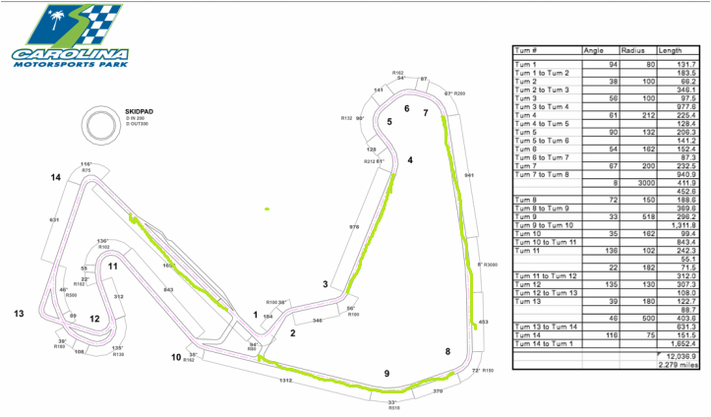
Track Trial/ PDX Passing Zones in Light Green (Course length 2.279 mi)

Chief Steward: Brian Gause
Race Chair:
Safety Stewart: Tony Wentworth
Registrar: Vicki Lanning Eckerich
Chief Instructor: Robert McManus

CentralCarolinasRegion,SportsCar ClubofAmerica EntryForm SEDivTimeTrialsChampionship Event &PDX
Carolina Motorsports Park,May30,2016 -Sanction #

TT/PDXEntryForm

Entry: SEDIV Championship TimeTrial $150

SEDIV TimeTrial &PDXInstructor$75(PDXInstructors Selected fromapplicants).

PDX $150

. MAKE ALL CHECKS PAYABLE TO CCR-SCCA.
SEND TO: Vicki LanningEckerich- REGISTRAR

PO Box 1044

Fletcher, NC 28732

Make: Model: _Color: Year:

AMBTransponder Number _

Number Desired: _2ndChoice: Is1stChoice aSEDivTimeTrialsReserved Number? Yes No

Driver Name: SCCAMemberNumber:

Address: Phone:

City: _State: Zip: Fax:

Comp. Lic. No. Grade: Regionof Record: Email:

I agreetoenterunder theGeneral CompetitionRulesof theSports CarClubof America, Inc., TimeTrial Rules and Supplemental Rules pertainingtothis event.I furtheraffirmthatthecar I haveentered complieswith all requirements for theclassandcategoryinwhich itis listed above.

OFFICIALUSEONLY

Group No:
Car No: Class: Postmark: AmountPaid:

Cash/CheckNo: DriverLicenseNo: Exp. Date:

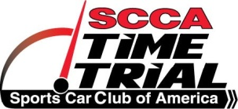 TECH SHEET
Complete this sheet before coming to the track and bring it with you.
Driver: _____________________ Run Group: __________________ Car #: ______
Car Make:_____________ Model:______________ Color:_____________ Year: ____
The entrant/participant is responsible for the safety of his/her vehicle. Neither the tech inspectors, the event organizers, nor the sanctioning body will be held responsible for the safety of this vehicle. Have a qualified mechanic check over your car and make certain everything is in good working order for an event such as this. Event tech inspectors will inspect those items listed as required. Please have all the items listed above as required items out prior to entering the inspection line, along with this form.
DRIVER SAFETY  ____ Helmet (Snell M/SA 2000 or newer, SFI, FIA)  ____ Shoes must be solid and in reasonable condition  ____ Seatbelts/Harness must be in good condition ____ A Proper ROLLBARwhen it is required  ____ Rollbar padding  ____ Seats bolted securely  ____ Interior & trunk clear of loose items  BRAKES  ____ Pads are less than half worn  ____ Fluid is clear. Reservoir is full. Dot 4 recommended.  ____ Pedal is firm  ____ All Brake lights are working  ____ Master Cylinder/Calipers are not leaking  ____ Rotors have no cracks or discoloration  TIRES & WHEELS  ____ Adequate tire tread, speed rating, good condition  ____ All lug nuts present & torqued  ____ Hubcaps removed  ____ Wheels - No cracks or structural damage | SUSPENSION & STEERING  ____ Wheel bearings - no play  ____ Ball joints in good condition ____ No excessive steering play.  ____ Shocks - no leaking  ENGINE & DRIVE TRAIN  ____ Check all fluid levels, belts, and hoses. Tighten all caps  ____ No fluid leaks (oil, fuel, water)  ____ Battery secured (no bungees)  ____ Battery terminals covered  ____ Overflow containers present  ____ Exhaust system functional (may have to meet sound restrictions)  ____ Throttle has quick, positive return  ____ Fuel cap tightened  OTHER  ____ Windshield has no large cracks  ____ Windshield wipers function properly  ____ Outside & Rear View mirrors  ____ Car numbers visible on both sides of car

Signed: ________________________________________________________Driver/Mechanic

