Safety Level 2.

First, all of Safety Level 1 is followed, maintained, serviced, and otherwise made good. Then we stack on Safety Level 2.

- Overview

Safety Level 2 generally means an appropriate racing-specific seat, 4-point roll bar, 5-point racing harness, arm restraints or window net, and fire-retardant helmets and clothing.
All vehicles required to meet Safety Level 2 Standards must meet the Safety Level 1 Standards, plus the additions below.
- Vehicle Equipment

  - Roll Bars

These specifications apply to all vehicles (other than those issued an SCCA Logbook before 1/1/19). Cars issued an SCCA Logbook before 1/1/19 may continue to compete with their previously approved rollover structure or comply with the following specifications.
A roll bar is defined as a main hoop and diagonal placed behind the driver and supplemented by two braces. The roll bar must be designed to withstand compression forces resulting from the weight of the car coming down on the roll structure, and to take fore-and-aft loads resulting from the car skidding along the ground on the roll structure. The basic purpose of the roll bar is to protect the driver in case the vehicle rolls over. Roll bars must meet the following criteria:
A. One continuous length of tubing must be used for the hoop member with smooth continuous bends and no evidence of crimping or wall failure.
B. The top of the roll bar must be above the top of the driver’s helmet when the driver is in normal driving position.
C. The two (2) vertical members forming the sides of the hoop must be more than 15 inches apart (inside dimension), and it is desirable that it extend the full width of the cockpit.
D. An inspection hole of at least 3/16 inch diameter to facilitate verification of wall thickness may be required. It must be drilled in a non-critical area of a roll bar member at least three inches from any weld or bend.
E. All bolts and nuts shall be SAE Grade 5 or better, 5/16-inch minimum diameter.
F. Braces and portions of the main hoop subject to contact by the driver’s or passenger’s helmet, as seated normally and restrained by seatbelt and harness, must be padded with a non-resilient material such as Ethafoam® or Ensolite® or other similar material with a minimum thickness of 1/2 inch. Padding meeting SFI spec 45.1 or FIA 8857-2001 is strongly recommended.
G. The size of tubing to be used for the main hoop, braces and diagonals shall be determined on the basis of the weight of the car. The following minimum sizes are required and are based upon the weight of the car without the driver. Dimensions are nominal; 0.010-inch variation in wall thickness is allowed.
Vehicle Weight  (Without driver) | Tubing Size (inches)  (outer diameter x wall thickness)
Up to 1,500 lbs. | 1.25 x 0.090
1,501–1,700 lbs. | 1.375 x 0.080
1,701–2,699 lbs. | 1.500 x 0.095  1.625 x 0.080
2,700 lbs. and up | 1.500 x 0.120  1.750 x 0.095  2.000 x 0.080
H. The roll bar hoop and all braces must be of seamless or DOM mild steel tubing (SAE 1010, 1020, 1025) or equivalent, or alloy steel tubing (SAE 4130). For cars logbooked before 1/1/16, existing ERW tubing is acceptable.
I. All welding should be of the highest possible quality with full penetration. Craters should be filled to the cross section of the weld and undercut should be no more than 0.01 inch deep.
J. All roll bars must be braced in a manner to prevent movement in a fore-and-aft direction with the braces attached within the top third of the roll hoop. At a minimum, two (2) braces must be used, parallel to the sides of the car, and placed at the outer extremities of the roll bar hoop. Such braces should extend to the rear whenever possible. Diagonal lateral bracing must be installed to prevent lateral distortion of the hoop. In most cases, a lateral brace from the bottom corner of the hoop on the side to the top corner of the hoop on the other side is sufficient. Although installing the diagonal lateral brace in the main hoop is the strongest alternative (and hence most preferable), there may be instances where such an installation is not practical. In such situations, the installation of the diagonal brace running from the bottom of the fore/aft brace on one side to the top corner of the hoop on the other side is acceptable. In convertible vehicles with a production line beginning 1990 or later, such as the Mazda Miata, a “V” design, also known as a “double diagonal” used between the rear supports is acceptable.
K. Removable roll bars and braces must be very carefully designed and constructed to be at least as strong as a permanent installation. If one (1) tube fits inside another tube to facilitate removal, the removable portion must fit tightly and must bottom on the permanent mounting, and at least two (2) bolts must be used to secure each telescope section. The telescope section must be at least eight inches in length. One (1) bolt is required if one (1) end is welded to the main hoop.
L. Roll bars and braces must be attached to the frame of the car wherever possible. Mounting plates may be used for this purpose where desired.
M. In the case of cars with unitized or frameless construction, mounting plates may be used to secure the roll bar structure to the car floor. The important consideration is that the load be distributed over as large an area as possible. A backing plate of equal size and thickness must be used on the opposite side of the panel with the plates through-bolted together.
N. Mounting plates bolted to the structure shall not be less than 0.1875 inch thick and the use of a back-up plate of equal size and thickness on the opposite side of the panel with the plates through-bolted together is recommended. A minimum of three (3) bolts per plate is required for bolted mounting plates.
O. Mounting plates welded to the structure shall not be less than 0.080 inch thick. Whenever possible, the mounting plate should extend onto a vertical section of the structure, such as a door pillar.
  - Seats
Seats must a one-piece, bucket-type race seat, be securely mounted and provide fore/aft and lateral support. Seats must accommodate, with appropriate routing, 5 (or more) point safety belts including sub-strap. OE seats may not be modified to accommodate belts, aftermarket seats must be installed per manufacture guidelines.

- Driver Restraints

A. All drivers shall utilize either a 5-, 6- or 7-point restraint harness.
B. The following harness requirements must be met:
1. Shoulder straps shall be separate.
2. Two inch shoulder straps shall only be used with head and neck devices.
3. All harnesses shall bear labels bearing either of the following SFI or FIA certifications:
a. SFI specification 16.1 or 16.
b. FIA specification 8853/1985 including amendment 1/92 or FIA specifications 8853/98 and 8854/98.
4. Harnesses shall be in good condition (no cuts, abrasions, abnormal wear, etc.). It is highly recommended that harnesses are not utilized past their expiration date.
5. The following steps shall be taken when threading harness through a harness bar
a. Figure 1
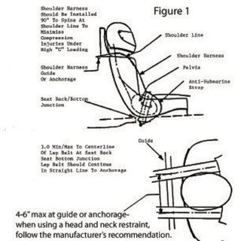
b. Figure 2
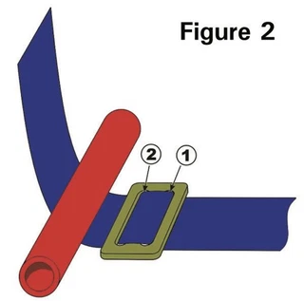
c. Figure 3
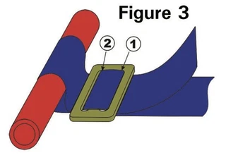
  - Figure 4
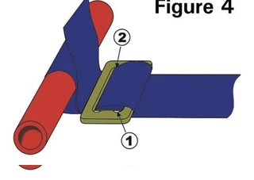
  - Figure 5
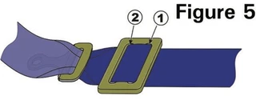
  - Figure 6
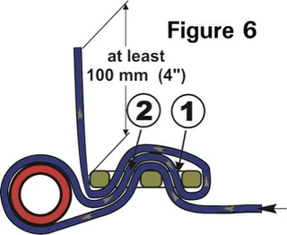

- Fire Suppression
A. All vehicles shall have a device (such as a fire bottle/fire extinguisher/fire suppression system) securely mounted with metal mounting brackets of the quick-release type within reach of the driver to suppress fires.
The device should meet at least one of the following minimum requirements:
1. On-board fire systems per SCCA Road Racing General Competition Rules (GCR).
2. Halon 1301 or 1211, 2 pound minimum capacity by weight.
3. Dry chemical, 2 pound minimum with a positive indicator showing charge. Chemical: 10 BC or 1A10BC Underwriters Laboratory rating.
Safety Level 2 Driver Gear
- Helmets - Safety Level 2 and 3
1. For Safety Level 2, helmets meeting one of the following standards are acceptable and must be worn while on course:
A. Snell Foundation Standards with Snell sticker 2015 or later for Special Application (SA2020, EA2016, SA2015).
B. SFI standards 31.1/2015, 31.1/2020
C. FIA standards 8859-2015, 8860-2010 or newer.
2. For drivers of any vehicle without a DOT-approved windshield (such as kit-cars, Sports Racers, Formula Cars and Specials) or any other vehicle with less than standard-sized windshield, helmets meeting these additional criteria are required:
A. Helmets must be full face.
B. A shield, preferably made of impact-resistant materials, shall be used while on course (conventional eyeglasses are not sufficient).
- Driver Clothing - Safety Level 2 and 3
1. Driving suits shall meet one of the following standards:
A. FIA standards (8856 -1986, 8856-2000 or 8856-2018).
B. SFI 3-2A/5 or higher (e.g., /10, /15, /20) certification.
C. Suits carrying SFI 3-2A/1 certification may be worn only with fire resistant underwear.
D. Gloves made of leather and/or accepted fire-resistant material containing no holes.
E. Socks made of accepted fire-resistant material.
F. Face coverings (balaclavas) of accepted fire-resistant material for drivers with beards or mustaches.
G. Shoes, with uppers of leather and/or nonflammable material that, at a minimum, cover the instep
- Driver Accessory Gear - Safety Level 2 and 3
1. For drivers of any vehicle where the compatibility of belts and seats meet the use of head and neck support systems, the use of a head and neck support system is highly recommended.
2. For a track-based event (Time Attack/TrackSprint) a driver’s-side window safety net or arm restraints are highly recommended for all cars.
3. For a HillClimb event, arm restraints are required in any open car and a window net or arm restraints are required for closed cars.

