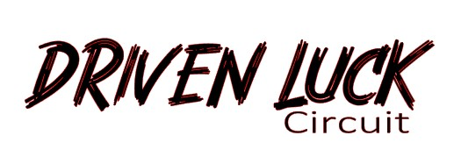

550 Brewers Point Court . Bryant, Alabama 35958 . drivenluck@gmail.com

Rules and Regulations
Failure to follow rules and regulations will
result in removal from track with no refund!

- Speed limit is 5mph if not on track.
- There will be NO drinking (or substance use) while driving. You will be asked to pack and leave immediately. Driving while altered will NOT be tolerated! After the track closes or you are finished driving, have at it!
- All drivers/ passengers on track must wear seat belts or harnesses.
- All drivers must wear 2015 or newer Snell approved helmets.
- Be consistently aware of other drivers and flagger locations.
- Hands should be kept inside of the car at all times!
- One spin rule applies! Spin and move.
- All cars must have an exhaust system. No straight pipe exhausts.
- Change tires before you have to. If they are bald or cords showing, you will be asked to stop driving until changed.
- If you suspect a fluid leak, pull off track.
- All vehicle body panels should be securely attached.
- Do NOT get out of your car! In the event of an accident or mechanical failure, stay in your car until an official gets to you. The only exception is fire.
- Please place all trash in the receptacles provided. Keep your pit area clean. There is plenty of wildlife around. We do not want them looking at our pit area as a buffet. Before an overnight stay, please ensure all food is secure.
- If you are staying overnight at the track, quiet hours are 11pm-8am.
- At the end of the day and during breaks, brooms will be available to assist in cleaning the track. Please do your part.
- Before exiting the facility, please ensure you are leaving your pit area as you found it.

The Track Office are 8:00am-9:30am, 11:00am-12:30pm, and 3:30-dark. You may purchase ready to heat breakfast foods, coffee, snacks and Driven Luck merchandise. We also stock zip ties, electrical tape, hose clamps, etc.

Tech will begin at 8:00am. If you arrive later than 8:30, you will have to wait until a designated inspector is available for track approval. You cannot go on track without an approval sticker.

Driver’s meeting and track walk at 9:00am.

Track will be hot immediately following meeting.

