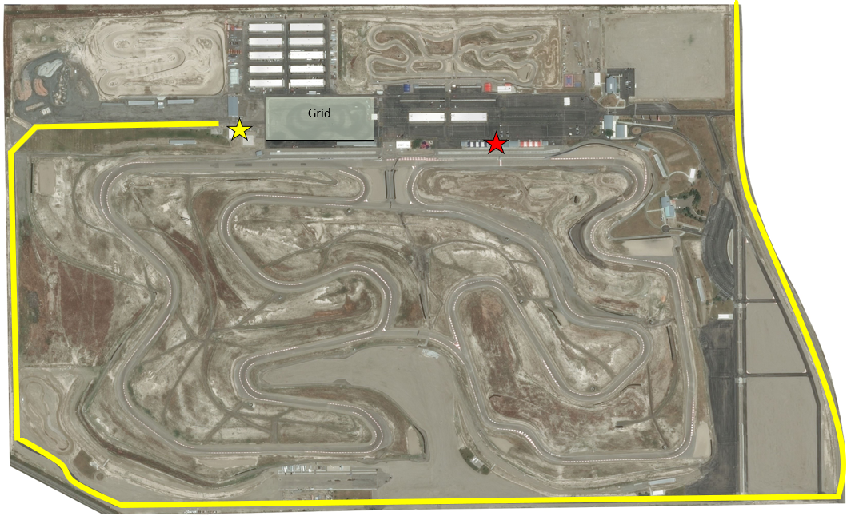
DRIVERS
- Please arrive between 3:00pm and 4:10pm.
- Check in at the tent
- Park in Grid – walk to drivers meeting.
- Mt. Suites Driver’s Meeting at 4:30pm
- 2nd Driver’s Meeting in Mt. Suites at 6:45pm.
- No check in’s after 6:45pm

