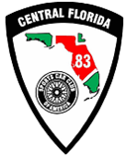

Central Florida Region Building Maintenance and Improvement’s Weekend
OCT 14-15-2023, 8am start for both days.
This event is open to all CFR Members, Specialty Chiefs and Worker’s.
Work to be accomplished:
- Green Park Building Porch Top Rail removal and replacement.
- Repaint of Grid Lines
- Green Park compound debris removal and fill in holes from 12 Hour.
- BMC Building General clean up and repacking of shelves, Equipment inventory.

Compound will be open for camping

