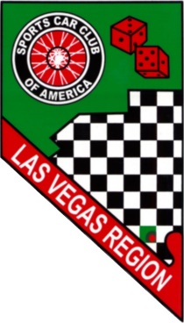
Las Vegas Region SCCA Track Event
LVMS Outside Road Course
April 17, 2022

Drivers Information Packet
Welcome to the LVRSCCA Track Event. This information packet has information that will help you get your day started and contains important information for the event. Track Events are experience-based events which give enthusiasts the opportunity to drive at speed on a closed course. You will share track and course space, however, this event is not a competition.

Tech (Start Here):
- Take your helmet and completed SCCA Tech Form to Tech Inspection for Tech signoff.
  - Download Tech Form from Motorsportsreg event registration
  - Effective January 1, 2022 SNELL 2005 helmets are not allowed
- If your car has any of the following features, take your car to Tech for Tech Signoff
  - Convertible
  - Aftermarket Seat
  - Aftermarket Seat Belts/Harnesses
  - Roll Bar/Cage
  - Non-DOT Windshield

Registration:/Waivers (After Tech form is signed)
- Registration and Waivers are in Outside Road Course Building
- All entrants must be current SCCA members or weekend members

Basic Course/Event Rules:
- Legible numbers on both sides of car
- Helmets and closed toe shoes are required
- Long sleeve shirts and long pants are recommended
- Entering Course, do not cross merge line
- On Course, don’t drive over pit entry line or pit out merge line
- Exiting Course, raise hand with closed fist to indicate to drivers behind you that you are exiting course, pit entry at beginning of exit line
- Vehicle breakdown: slow down in a controlled manner, pull off course if possible (Do not drive back to pits if you are leaking fluids)
- Self-report to Grid/Black Flag if you go 4 wheels off, spin or make contact with anything
- No passengers
  - Passengers allowed only during Parade Laps at Lunch time
  - Parade Laps Maximum speed 45 mph
- After each session (Advanced/ Intermediate/Advanced, Intermediate)
  - Park your car at your pit area
  - Immediately report to East side of ORC Building for Download with Instructor/Coach
  - Download after last session of day is voluntary
    - Get your logbook signed
- Novices will meet with Instructors for Training Session at 8:00am at designated location
  - Additional Training Session times will be announced at 8:00am Novice meeting

Passing:
- Advanced, Intermediate/Advanced, Intermediate Groups:
  - Passing anywhere on track with point-by
- Novice Group(s):
  - Passing on Front and Back Straights in marked Passing Zones
  - All passing on Right side of car being passed
- Only pass with point-by
- After giving point-by lift throttle to allow passing car to pass quickly
- If you want open space on course, enter hot pits and indicate you need space
Flags
Green. You’ll find this one at the starting/finish line. It generally indicates that the session is in progress, the track is clear and passing is allowed.
Yellow. If the corner worker is holding this flag still with both arms outstretched, it means passing is not allowed, due to a problem ahead. If the flagger is waving a yellow flag, it’s a sign to slow down and pay attention because there’s a problem immediately ahead.
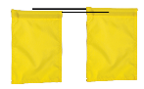Double Yellow. full course entire track is in Yellow Flag condition.
White. Slow vehicle ahead. You may pass with point-by. Displayed on warm up lap.
Passing – Blue with a diagonal yellow or white stripe. This tells you that there are faster cars behind you that you should allow to pass.
Debris – Vertical yellow and red stripes. This flag indicates that something potentially hazardous is on the track ahead (dirt, leaked fluids, an animal, etc.) and you need to be cautious.
Black. If you see a black flag, you need to pit in, either because there’s something wrong with your car or there’s something about your driving that needs to be addressed. Ignoring a black flag can get you removed from the event.
Mechanical – Black flag with orange spot. This flag indicates that you have a mechanical problem such as a noticeably loose or missing part or a fluid leak. When you see this flag, slow down, pit in and find out what’s going on.
Emergency – Red. The red flag tells you to check your mirrors and come to a stop off of the line, near next flag station. It indicates that something has happened that requires a clear track for emergency responders.
Checkered – Black and white checks. This marks the end of the session and lets you know to begin your final cooldown lap and then pit in. Passing is not allowed during this final lap.
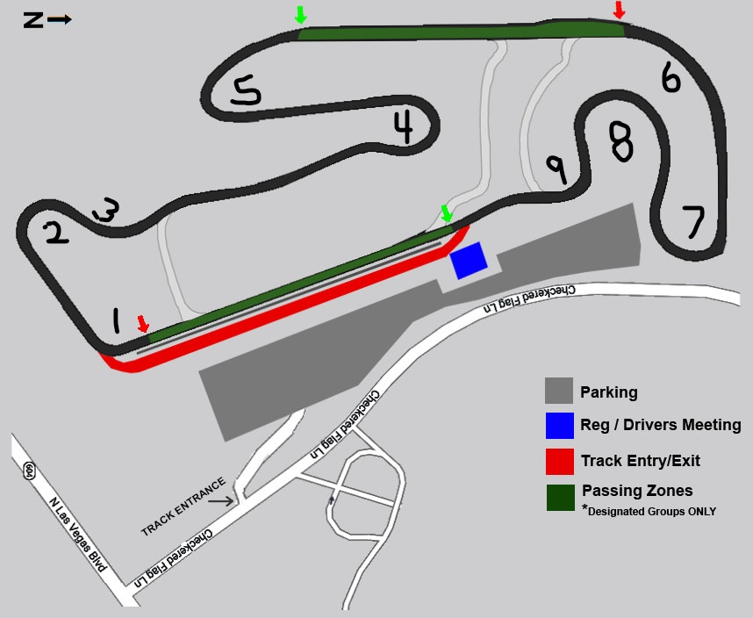
Schedule

Group | Start Time
Advanced | 8:00am | (20-minute session)
Intermediate/Advanced | 8:25am | (20-minute session)
Intermediate | 8:50am | (20-minute session)
Novice | 9:15am | (20-minute session)
Worker Break | 9:40am – 9:50am | 10-minute worker break
Advanced | 9:50am | (20-minute session)
Intermediate/Advanced | 10:15am | (20-minute session)
Intermediate | 10:40am | (20-minute session)
Novice | 11:05am | (20-minute session)
Lunch | 11:30am – 12:30pm | 1-hour lunch
Parade Laps | 11:45am – 12-10pm | 25 minutes
Advanced | 12:35pm | (20-minute session)
Intermediate/Advanced | 1:00pm | (20-minute session)
Intermediate | 1:25pm | (20-minute session)
Novice | 1:50pm | (20-minute session)
Worker Break | 2:15pm– 2:25pm | 10-minute worker break
Advanced | 2:25pm | (20-minute session)
Intermediate/Advanced | 2:50pm | (20-minute session)
Intermediate | 3:15pm | (20-minute session)
Novice | 3:40pm | (20-minute session)
End of Day | 4:05pm
6:00am Gate Opens
6:30am Registration & Tech open
7:30am Registration & Tech close
7:30am Driver’s meeting
7:55am 5-minute board for 1st group
6:00pm Gate Closes

