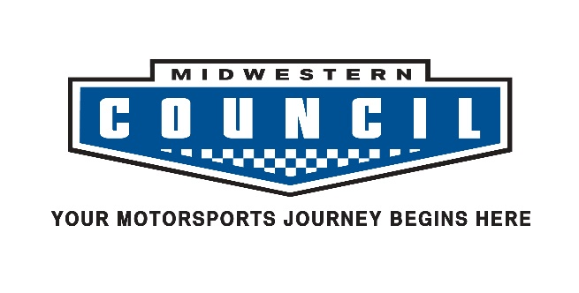
2021 License Renewal/ Provisional Application
for
Wheel – To – Wheel Competition

Name:
Address:
City, State Zip:

Home Phone:
Work Phone:
E-Mail:
Club:
Date of Birth:

Have you ever held a Midwestern Council Competition License? YES NO
If YES, previous license number and type? _____________________________________________________

Have you held a Competition License with another organization? YES NO
If YES, with what organization(s) and what level license(s)?

Have you had any medical problems in the last 12 months that would fall under MC GCR Sec’s 3.1.1.1.2 YES NO

If YES please list: _____________________________________________________________________________

I CERTIFY THE ABOVE INFORMATION IS CORRECT AND VALID

DATE: SIGNATURE:

INSTRUCTIONS FOR FILING:

1. | Be sure to join the MC club of your choice on MotorSportReg (msreg.com) for 2021.  You can also now apply for a license at msreg.com/MC-2021CompLicense as well!
2. | If current medical (completed within past 2 years) is not on file, visit your doctor and have him/her complete the medical form. (Available at: https://www.mcscc.org/forms/MCSCC-MedicalForm-2021-2022.pdf )
3. | License Fee schedule below. Make check out to MCSCC.
4. | Answer all questions.
5. | Sign and Date application.
6. | Make copies of all of your documentation before mailing it.
7. | Mail Application and Medical to the Licensing Director at the address below.  Licensing Director License Fee Schedule  Rob Woelfle Type Before 4-9-21 After 4-9-21  W1389 County Rd C Novice $45 $55  Brooklyn WI 53521 Full Comp $45 $55  Licensing@MCSCC.org Provisional $75 $75  608 712 4605 5pm – 8pm only MPL $45 $55

