The SCCA strives to ensure that ALL participants in its events and activities enjoy a welcoming environment. The SCCA supports equality of opportunity and treatment for all participants and will make every effort to maintain an environment that is free of harassment, discrimination, and any behavior that interferes with a safe, fun, and exciting experience. A commitment to a welcoming environment and the SCCA Values is expected of all its members and attendees, including drivers, workers, crew, guests, staff, contractors and exhibitors, and other participants at SCCA activities, sessions and social events and when representing the SCCA in print or electronic media.
SUPPLEMENTAL REGULATIONS
This event is governed by the 2025 General Competition Rules (GCR) and Category Specifications, as amended for 2025 per “Fastrack” and these Supplemental Regulations

- REGISTRATION and FEES
- TRACK EVENT DAY: Steel Cities Region will hold a Track Event day on Friday, May 2nd, 2025. Additional information is available on MotorsportsReg. The Track Event is a SCCA sanctioned event. Participants in the Track Event day do not have to be entered in the Majors, they do however have the appropriate license to run in any of the race car groups. In the Race Experience group, we are requiring all novice drivers to participate in their own Practice session.

- ENTRY FEES: The entry fee is $695.00 per entry. Each SRF3, FE2 entry will be charged an additional $30.00 compliance fee per entry for the weekend. Each SM and SMX entry will be charged an additional $20.00 compliance fee per entry for the weekend. Late registration fee (walk ups) is $50.00.

- PAYMENTS & REFUNDS: Register online at MotorsportsReg. Drivers without internet access may request a paper entry form and mail it with their entry fees to the Registrar.
- Payment Options: There are three (3) ways to pay your entry fee:
  - By credit card via MSR. All entries will not be charged until they register for either the Track event or the Majors. If you are at the track and qualify for a refund see the registrar. There will be no refunds once a wheel is turned on track in any session.
  - Mail a check to Beth Anselm, 6334 Helen St, South Park, PA 15129 at least 1 week before the event. If paid by check, contact the registrar for a refund.
  - Pay at the track (cash or check)

- PASSES: Hot crew must be SCCA members (weekend memberships are available at $25.00). There is no charge for guests who are in the paddock.
- PADDOCK AND GARAGE RESERVATION: Garages and Electric Spots:
  - A limited number of enclosed garages and paddock spots with electrical connections are available for rent on a first come/first serve basis.
    - Rentals are for the duration of the event weekend (Thursday at 6:00 pm through Sunday Evening).
    - For 2025, Steel Cities Region is managing the purchase of these spaces within MSR registration for the event.
  - General Camping at the track is included with purchase of electric spot rentals.
    - These rentals are non-refundable.
  - North Track Paddock Spot Reservation:
    - A limited number of North Track Paddock Spots are available for reservation.
  - General Camping at the track is available with a $10 fee, see track map for available locations.
  - Rental Pricing (per spot for duration of the weekend)
    - Garage: $350
    - Electric: $155
    - North Track Paddock Spot Reservation: $35
    - General Camping: $10
  - NOTE: Payment for rentals and reservations will be charged with event fees at the time of MSR registration submission!
- PREFERRED NUMBERS: Every effort will be made to honor Conference Preferred Numbers until 14 days prior to the event. However, due to the make-up of the run groups, this may not be possible in all situations. If two drivers holding the same Preferred Number request that number for the same run group, the number will be assigned to the driver with the earliest request.

- PADDOCK/PARKING INFORMATION: PittRace is a multiple use facility. Paddock parking for this event is areas 1B, 1C, 2A, 2B, 2C, 4A and 4B as shown on the attached track map.

- DRIVER INFORMATION
- DRIVER ELIGIBILITY: Each driver must be a current member of the SCCA and hold a SCCA Full Competition license to participate in this event. SCCA Pro Racing licenses are not accepted. If you do not have the proper credentials, it is your responsibility to contact the Registrar prior to the event.

- CAR ELIGIBILITY: Competition is open to all cars conforming to the GCR, as amended, for all Majors-Eligible classes

- TIMING & SCORING: All cars are required to use fully operational MyLaps (formerly AMB) transponders, and the driver is responsible for providing correct information to Timing & Scoring. Make sure your transponder is on and functioning for ALL SESSIONS. Information gathered from personal timing and data collection systems is unofficial and will not be used by race officials. Cars without working Transponders will not receive times.

- COURSE: The track length is 2.78 miles for the Full Course (the North and South combined circuits in a Clockwise Direction).
- BLACK FLAG: The Black Flag stations are Driver’s left at Stations 7 and 12 and the Start/Finish. When you are black flagged, report to the Black Flag (SOC) Pit (Pit #1) and wait for an official to clear you to resume driving.
- CHECKERED FLAG: For Practice and Qualifying Sessions, the Checkered Flag will be displayed at Stations 7, 12 and Start Finish. Competitors will exit the track at pit in at the first opportunity.
- HARDSHIP LAPS: Hardship laps will be available for a limited number of cars between sessions, time and schedule permitting. A hardship lap is defined as a single lap from pit out to pit in. To request a hardship lap, please visit the Race Director or Chief Steward.

- AWARDS: Trophies for all races will be awarded in accordance with the GCR. Trophies will be presented at the event. SCCA U.S. Majors Tour points will be awarded in accordance with the GCR and these Supplemental Regulations.

- VICTORY LAPS: Winners of all races will receive a checkered flag. There will be no victory laps.

- CAR SAFETY and TECH INSPECTION
- DECALS: Competition vehicles must display the official SCCA Road Racing decal per GCR section 9.3.29.C (Figure 4.) Stickers will be provided free of charge and may be obtained at registration and/or tech. (The official SCCA Summit Racing Equipment Road Racing decal does not serve as the Summit Racing Equipment contingency program decal.)

- DATA ACQUISITION: U.S. Majors Tour staff and their delegates may install data acquisition equipment in a competitor’s car. This program is to assist the CRB in performance balancing. If selected, participation is not optional and is not pro-testable. The data collected from the device will not be used for compliance purposes. All cars carrying an SCCA data collection device must report to impound after their session. Failure to do so may result in penalties.

- SCALES: Availability of scales and times will be posted at Tech. Scales will not be available for general use during impound.

- SPEC MIATA & SMX COMPLIANCE: At post-race inspection, Spec Miata and SMX participants may be instructed by the designated Class Compliance Chief (CCC) to remove parts, including but not limited to the cylinder head, for disassembly and/or inspection. Competitors are responsible for performing required disassembly and/or reassembly of their car, as well as any resulting expenses incurred. The CCC will report any findings of non-compliance to the Race Director, who will then determine the need for a Chief Steward’s Action (CSA) or Request for Action (RFA).

- QUALIFYING
- GRID:
- Qualifying 1: Starting positions for the first sanctioned, official on-track session will be set using the order by which drivers registered for the event, first come, first to grid.
- Qualifying 2: Grid positions for qualifying session 2 will be determined by a driver’s fastest lap during the qualifying 1.
- Race 1 (Saturday): Grid positions for race 1 will be determined by the driver’s fastest lap in qualifying 1.
- Race 2 (Sunday): Grid positions for race 2 will be determined by the driver’s fastest lap during competitive sessions during the weekend.

- QUALIFYING: A driver not qualifying within a maximum of 120% of the recognized track record of their class must obtain permission from the Race Director to race. In the case of unusual circumstances, the Race Director can waive this rule for the entire event.
Class | 120% | Record | Class | 120% | Record | Class | 120% | Record
AS | 2:15.11 | 1:52.59 | FX | 2:04.22 | 1:48.02 | SM | 2:19.48 | 2:01.29
B-Spec | 2:34.31 | 2:08.59 | GT1 | 1:54.96 | 1:39.97 | SRF3 | 2:15.12 | 1:52.60
EP | 2:20.32 | 1:56.86 | GT2 | 2:03.54 | 1:42.95 | STL | 2:19.15 | 1:55.96
F5 | 2:08.65 | 1:47.21 | GT3U | 2:11.96 | 1:49.97 | STU | 2:15.66 | 1:53.05
FA | 1:53.08 | 1:34.24 | GTL | 2:12.46 | 1:55.18 | T1 | 2:07.28 | 1:46.07
FC | 2:00.49 | 1:40.41 | GTX | 1:54.96 | 1:39.97 | T2 | 2:13.80 | 1:51.50
FE2 | 1:54.39 | 1:39.47 | HP | 2:27.61 | 2:02.61 | T3 | 2:19.13 | 1:55.94
FF | 2:09.11 | 1:47.59 | P | 1:59.70 | 1:39.75 | T4 | 2:23.86 | 1:59.88
FP | 2:17.96 | 1:54.97
FV | 2:23.06 | 1:59.22

- RACE: A driver who is unable to maintain a safe pace during the race may be black flagged.

- IMPOUND
- MANDATORY DRIVERS MEETING: A Drivers Meeting will be held at the end of the first qualifying session for each group. Impound All will be given at the end of the First Qualifying session. Impound will be in the Tech Area. Look for the signs for proper location. Drivers who do not participate in the Qualifying session should attend the Drivers Meeting.
- SPLIT STARTS: The Race Director will consider requests for split starts at the Drivers’ Meeting.
- IMPOUND: Saturday races: The top three competitors in each class shall report to impound immediately following the completion of their race. Trophy presentations and photos will occur in the Victory Circle area near impound following the race. Sunday Races: Impound all following completion of the race for podium ceremonies. Victory celebrations and award ceremony will be conducted in the Victory Circle area near impound following Sunday’s races.

- CONTACT: GCR Section 6.11.1.E requires that the driver and car, involved in significant body contact, to stop at the designated incident investigation site, which shall be impound, for review of the incident by stewards or satisfy this requirement by reporting to the Race Director or Chief Steward during Impound of their sessions. Drivers who do not satisfy this requirement will be referred to the Stewards of the Meeting (SOM).

- GENERAL
- RACE LENGTH: Saturday races will be 25 minutes. Sunday races will be 35 minutes or 16 laps (not to exceed 50 miles unless approved.)

- STARTS: Starts will be conducted per GCR.

- RACE CLOCK: The Race Clock will be started for either a timed or lap race when the lead car crosses the time loop/Start-Finish weather or not the race is started or aborted after the prescribed pace lap(s). The Race Clock will not be stopped under a Red Flag situation or directed by the Race Director. In the case of a long delay and the time limit for either a lapped or timed race has expired, the Race Director may convert the race to a specific number of laps to allow for a “Green, White, Checker” to complete the race.

- LAST LAP: If/When the Last Lap indicator is given at Start/Finish, the next flag at Start/Finish will be a checkered flag (The lack of a Last Lap Indication is not protestable as a Last Lap indication is only a courtesy).

- RESULTS: Live timing may be available during the event on Race Monitor. Live timing information is neither official nor subject to protest. There will be no hard-copy distribution of results. Results will be available online on the Steel Cities website.

- START TIMES: Schedule times are cars on course.
1. For Qualifying, the session clock starts when cars are released from Grid.
- Race session clock starts when the first car crosses the Start/Finish control line after the scheduled pace lap.
- EVENT SCHEDULE / RUN GROUPS: We shall use a “Follow by Schedule”, meaning that the only groups to run ‘on time’ shall be those at the beginning of the day and after lunch. It is the driver’s responsibility to listen to the PA system and pay attention to activity on track. The schedule or run groups may only be changed (or start times advanced) at the discretion of the Race Director, with concurrence by the Event Chair, depending on pre-race entry counts or as needed to accommodate situations during the event.
- CANCELLATION: If part of an event is canceled for reasons of safety or forces beyond our control as provided by GCR Appendix B 1.2.A., points will be awarded based on race grids.

- CLOTHING: Safe apparel must be worn in the pits at all times including sleeved shirts, pants (long pants are strongly recommended), and closed toe shoes during the Majors event. Crew members on pit lane must display their event credentials at all times while on pit lane.

- PIT LANE: Drivers are to maintain a safe speed on Pit Lane with absolutely no racing.
- TIRE VENDOR: Stupid Fast Tires: rasrboy@hotmail.com

- FUEL PROVIDER: Facility pay-at-the-pump station. There is a Sunoco mandated security program in place that will limit you to three transactions on the same card in one day. If you think you will need more fuel, bring more than one card.
  - Leaded 110 Octane
  - Unleaded 100 Octane
  - Premium Unleaded 93 Octane (There are two pumps with 93 octane. They are dispensed from different tanks but are the same fuel)

- TRACK RULES

- All persons entering the track must use the SmartWaiver process prior to arriving at the track. Please use the waiver process for all attendees. The waiver link will be sent out 14 days prior to the event.
- All participants are subject to the PittRace Track Rules and Regulations. Copies of the current Track Rules are available at www.pittrace.com and are posted at the track. Violation of PittRace Rules and Regulations will be considered as violations of these supplemental regulations.
- QUIET HOURS: Running of un-muffled or loud engines is prohibited between 8PM and 8AM
- FACILITY DAMAGE: Damage to PittRace not covered by SCCA Insurance will be billed to the entrant by the region.
- UAV/DRONES: UAV/DRONE use is prohibited at PittRace.
- CAMPING: Camping is permitted at the track. Please see the PittRace policy Section I.
- PETS: Pets are permitted only in designated areas and must be leashed at all times. All pets must be kept under the control of their owner. Owners are required to pick up immediately after their pets and to dispose of waste in receptacles located throughout the facility.
- PARKING: No parking on the grass or in no parking zones.
- PAVED PADDOCK: All paved surfaces must be protected. All participants must use flat blocks or wood squares to absorb weight beneath any equipment that may cause damage to the surface, such as jack stands and kart stands. No holes will be permitted in any asphalt surface, including but not limited to the racing surface, pit area, VDA, and paddock area.
- WASTE PRODUCT DISPOSAL: All trash must be placed in proper containers. Do not place any petroleum products in trash containers. Oil disposal site is near the rear of tech garage. Participants must use properly marked containers for all refuse. Tires must not be left at the track Costs incurred by PIRC to handle or dispose of tires or trash left at the Facility will be billed to the entrant.
- VEHICLE TESTING: Vehicle testing, brake bedding, shift point checks, etc... on paddock roads is prohibited.
- FIRES: No open fires are allowed. Grills and like heating equipment may be used only in designated areas.

EVENT OFFICIALS
NE Majors Tour Race Director | Kathy McLeod
NE Majors Series Administrator | TBD
NE Majors Series Clerk of the Course | Matias Bonnier
Chief Steward | Gene Kern
Chairman of the SOM | Terry Hanushek
Assistant Chief Steward–Safety  (ACS – Safety) | Paula Hawthorne
Stewards of the Meeting (SOM) | TBD
SOC
Race Chairperson | Dan Dennehy
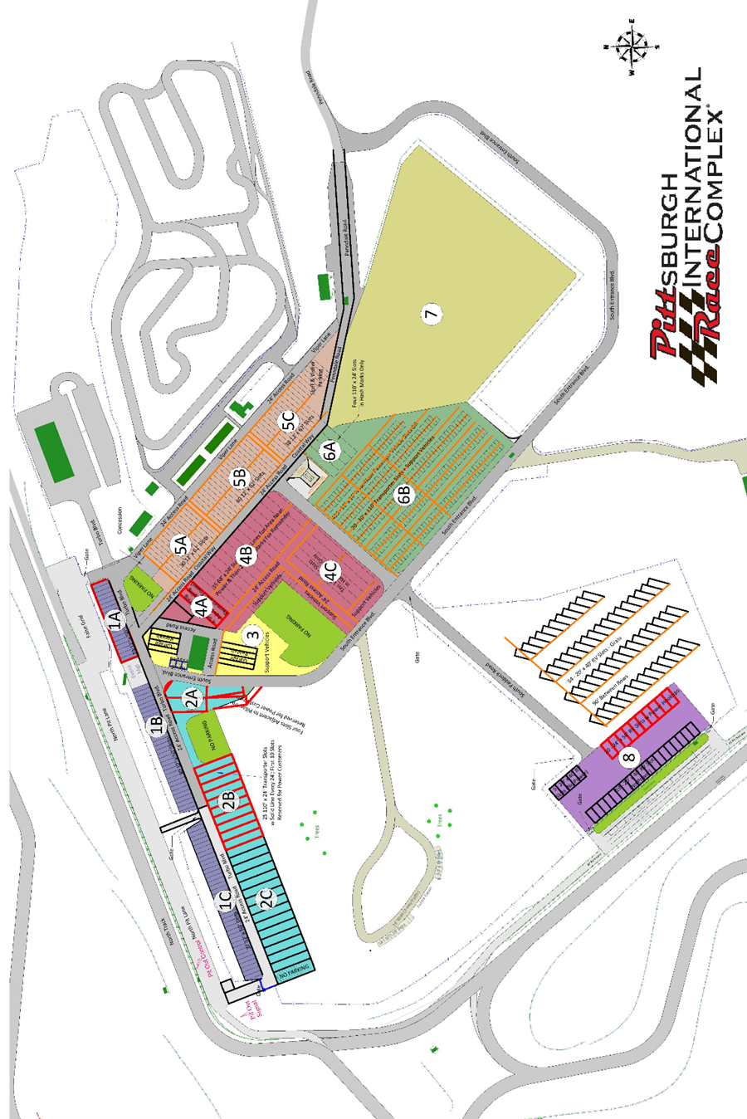
NEDiv Majors Event Schedule
Times are cars on course
Group 1 | Group 1 – SRF3 | Group 4 | Group 4 – SM, SMX
Group 2 | Group 2 – B-Spec, EP, FP, HP, STL, T4 | Group 5 | Group 5 – FA, FC, FE2, FX, P
Group 3 | Group 3 – FV, FF, F600 | Group 6 | Group 6 – AS, GT1, GT2, GT3U, GTX, STU, T1, T2, T3

Thursday, May 1st, 2025

6 PM | Track opens for competitor load in for those Participating in the Track Event. This is a hard entry time and no one will be permitted in earlier, so plan to arrive accordingly.
6 PM | Registration on the first floor of the timing and scoring building (Driver Information)

Friday, May 2, 2025

2 PM | Track opens for competitor load in for those not Participating in the Track Event
7 AM – 11 AM  5 PM – 8 PM | Registration on the first floor of the timing and scoring building (Driver Information)
7 AM – 11 AM  5 PM – 8 PM | Tech Inspection (Contact Chief of Tech for Annual Tech Appointment)  (Express Tech at Registration. Bring your logbook (and your helmet) if you need a 2025 sticker.)

Saturday, May 3, 2025

7:00 AM – 11:00 AM |  | Registration on the first floor of the timing and scoring building (Driver Information)
7:00 AM – 11:30 AM |  | Tech Inspection/Scales (After impound) Please Note Item C of track rules on running of race engines
7:30 AM |  | Flag meeting at the garage
8:30 AM* | 15 Minute Qualifying 1, Group 1 |  | 1:10 PM* | 25 Minute Race 1, Group 4
 | 15 Minute Qualifying 1, Group 2 |  |  | 25 Minute Race 1, Group 5
 | 15 Minute Qualifying 1, Group 3 |  |  | 25 Minute Race 1, Group 6
 | 15 Minute Qualifying 1, Group 4 |  |  | 20 Minute Qualifying 2, Group 1
 | 15 Minute Qualifying 1, Group 5 |  |  | 20 Minute Qualifying 2, Group 2
 | 15 Minute Qualifying 1, Group 6 |  |  | 20 Minute Qualifying 2, Group 3
 | 25 Minute Race 1, Group 1 |  |  | 20 Minute Qualifying 2, Group 4
 | 25 Minute Race 1, Group 2 |  |  | 20 Minute Qualifying 2, Group 5
 | 25 Minute Race 1, Group 3 |  | * | Follow By Schedule In Place
12:10 PM | LUNCH (1 Hour) |  | 6:00 PM | Dinner

Sunday, May 4, 2025

7:00 AM – 11:00 AM |  | Registration
7:30 AM – 11:30 AM |  | Tech Inspection/Scales (After impound)  Please Note Item V11.C of track rules on running of race engines
7:45 AM |  | Flag Meeting at the garage.
8:30 AM* | 20 Minute Qualifying 2, Group 6 |  | 2:30 PM | Time Trial Group 1 (20-minute session)
 | 16 lap Race 2 (35-minute max), Group 1 |  | 2:50 PM | Time Trial Group 2 (20-minute session)
 | 16 lap Race 2 (35-minute max), Group 2 |  | 3:10 PM | Time Trial Group 1 (20-minute session)
 | 16 lap Race 2 (35-minute max), Group 3 |  | 3:30 PM | Time Trial Group 2 (20-minute session)
 | 16 lap Race 2 (35-minute max), Group 4 |  | 3:50 PM | Time Trial Group 1 (20-minute session)
12:00 PM | LUNCH (1 Hour) |  | 4:10 PM | Time Trial Group 2 (20-minute session)
1:00 PM* | 16 lap Race 2 (35-minute max), Group 5 |  | 4:30 PM | Time Trial Group 1 (20-minute session)
 | 16 lap Race 2 (35-minute max), Group 6 |  | 4:50 PM | Time Trial Group 2 (20-minute session)

