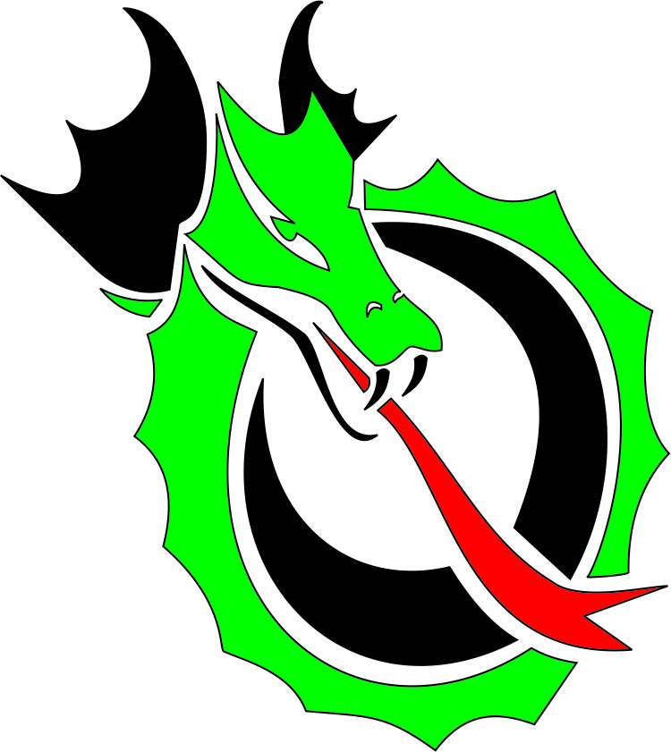
HILLCLIMB EVENT SCHEDULE

FRIDAY, July 24th, 2026
8:00am - 5:00pm Course set-up Want to help? Email; vlanning98@charter.net

3pm - 8:00 pm Registration and Tech Inspection – Hillclimb Start Area

Tech Inspection will be a roving tech on Friday. On Saturday morning, you are responsible for finding Tech Inspector at Start to get approved to race. Race cars will not be tech inspected until driver is registered. Event Paddock Parking is First come, First served.

NOVICE Workers Flagging Chief Chris Polhamus will be happy to assist with any questions. Cpolhamus74@gmail.com

6 pm : Cookout at Start Line

5 pm: NOVICE DRIVER MEETING AT START LINE (if you can’t make this – there may be one on Saturday morning at 7 am if needed).

9:00 PM Hillclimb site road closed. No overnight camping on the hill but several campgrounds are nearby.

SATURDAY, July 25th, 2026
7:00am - 8:00am. Road opens and late registration open in the paddock. Workers must stop by registration at start line to sign wavier and receive meal tickets
7:00am - 8:30am Roving Tech (Please see Mark Seiler or ask registrar for his location)
7:00 am NOVICE DRIVERS MEETING AT START LINE if you missed Friday night meeting
8:00am - Worker Meeting - gravel parking area at TOP of hill.
8:15am - Driver Meeting gravel parking area near start gate.
8:00am – Drivers may drive course (NOT at speed – both lanes in use!)
9:00am - 12:00 Course goes Green - Event Chair determines official timed runs for all classes. Between groups, expect traffic on course, course workers rotate stations per directions of Worker Chief.
Approx. 12:00 - 12:45pm Stop runs for worker lunch
(Lunch provided for workers )
1:00pm - 5:00pm Resume timed runs.
6:00pm - 7:00 am No Race Engines

6:30 PM Worker dinner. Details to be provided at event.

SUNDAY, July 26th, 2026
7:00am - 8:30am Roving Tech (Please see Mark Seiler)
7:30am Worker Meeting
7:45am Driver Meeting
8:15am - 10:30am Official Timed Runs begin
10:30am - 12:00pm Stop runs for worker lunch (lunch provided for workers at Start gate).
NOTE: Mandatory “Quiet Time”, NO RACE ENGINES FROM 11:00 AM to 12:30 PM
12:30pm - 3:30pm Official Timed Runs
3:30pm – 4:30pm DRAGON SLAYER Awards Approximately 30 minutes after last car on track.
Trophy presentation procedures will be announced at the Driver’s meeting. If you want your trophy, either be there to accept or make arrangements with the Event Chair to have someone accept your award. We will award a KING of the Hill and a QUEEN of the Hill Dragon Slayer sword for fastest times of weekend.

