2022 Roadrunner Region PCA Autocross Rule Changes

2022 Car Classification

Roadrunner Region PCA's event and car classification rules are based on the 2021 Porsche Parade Competition Rules (PCR). The rules, guidelines and procedures are intended to promote safe and fair competition within the ideals of good sportsmanship.

For 2022, Roadrunner Region will be returning to a car-based classing system to improve fairness between competitors of differing skill levels competing in cars with vastly different performance potentials. The rules are based on the national PCR recommendations for a “Small Sized” autocross, with further consolidation of classes to try to prevent classes consisting of only a handful of drivers based on our historically small number of competitors. In addition, two classes have been created for drivers of non-Porsche cars and for experienced drivers of Porsche or non-Porsche cars. The intent of these classes is to (1) provide a place for our non-Porsche competitors (since the PCR don’t include such cars) and (2) to prevent very experienced drivers from dominating the Porsche classes (thereby maintaining some of the advantages of previous years’ driver skill-based classing).

Model Classification

Competitors are responsible for the policing of and adherence to the car classification rules. If you have questions about where your car falls, please consult the National PCR on the RRRPCA website https://rrrpca.com/autocross/ or through the Porsche Club of America website if you are a PCA member. The Autocross and Tech Chair shall handle all Classification and Modification protests. All decisions are final. Model Classification Tables follow the Class Summary Descriptions.

Class Summary Descriptions

The PCR has four categories of classes for Porsche automobiles – Showroom Stock (S), Production (P), Improved (I) and Modified (M). Each category is then broken down into classes based on the specific automobile for Showroom Stock and Production classes, and based on number of cylinders and displacement for Improved and Modified classes. Based on historical attendance numbers, a number of these classes are being combined for 2022 in the Roadrunner Region. Specifically, all Showroom Stock and Production Classes have sub-classes based on a car’s performance potential (i.e., S01-S05, and P01-P05). For 2022, the sub-classes for Showroom Stock and Production cars are being combined, resulting in only 5 Stock/Production sub-classes (P01, P02, P03, P04, and P05). It is possible that P01 and P02 will be combined based on the number of cars running in these sub-classes. In addition, there will be only one class for all Modified and Improved vehicles, M01.

Showroom Stock (S) - As the name implies, the Showroom Stock (S) category is for automobiles nearly identical to as they were available from the dealer. Very few changes are allowed and tires must have a tread wear rating of 180 or greater. Aftermarket wheels are allowed, but they must have the same width and diameter as available from the factory. Neither supplemental driver restraints nor aftermarket seats are allowed. RRRPCA is combining cars in Showroom Stock class with the Production class for 2022.

Production (P) - The Production (P) category is for automobiles that have limited performance modifications. Aftermarket seats, supplemental driver restraints, roll bars, and steering wheels are allowed, but the rest of the interior must remain intact. Aftermarket coil springs/torsion bars and shocks/struts are allowed, but they must be the same type and mount in the same manner as original. Camber plates are NOT allowed in Production category. Although DOT-approved R Compound tires are normally allowed in Production category, since Roadrunner Region is combining this category with Showroom Stock, all tires must have a tread wear rating of 180 or greater. Use of a tire with a tread wear rating of less than 180 will bump the car into the Modified category.

Improved (I) - The Improved (I) category is for automobiles with more substantial performance-affecting changes from standard (stock) specification. These modifications have defined limits, whether changed by the factory, dealer or owner. Supercharged cars are probably in this class or in the Modified class.This category includes R-Rated, less than 180 tread wear tires, even if they were on the automobile as delivered. Cars in this class are combined with those in the Modified class for RRRPCA in 2022.

Modified (M) - The Modified (M) category contains automobiles that have performance-affecting modifications outside of the limits of the Improved category and for race automobiles (factory-built or otherwise).

Non-Porsche cars and Expert Drivers in lower-classed Porsche cars (X01) - At a minimum, all drivers of non-Porsche cars will be placed in this class. This class is intended for drivers of non-Porsche cars of all skill levels, and for very experienced (“Expert”) drivers of Porsches that would otherwise be classed in P01-P04 or slower M01 cars. For experienced Porsche drivers, this class is elective. In other words, such drivers may choose to run either in the standard PCR class for which their car qualifies (P01-P04 or M01), or in X01. Porsche drivers who consistently win season championships in their PCR class will be encouraged to step up to one of the expert classes to promote competition in the standard PCR classes.

Expert GT Class (X02) - This class is intended for very experienced (“Expert”) drivers of Porsche cars that would otherwise be classed in P05 or the fastest M01 cars. In addition, this class is appropriate for very experienced drivers in the fastest non-Porsche cars. As a general guideline, this would include cars that are classed in Super Street or above (based on relative PAX index) in SCCA classing. As with X01, this class is elective and drivers may choose to run in this category or compete in one of the standard categories (P05 or M01 or X01).

So is your Porsche Showroom Stock, Production, Improved or Modified? Find your Porsche model and generation in the charts on the following pages to determine your Production class. If your car has performance-affecting changes, see the PCR autocross rules (https://rrrpca.com/autocross/) for category allowances to determine if your car falls into the Modified category. Only one class exists for Improved and Modified Porsches.

If you are unsure about your vehicle class, please check with the autocross staff for guidance.

Additional Driver Designations:

Novice – Novices will not run in a separate Novice class for 2022. Novices will run in the class in which their cars are classed. However, a Novice designation (“N”) will be denoted in results for drivers that have never autocrossed or do not compete on a regular basis. Novices can have competed in no more than three autocrosses in the last twelve months and can never have received an autocross award in a previous season. The novice drivers will have an instructor identified during the drivers’ safety meeting to help answer any questions the driver may have. Safety and instruction are to be emphasized with an instructor coaching the entrant from the drivers’ meeting through the end of the entrant’s run. An instructor will be available to go over the course before each run, be in the car for all runs and will go over the course after each run completed and the car is in grid. During the run the instructor will be focusing on safety, then proper driving techniques. After three events, the “N” designation will be removed and drivers will continue to run in the the class in which their car is placed.

Masters – Competitors aged 62 years or older may self-designate themselves as “Masters” and will be denoted in event results by a Masters (“M”) designation. These drivers will still run in the class in which their car is placed, but will vie in competition for the highest placed Master in the overall results.

PCR Small-Size Autocross Class Listings
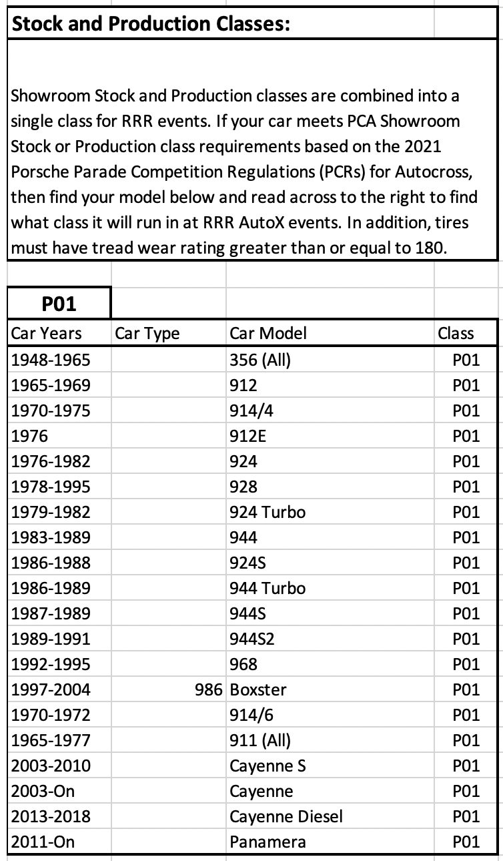

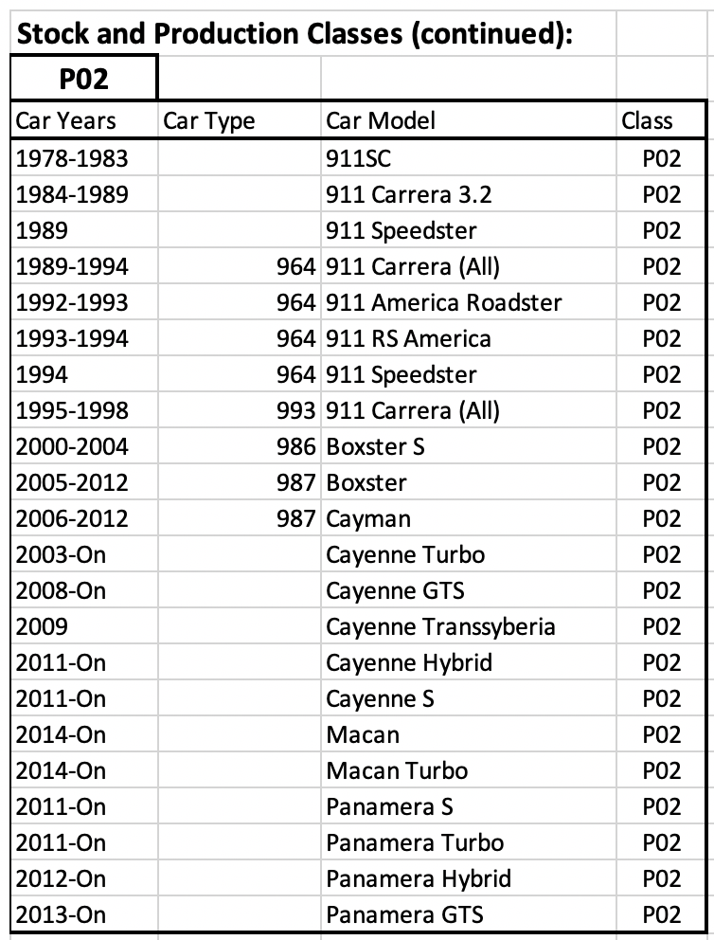
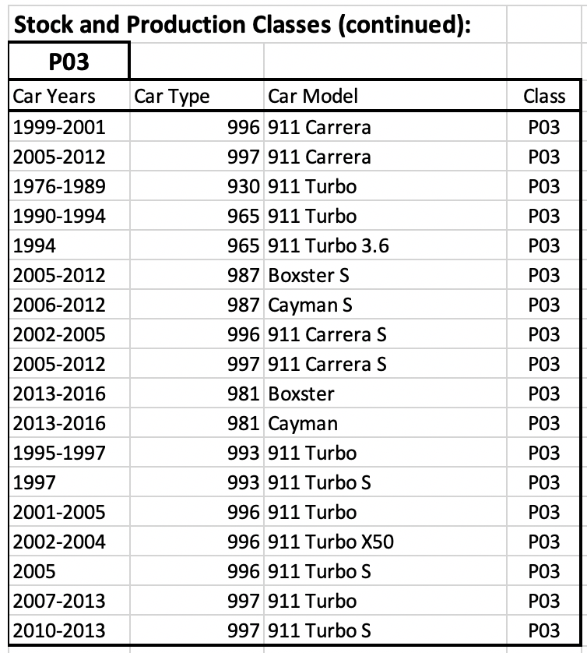
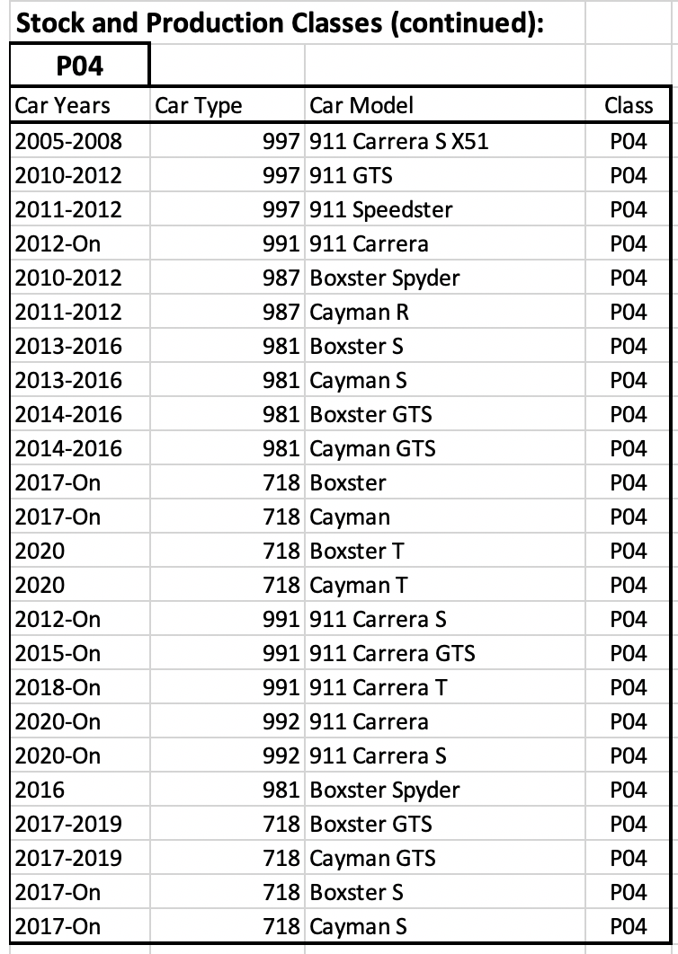
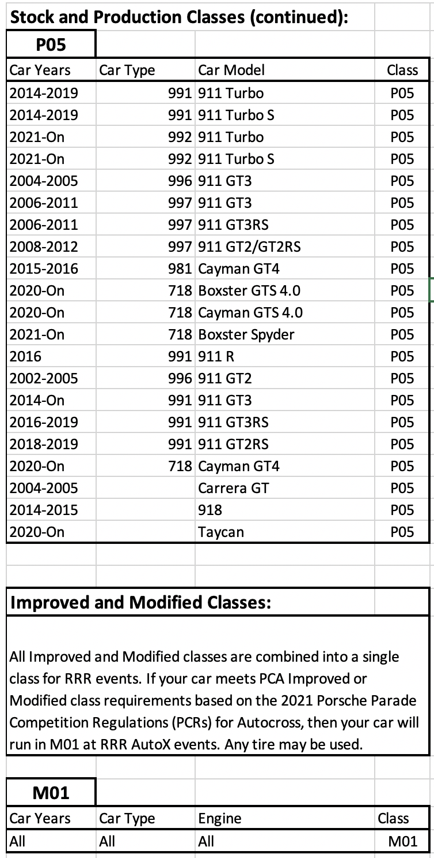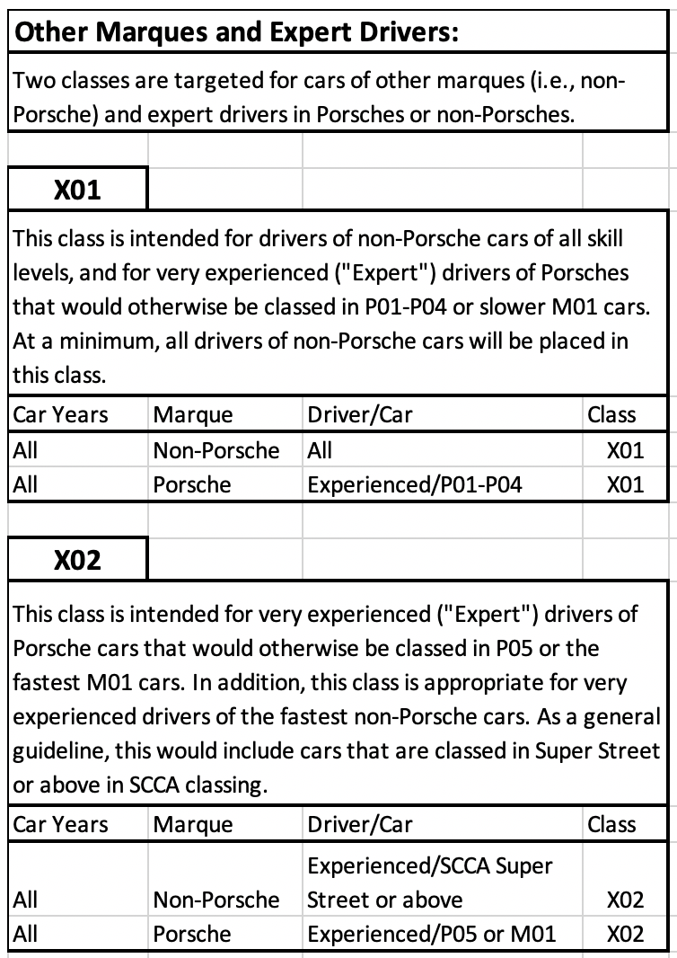

Protests:

All classification and modification protests must be presented in writing to the Autocross Chair within 20 minutes of the last run. The decision of the Chair is final. The decision need not be made at the event.

Scoring and Awards

Scoring:

Event points will be awarded to the finishers within each class, All participants will receive at least 1 point for participation. Drivers who do not work at the event forfeit their points for that event.

Points are awarded as follows:
Place Points
- 8
2 6
3 5
4 4
5 3
6 2
7+ 1

Class awards:

Class awards are awarded at the end of the season to participants who have competed in the majority (half plus one) of the season’s competitive events. An entrant is deemed to have participated if they started at least one run during the event. Participants must be driving Porsches and be PCA members to be eligible for end of season awards.

Awards are to be based on a driver’s total accumulation of points based on counting a driver’s best finishes in a single class. If a driver competes in more than one class during the season, they must have competed in one class for a majority (half or more) of the season’s events in order to be eligible for an award in that class. The number of events that will be counted for class awards is the total number of events held minus two (n-2).

Number of awards per class (minimum):
Drivers Awards
1-2 1
3-5 2
6+ 3

In addition to the class awards, special awards may be presented, e.g. Master’s award, Spirit/Sportsmanship award, Most Improved, et.al..

