Ice Breaker
SCCA Road Racing - Competition Driver School / Regional
SANCTION NUMBERS: TBD – Sanctioned by Continental Divide Region
La Junta Raceway
April 28, 2023 – April 30, 2023
Registration Hours

Fri., 7:00 am - 12:00 pm
& 6:30 – 8:30 pm
Sat., 7:00 am - 12:00 pm
& 4:45 – 5:45 pm
Sun., 8:00 am - 12:00 pm

Classroom Bldg.

Tech Hours
School Tech:
Fri., 7:00am – 8:00am

Express Tech:
Fri., 6:30 pm – 8:30 pm

Classroom Bldg.

Tech / Scales:
Sat., 7:00 am
Sun., 8:00 am

Paddock / North.

Meetings

Workers Muster:

Fri., 12:30 pm
Sat., 7:45 am
Sun., 8:00 am

At the big tree.

Drivers Meeting:

In impound after qualifying for each group

Run Groups
Group 1: Time Trial Novice
Group 2: Time Trial Intermediate / Advanced
Group 3: AS, GT1, GT2, GT3, GTL, T1, T2, T3, T4, EP, FP, HP, STL, STU, B SPEC, RSM, SM, Spec M3, S7, Pro7, ITA, ITB, ITC, ITE-O, ITE-U, ITR, ITS, SPEC 944, SPEC E30, GTX
Group 4: FA, FB, FC, CC, FE, FE2, FX, ASR, P1, P2, FS, FST, F5, SRF, SRF3, CF, CV, FF, FV, RF
Group 5: Omitted
Group 6: Closed Wheel Driver School
Group 7: Performance / TT Driver School

Schedule

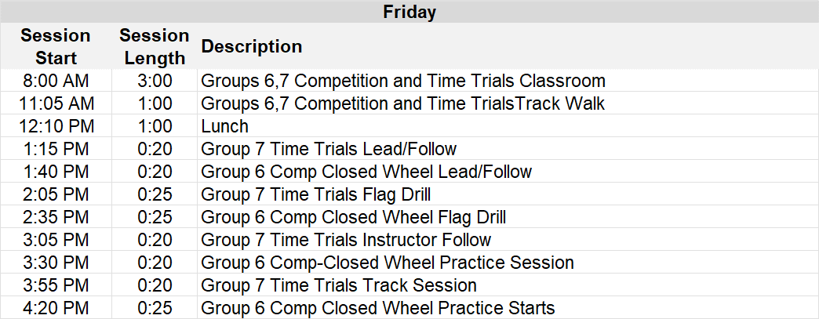

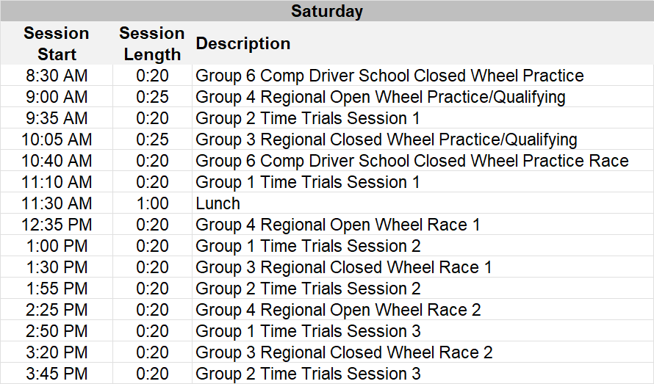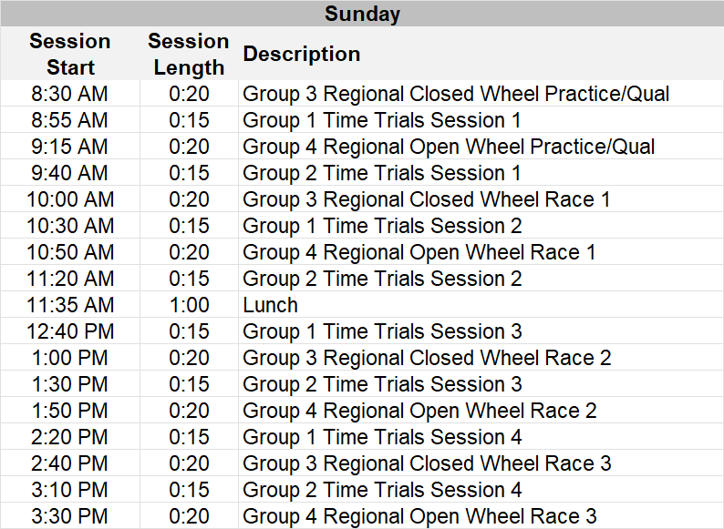

Time Trials Participants, TT (Performance Driving) School – for supplemental regulations, tech, meetings, and registration,
please visit: msreg.com/IceBreaker-TimeAttack-TTSchool
GENERAL
Event Facility: La Junta Raceway Phone: 719-469-1424
30267 1st Ave.
La Junta, CO 81050

Length of the Racetrack: 1.3 mile, 7 turn road course
Direction of the Race: Clockwise
Pole Position: Chosen by Pole Sitter
Location of Race Control: Tower
Start Line: On the Front Straight
Finish Line: On the Front Straight

ADDITIONAL REGULATIONS

This event is governed by the current General Competition Rules (GCR) and Category Specifications, as amended by “FasTrack.
Track Event portions of this event are governed by the current Track Event Rules.

Name of the Event: Ice Breaker
Close of Entries: Tue., April 25, 2023 or as extended by registration officials

ENTRY FEES:
- Competition Driver School $300 (Friday and Saturday)
- Student Sunday Regional Add On $175 (Sunday Only for School Graduates)
- Regional Weekend: $395 (Saturday and Sunday)
$300 for 2nd Entry (Double Dip)
- Regional Single Day: $275 (Saturday or Sunday)
- Enterprises Compliance (SRF, SRF3, FE, FE2): $30 / per entry

- Double Dip: A driver wishing to register with additional cars or in multiple classes. Applies to each additional registration. Driver agrees to comply with the published groupings and group order. Please use the double dip option at the time of registration.
- A change in any entry after the start of the event requires re-registering and may involve additional fees.
- Spectator entry at La Junta is FREE.

REGISTRATION: Online registration is held at http://coloradoscca.motorsportreg.com. Acceptable payment includes Visa, MC, Discover, Check, or PayPal. If you need help registering, please contact the Race Chairman or the Registrar.
- Online registration will close at midnight of the Tuesday prior to the event, unless extended by registration officials.
- Event payments will be processed the Wednesday prior to the event. A $50.00 late fee will be assessed after registration closes. A $50.00 fee will be assessed on returned checks/bankcards.
- Cancellations may be made through the Chief Registrar prior to the event. Cancellations made after payment processing may incur a $50 processing fee. Refunds requested during the event will be considered by the Chief Registrar for cars that have not been on the racing surface. Refund requests should be made before the end of the event. “No Show” refund requests must be made to the region Treasurer teri.massey@comcast.net within 3 calendar days following the event. Approved refunds will be issued via MotorsportReg.
- Registration check-in will be held in the Registration/Hospitality/Classroom building in the paddock. All drivers, volunteers, and officials must check-in to complete registration and receive credentials, even if you have signed an annual SCCA waiver.
- Only members who hold a current SCCA membership may be credentialed for the hot areas. Weekend memberships can be purchased at Registration, during posted hours, for a fee of $15.00.

DRIVER ELIGIBILITY: Drivers must have a current SCCA membership and current SCCA Full Competition License, SCCA Pro License, SCCA Vintage License, or SCCA Novice Permit. Also welcome are licensed drivers from organizations whose licenses are currently approved by SCCA for competition as listed in the GCR, Appendix C, 2.8.B (pages 118 & 119). Download GCR. Proper credentials must be presented to complete registration.

CAR ELIGIBILITY: This competition is open to all cars conforming to the GCR, as amended.
- Colorado Region also recognizes Regional and Spec Classes specific to the Rocky Mountain Division as follows: Club Ford (CF), Club Formula Continental (CC), Club Vee (CV), ITE Everything (ITE-0, ITE-U), Spec RX-7 (S7), Spec 7 with 13B (Pro 7), Spec 944 (S944), Spec E30 (SE30), Spec M3, Regional Formula F (RF), and Regional Spec Miata (RSM). Class rules and information for these classes can be found at http://www.coloradoscca.org/rulesforms.php
- Rocky Mountain Division Regional Championship rules are available online at http://www.coloradoscca.org/rulesforms.php

COMPETITION NUMBERS: Preference will be given to numbers assigned through the Rocky Mountain Division numbering program. Unreserved numbers are on a first-come, first-served basis. All numbering assignments are subject to race group configurations.

TECHNICAL INSPECTION: Tech inspection hours are posted on the event schedule.
- Express Tech is available for drivers with both a current annual tech and a current year helmet sticker. Drivers should bring their vehicle logbook and registration credential to get their Event Tech Stickers.
- Drivers without a current year Helmet Sticker must present all driver gear as required by the GCR, vehicle logbook, and registration credential to Tech. If your car requires an annual tech, you must also bring the car to tech. An Event Tech Sticker will be issued after everything is examined and approved.
- The order of inspection at the track will be:
  - Express Tech
  - Re-inspection, logbook notation
  - Annual inspection or Cars with no logbook (new or lost logbooks) – must make prior arrangements with the Chief of Tech to have this performed at the track.

SCALES: Scales will be available each day until the end of the competition races, except during impound. Driving on or off the scales is prohibited unless otherwise instructed by Tech personnel. Motors must be turned off and competitors and/or crew must push cars on and off scales.

EVENT SCHEDULE / RUN GROUPS: The course configuration for this event will be Clockwise. The event schedule or run groups may be changed at the discretion of the Chief Steward. If changes are made, as much notice as possible will be given to all competitors.
- The schedule as published is for planning purposes. Session start times may vary from the published schedule as the event progresses.

TIMING AND SCORING: All cars are required to use fully operational AMB transponders.
- It is the driver’s responsibility to make sure their transponder is working AND that the correct transponder number has been provided in the registration system or to the Registrar. A vehicle without a working transponder or with a missing transponder number may not be scored.
- Additional transponders may be available for rent at the rate of $30.00 per day, along with a $500 retainer on a valid credit card. The retainer will not be charged unless damage or loss of the transponder occurs. These are available on a first-come, first-served basis and should be reserved through the online registration process.
- The clock will continue to run during all flag conditions with the exception of the red flag.
- Personal timing beacons are not allowed within 20 feet on either side of the T & S system at Start/Finish, or across track from S/F.

SOUND: A maximum limit of 103dB is in effect for this event. Sound control will be located on the left just after Start/Finish. Sound readings will be posted at Hospitality.

GRID: Each day, the Starting positions for Race 1 will be based on the practice/qualifying session immediately preceding the race.
- Saturday – Race 2 will be an inverted grid, based on the finishing order from Race 1.
- Sunday – Race 2 will be an inverted grid, based on the finishing order from Race 1. Race 3 will be a normal grid based on the finishing grid from Race 2.
- Cars arriving at the grid after their group has been dispatched on track may, at the discretion of the Operating Steward, be held at pit out and released at the end of the pack after the field has completed the pace lap.
- Crew / Guests must leave the grid at the one-minute warning.
- Drivers are prohibited from scrubbing tires in the paddock, grid, pit out to the course and hot pit lane.

RESULTS & AWARDS: Trophies for Feature Races (Race #2 on Saturday – Race #3 on Sunday) will be awarded in accordance with the GCR.
- Results and trophies will be available in the hospitality area. Sunday trophies will be available until 1 hour after the last checkered flag. Trophies not picked up will be considered forfeited unless prior arrangements have been made with the Race Chairman.
- All Races are awarded RM Division Points. Only cars with an SCCA logbook will be eligible for points towards the Rocky Mountain Division Championship Series.

FLAGGING: GCR 6.1.1 flag rules apply to all sessions
- BLACK FLAG station is at corner station 6
- For practice sessions, a CHECKERED FLAG signaling the end of the session may be displayed at BOTH Start/Finish AND Corner 6. Cars receiving the Checkered Flag at Corner 6 must proceed directly to the pit lane/paddock
- Last lap may be a waiving white flag or “1 to go” sign at start/finish.

DESIGNATED INCIDENT INVESTIGATION SITE: If a driver is involved in significant body contact, the driver and car shall stop at the designated incident investigation site located in Race Impound for review of the incident by the stewards before going to their paddock area. “Significant body contact” includes but is not limited to: contact resulting in 2 or 4 wheels off course, spins, loss of position, or repairs to suspension or bodywork.

DISABLED CARS: Disabled or damaged cars may be removed from the course and delivered to a central location. If the car has sustained body/chassis damage it will be taken to impound and will be released to the driver/crew after tech has made appropriate notations in the vehicle logbook. Cars disabled due to a mechanical failure will be released to the driver/crew immediately. If the car requires wrecker support to return to its paddock location, there may be a delay depending on the availability of wreckers or flat tows.

RADIO FREQUENCIES: The region frequencies below shall not be used for communications by any participant.

451.2875 | 451.3125 | 451.3375 | 451.3625 | 451.3875 | 461.5125
463.2625 | 466.2125 | 466.5875 | 468.3125 | 469.1250

PADDOCK: Access ways for general paddock traffic and Emergency Vehicles must be kept clear at all times or vehicles will be towed.
- You must have a valid motor vehicle license to operate any 2, 3, or 4-wheeled motorized or non-motorized vehicles in the paddock.
- Skateboards, skates, rollerblades, and one-wheel electric boards are prohibited.
- The paddock speed limit is 10 M.P.H. Vehicles in the paddock must be operated in a safe manner.
- Entrants are responsible for the conduct of their crew, guests, minors, and pets. All minors must be always under direct adult supervision. Pets in the paddock must be always leashed and under direct supervision of an adult.
- Minors and non-members must remain behind any barrier paralleling the Hot Pit lane. No one will be allowed to view from in front of the Race Control and Timing structure.

GENERAL: Participants must display proper credentials at all times.
- The organizers reserve the right to postpone, abandon or cancel the event, or any part of the event. Entry fees will be refunded to those offered no opportunity to compete.
- Any test day or session not on the official schedule is NOT sanctioned by SCCA and is NOT covered by SCCA Insurance.
- Vendors wishing to display or sell any items must obtain prior approval from the Race Chairman.
- The consumption of alcohol is prohibited until after the daily on track activities are concluded. In addition, GCR 2.3.1.B shall be in effect as it relates to Narcotics and Dangerous Drugs.
- The organizers reserve the right to refuse entry and/or issuance of credentials to the premises or event for any reason except race, color, creed, sex, or national origin.
- Unmanned aerial vehicles, also known as drones, shall not be used anywhere in the airspace over the property.
- All on track body contact (including contact during drafting) that causes a car to act erratically and results in a change of position or a car leaving the course will be investigated.
- Club racing penalty guidelines can be found at http://www.coloradoscca.org/documents/penalty_guidelines.pdf

DRIVERS’ SCHOOL STUDENTS: SCCA Membership and Novice Permit are required. Both can be obtained at
https://www.scca.com/pages/i-want-to-road-race
A. Obtain an SCCA Legal Race Car with current Annual Tech Inspection
B. Register for the school at coloradoscca.motorsportreg.com
C. Read Drivers School Student Handbook at coloradoscca.org
D. Complete SCCA Online Drivers’ School Course – Print Certificate of Completion and bring to class.
- To access your training, complete the one-time self-registration process at: https://sccatraining.com/rockymtdivision_reg
- Fill out the Group Registration form. Make note of your username and password. Once registration is complete, select “Go to Dashboard” on the next screen.
- Your Dashboard will display the remaining course modules that you are required to complete.
- You may exit the course at any time. The system will bookmark your progress so you can return to the point where you left off.
- To return to the course after logging out, select “Login” and enter username and password. Do not re-register.
- Select “Dashboard” to view your course progress and print your Certificate.
- If you have any issues, select “Support” and open a ticket.

E. At coloradoscca.org, download and complete the GCR Exam and Flag Test. Bring your answers to class. Contact the Chief Driving Instructor with any questions.

DRIVER SCHOOL GRADUATES ENTERING THE SUNDAY REGIONAL: Driver school graduates who have been signed off to compete in the
Sunday Regional races need to return to registration on Saturday evening to complete that registration process for an additional one-day entry.

EVENT OFFICIALS:

Event Chief Steward | Chick Misura  303-817-9714  chickmisura@msn.com | Chief of F & C | Ed Kajko  303-650-1590  zydecolds@gmail.com
Clerk of Court | Kathy Bradley  (C) 303-579-8841  katbrad52@gmail.com | Chief of ES | James Framel  719-248-4886  james.framel@gmail.com
Race Chairman | Amanda Melanson  719-659-1890  amandini81@gmail.com | Chief of Course | William Carter  303-827-8721  Turnandburn86@gmail.com
Chief Registrar | Annita Braun  812-298-4301  annita.braun09@gmail.com | Chief Starter | Leah Street  208-360-0448  moonstonelvs@gmail.com
Chief of Tech | Nikki LaRue  303-489-2583  nlarue@scca.com | Chief of Sound Control/Radios | Nancy Foster  303-304-6661  nlfradioqueen1@comcast.net
Chief Driving Instructor | Ted Winning  303-919-9122  tedwinning1@aol.com | Chief of Timing/Scoring | Ed Shuler  303-910-0147  eshuler@mac.com
Chief of Pit / Grid | Teri Massey  303-913-1142  teresa.massey54@gmail.com

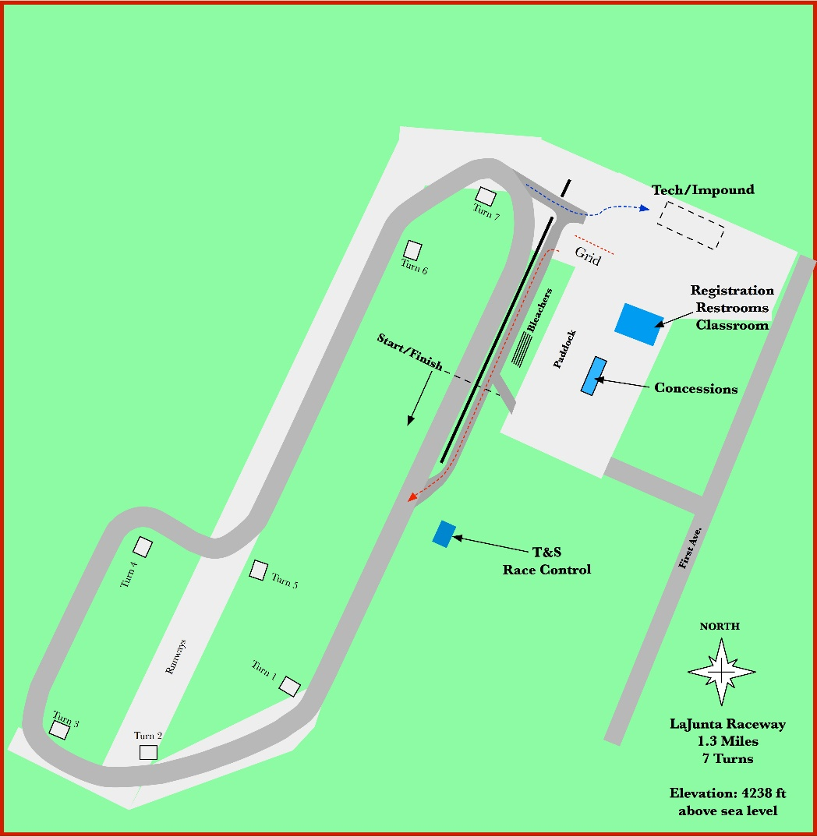

ADDITIONAL EVENT INFORMATION

Test and Tune: Any Open Lapping or Test Day held prior to the event is sponsored by the track and is not sanctioned by SCCA.

Race Fuel: La Junta Municipal Airport has 100 low lead AV gas at the self-serve pump (credit card only), within walking distance of the race track. Loaf n Jug, about 2.5 miles south of the track, has 91 octane. There is no other fuel available at the track.

Directions to La Junta Raceway: La Junta Raceway is on Route 109 (Main Street) about four miles north of US-50 in the Airport Industrial Park of La Junta CO. Enter at the main Industrial Park entrance (Harris Ave.) then turn left onto Otero Avenue, keeping the golf course to your right. Turn left again in about 1/3 mile, then right on Railroad Avenue and proceed to the track entrance, on the left.

Accommodations: RVs may be parked overnight at the track. A limited number of electrical hookups are available for rent. First Come, First Served, by pre-arrangement with the Track Manager, Allan Lasater at Allan@lajuntaraceway.net. Rent is 20A - $50/weekend, 30A & 50A - $80/weekend, payable by cash or check at the track.

Other accommodations near La Junta Raceway:

Preferred Hotel
La Junta Inn Hampton Inn Econo Lodge
1325 East 3rd Street 27800 W US Highway 50 27882 Frontage Road
La Junta, CO 81050 La Junta, CO 81050 La Junta, CO 81050
Phone: (719) 383-3946 Reservations: (719) 384-4444 Phone: (719) 384-4408

Volunteer Incentives: Volunteers are needed for Friday, Saturday, and Sunday. Volunteers are required to pre-register on MSReg, so arrangements can be made for lunches, Saturday night dinner / party, etc. For help with registration, please contact the Race Chairman or Registrar.
- A lunch ticket will be given to each volunteer for each day worked.
- Volunteers are invited to participate in one Free TT session on Saturday and Sunday. Sessions should be coordinated with each worker’s specialty chief and the TT Event Lead.
- Volunteers will receive accommodations reimbursement for 1 – 3 nights, depending on the number of days worked. Volunteers are required to book their own accommodation. The region will reimburse ½ of the accommodation rate per volunteer. Share with another volunteer and get 100% reimbursement. The maximum amount of reimbursement will be based on the nightly rate at the preferred hotel, though volunteers are not required to stay at one of the preferred hotels. Please present the paid receipt to the Race Chairman before the end of the event. The Region Treasurer will mail reimbursement immediately after the event.

