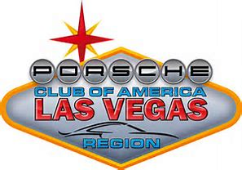
Las Vegas Region – Porsche Club of America
Vehicle Technical Review Form

Name:_______________________________ Signature: ____________________________________________

Car Make: _____________________ Car Model: ___________________________ Year: _________________

Color:_________________________ Car Number:_________________ Date:__________________________

INTERIOR
Remove all loose items – including trunk
Check under seats
Seats secured
Fire Extinguisher (recommended)
Floor Mats Removed (factory tie-down is OK)
Roll Bar (required for convertible)
BRAKES / WHEELS / TIRES
Lugs tight / torqued
Hubcaps removed
Wheel bearings checked
Sufficient tire tread
Sufficient brake pads
Brake pedal travel
Brake fluid level
BODY / LIGHTS
Brake Lights Work
Door/Hood/Trunk close securely
Fender Clears tires
Windshield/Screen

ENGINE / TRANSMISSION / REAREND
Battery Secure
No loose parts
No fluid leaks
Throttle return springs
Fan/Aux belts
Tailpipe/Muffler secured

SUSPENSION
Shocks (bushings/leaks)
Linkage Tight
Steering Wheel Play
Travel/Noise/Clunks
EQUIPMENT
Approved Helmet (SA2015 or later)
Googles/Shield (required for convertible)
Long Sleeve Shirt
Close Toe Shoes
HANS device required for 5/6 point harness
Disable ADAS (auto-braking, lane keep, etc)

__________________________________________________________________________________________

LV – PCA use only

Track Tech Review Date: ___________________ Inspector Initials: ________________

Pass Fail Car Number: ____________________

Remarks:

