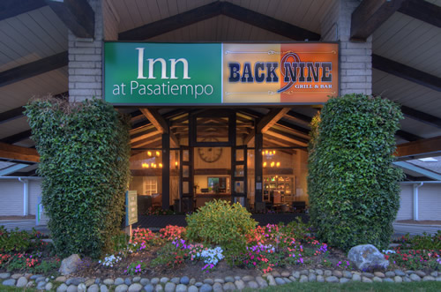 ------- 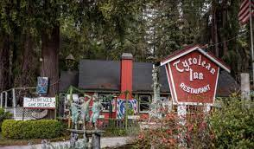

Inn to Inn Drive and lunch

Inn at Pasatiempo to Tyrolean Inn Drive and Lunch

Date: Sunday, September 19
Drive Start Time: 10:45am *please ensure you have enough time given Sunday traffic on Hywy 17
Drive Start Location: On the road in front of the Inn at Pasatiempo (not the parking lot, OK to use restrooms)

We will do a short 45min drive through the backroads of the Santa Cruz Mountains, ending at the Tyrolean Inn for lunch in their beer garden.

$15 per person (drinks not included)
Menu (Choose 1):
Kaspatzle: House made Spätzle with a cheese sauce and roasted onions.
Teller: Choice of either a Polish sausage or bratwurst sausage.
Jageschnitzle: Thin pork cutlets in a creamy mushroom sauce.
(all entrees include red cabbage, potato salad and apple strudel for dessert)
Please text or email your RSVP to Kris Vanacore 408.406.1410141410 vanacore1@mac.com WITH your menu choice or sign up using MotorSportReg.
EVENT IS LIMITED TO 30 GUESTS!

