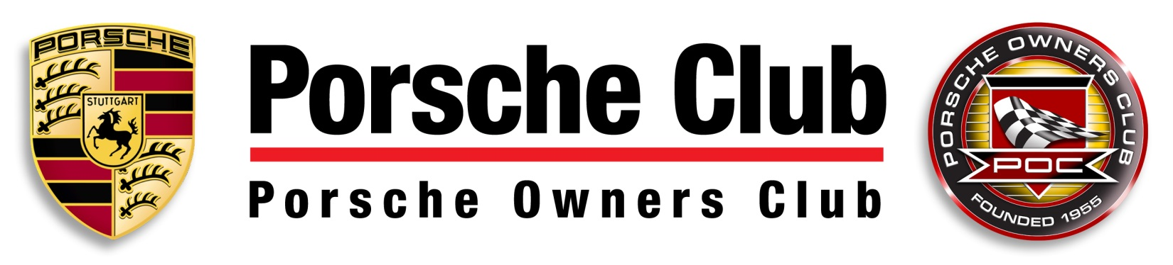
2021 Racers’ Clinic Application
Six completed Porsche Owners Club (POC) Time Trial Events (or fewer along with sufficient documented racing experience) are required for participation in a POC Racer’s Clinic. Current race license holders from other organizations may potentially qualify for a waiver of all or part of the Time Trial requirement. To apply for a waiver, contact the POC Chief Driving Instructor or Secretary. You may be required to submit the following:
1. Current S.C.C.A, P.C.A., V.A.R.A. Competition License or equivalent.
2. Certificate of Completion from an accredited Racing School (e.g. Bondurant, Barber, Russell).

Issuance of a waiver and/or acceptance into the Racers’ Clinic shall be at the discretion of the POC Chief Driving Instructor. The POC reserves the right to investigate any and all information submitted by the candidate for consideration. Should any information be deemed unreliable or false the POC may, at its discretion, suspend all driving privileges and refer the candidate to the POC Board of Directors for further investigation.

The POC will typically offer two Racers’ Clinics per year. The Racers’ Clinic will have its own Run Group (Blue). All Clinic participants will run in the Blue Group and will conclude with a Sprint Race on Sunday. Participants must complete all Clinic exercises and the Sprint Race to have their participation and subsequent graduation recorded in their Driver's Log Book. A candidate may be granted a Cup Racing License after successful completion of two Racers’ Clinic weekends subject to final approval of the Chief Driving Instructor. The Racers’ Clinic, as with all speed events sanctioned by POC, is governed by the 13/13 rule as defined in the POC GCR (General Competition Rules). Safety rules for any Clinic weekend may be added or changed by the Instructor(s).

All drivers and vehicles participating in the Racers’ Clinic must meet the requirements outlined in POC GCR Sections 11.0 Safety, 11.1.3. Racing, 11.2 Clothing, and 11.3 Restraint Systems, as they pertain to Cup Racing. Any exceptions must be approved by the Chief Driving Instructor.

Contact the Chief Driving Instructor or Secretary now to reserve your spot, and complete and submit the entry form below. The Clinic application must be included with your Clinic Entry and Base Event Entry fees.

POC Racers’ Clinic Application:

Name: ____________________________________POC Membership #: ____________ Car #: ________

Phone (Day): _____________ (Eve): ______________ Avg. Lap Time WSIR: ____________

E-mail: ___________________________________ Car Model & Color: ___________________________

Please List Your Last 6 Time Trial Events: ___________________________________________________
_____________________________________________________________________________________
_____________________________________________________________________________________
Email to: CDI@porscheclub.com
Porsche Owners Club, Inc., 1968 South Coast Highway #4911, Laguna Beach CA 92651

